2023-2024
Teacher Student Data Link (TSDL)

Contents
Overview 1
Timelines and Deadlines 2
Requirements 2
Data Submissions Process 3
Step 1: Collection Prep 3
Step 2: Data Collection, Entry, and Initial Review Processes 3
Step 3: File Extraction & Submission to CSI 4
PowerSchool Users 4
Infinite Campus Users 4
File Submissions to CSI 5
Step 4: Troubleshoot and Resolve Data Errors 5
Step 5: Review and Certify Data 6
TSDL Summary Report 6
Appendix I: Extracting TSDL Files in Your SIS 7
PowerSchool 7
Infinite Campus 9
Appendix II: Updating SCED Course Codes in Your SIS 11
PowerSchool 11
Infinite Campus 13

Overview
The Teacher Student Data Link (TSDL) enables the state to connect students with the educators responsible for their learning. The aim is for the system to provide dynamic data that enables users to learn from the past and understand the present so that they can take appropriate actions to impact the future.

CSI has begun to look at course completion as part of school performance, so accuracy and completeness has become even more important in reporting the TSDL collection.
Data from the TSDL collection will be used to partially populate the Civil Rights Data Collection (CRDC) so making sure your data is as accurate and complete as possible will save you time on the CRDC collection.

Please follow the instructions in this document to successfully complete the TSDL collection for your school. All resources specific to this collection are posted to the TSDL webpage of the CSI website.
New Schools/Submission Contacts: If you are new to reporting state collections, then we highly recommend that you first review the CSI Data Submissions Handbook for an overview on the collection processes in general (available on the General Resources webpage of the CSI website).
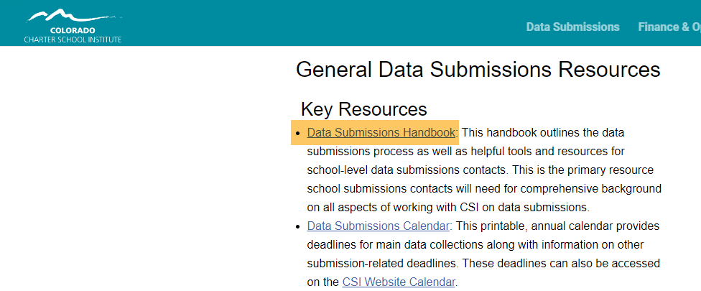

Timelines and Deadlines
All collection deadlines associated with the TSDL can be found in the CSI Submissions Calendar for the current year (available on the General Resources webpage of the CSI website). It’s important for schools to meet all CSI submission deadlines so that we can stay on track with meeting all state deadlines to CDE.

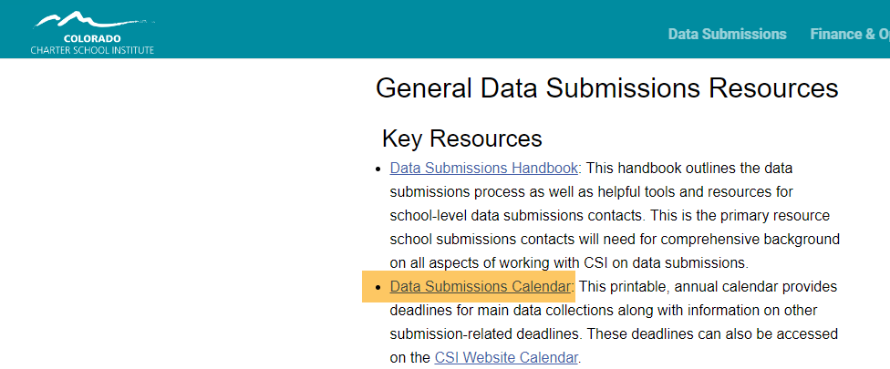

Requirements
Data to Report:
- All 6th through 12th grade students enrolled in a mathematics, English language arts/literacy, science, and/or social studies course for 6 weeks or more should be included in the TSDL file. All courses may be included for ease of submission, but only math, English, science, or social studies course are required. Include AP, electives, postsecondary option courses (both on and offsite), and onsite home school program classes in these instructional areas.
- All 8th through 12th grade migrant students enrolled in any course for 6 weeks or more must be included. These students must also have their Credits Granted reported for each course.
- Summer School Enrollment: All 22-23 summer school students should be reported in SY23-24.
- CSI schools are not required to report Teacher/Instructor information. However, if teacher/instructor data is extracting from your SIS it is fine to include it in your TSDL submission and it must be accurate.
- CSI recommends that schools use SCED versions 11 (or higher).

Data Submissions Process
General Reminder: The data submissions process can be summarized as a five-step iterative process. Steps 2 through 4 are repeated until a school is error free.

Step 1 – Collection prep
Step 2 – Collect, enter, update data within Student Information System (SIS)
Step 3 – Extract and submit data files
Step 4 – Review error report (s)
Repeat Step 2 – Step 4 until free of Level 1 and Level 2 Errors
Step 5 – Final review & close

More detail on the five-step submissions process can be found in the CSI Data Submissions Handbook for the current year (available on the General Resources webpage of the CSI website). This webpage also contains short recorded tutorials on some submission basics like securely sharing data with CSI, using file layouts, and others.
Each of the five steps are listed below from the perspective of reporting the TSDL collection.

Step 1: Collection Prep
Schools should download copies of the TSDL File Layout (with CSI additions) from the TSDL webpage. Please make sure you are using the current year file layouts and not versions from a prior year. It’s very common for changes to occur from year to year.
Please take the time to look through the file layout to get an idea of data that will be reported and important CSI notes on items specific to CSI schools.

Step 2: Data Collection, Entry, and Initial Review Processes
The second step for reporting TSDL involves collecting, entering, and completing an initial review of your data prior to submitting your initial files.

- Conduct an internal review within your Student Information System or SIS (PowerSchool, Infinite Campus,etc.) to confirm course code completeness and alignment with the acceptable SCED codes.
  - Instructional course for grades 6-12 (not including lunch, recess, etc.) in your SIS must be mapped (cross walked) to SCED version 11 codes (or higher). This includes all postsecondary option courses also.
    - Non instructional courses in your SIS can be marked as exclude from state reporting so that they will not pull into your extract file.
    - SCED—“School Courses for the Exchange of Data” is a national prior-to-secondary and secondary course classification system developed through the National Center for Education Statistics (NCES).
    - Codes are five digits in length.
      - First two digits refer to the subject area.
      - Last three digits refer to the content.
    - You may use the same SCED for multiple courses at your school.
    - You must have SCED codes beginning with 01, 02, 03, & 04 in order to cover all course reporting requirements.
    - Multiple SCED codes should extract as multiple line entries. Contact your SIS support if you are having issues with multiple SCED code extraction.
    - CSI recommends that schools use SCED version 11 (or higher).
- Summer School Enrollment: All 22-23 summer school students should be reported in SY23-24.
- Every student included in the TSDL file must have a record in the current year End of Year (EOY) Student Demographic file.
- It’s not expected that initial file submissions will have the Final Grade/Course Completion Status Field populated with something other than a code of 6 for Incomplete. However, all other errors can be corrected to have the file ready for a final submission at the end of the school year once schools have posted grades in their SIS so that the Final Grade/Course Completion Status Field will have the correct values.

Step 3: File Extraction & Submission to CSI
Each SIS has a process (and resources!) for extracting the TSDL interchange files

PowerSchool Users
  - A CSI Quick Reference Guide is available. See “Extracting the TSDL File in PS” https://resources.csi.state.co.us/teacher-student-data-link/
  - Schools will need to extract files and submit to CSI by the deadlines provided in the CSI calendar.
  - PowerSchool Colorado State Collection help resources: https://docs.powerschool.com/USACO/colorado-reports-in-powerschool

Infinite Campus Users
  - A CSI Quick Reference Guide is available. See “Extracting the TSDL File in IC” https://resources.csi.state.co.us/teacher-student-data-link/
  - Schools will need to extract files and submit to CSI by the deadlines provided in the CSI calendar.
  - Infinite Campus TSDL help resources are at the following link (login may be required): https://kb.infinitecampus.com/help/teacher-student-data-link-interchange-tsdl-colorado

File Submissions to CSI
- Please name the files with your school code, school name, interchange file name, and a date so CSI can track that we have the most up to date data
- File Names Examples:
School Code, School name/abbreviation, interchange type, and date
- TSDL file for Animas High School
0075_AHS_TSDL_09252021

- When submitting files to CSI, do NOT open the downloaded file directly and resave, or it will lose critical leading zeros! Instead, save the file first. Then you can open and/or submit the saved file.
- If you need to save edits to a CSV file format you must first import it to Excel as an xlsx and make changes there. More information on these steps is available in the CSI training module Excel for Data Submissions - Part 1 (link on the CSI website under the General Resources webpage)

- After saving, open and scroll through file to ensure that fields are not blank or incorrect prior to submitting to CSI. Look for:
  - Column E (Course Level) – Not Blank
  - Column F (Credit) – Courses have accurate credit amounts.
  - Column H (Terms) – Not Blank
  - Column I (State Course Code) – Does not contain letters. Is a 5-digit code per state guide. See SCED Version 11 (or higher), located under “Additional resources” on https://resources.csi.state.co.us/teacher-student-data-link/
  - To correct Credits, Terms, and/or State Course codes in IC, see the Quick Reference Guide “Updating Course Information in IC” located under “Quick Reference Guides” on https://resources.csi.state.co.us/teacher-student-data-link/
  - Upload files to G-Drive under Submissions/TSDL/22-23/Files to Run and then notify CSI by sending an email to submissions_csi@csi.state.co.us.

Step 4: Troubleshoot and Resolve Data Errors
Schools will be expected to make changes in their SIS if needed to resolve errors and then submit a new file
- Error reports will be loaded to G-Drive under Submissions/TSDL/School Year/Error Reports
- Consult the Troubleshooting Errors resource for help in clearing errors.
- Early in the collection, schools will typically use codes 6 and 7 for the Course Completion Status field (see the file layout). Until an end of year completion code is entered for all records, there will be TD087 errors. After grades are posted at the end of the school year, schools should submit a new file with final completion statuses.

Step 5: Review and Certify Data

TSDL Summary Report
- CSI will upload a copy of this report to G-Drive for schools to review and sign off on the Certification tab.
- This will be the final opportunity for schools to review their data for accuracy and resubmit if needed.

Appendix I: Extracting TSDL Files in Your SIS

PowerSchool

Extract TSDL File –
- Select School: (Some schools will choose “District Office” if pulling data for multiple schools)
- Select the Calendar Year: Current Year

Go to: “Reports”, (NEW VERSION – “Data and Reporting”)

Select: “System Reports, (NEW VERSION – “Reports”)

Go to: “State” tab, (NEW VERSION – “Compliance Reports”)
- Under Interchanges, Select: “TSDL Interchange”

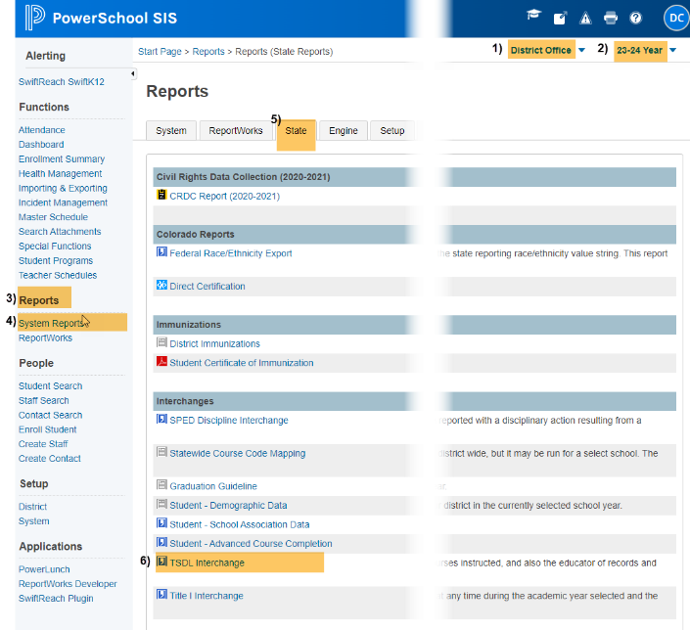
Original View New Version Update
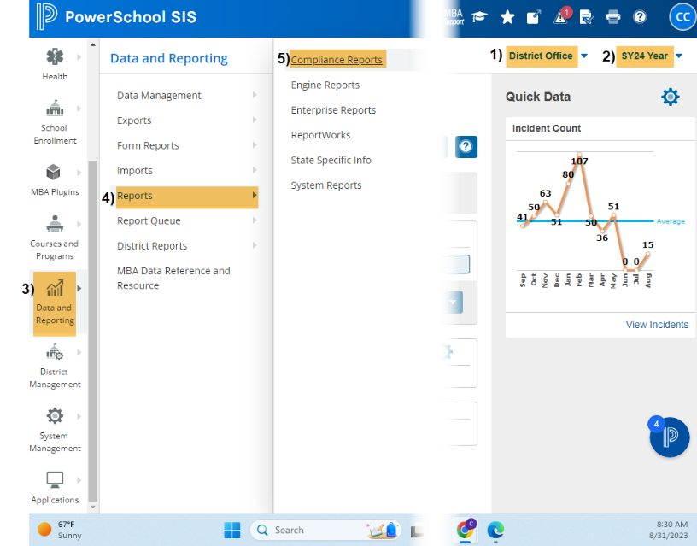

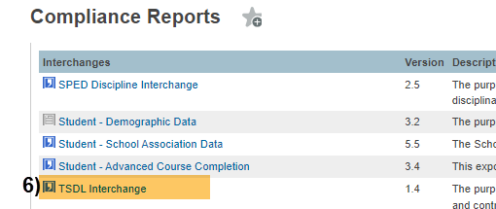

Under Report Parameters:

Select Schools to Include: Choose school/s that you would like to include. Use “Shift /Click” to select multiple,

Select Students to Include: Leave as Default “All Students”,

Enter minimum number of calendar days: Enter “1”

School Year: Use Current School Year,
- Start Date: Leave Blank (this will default to the first day of the school year),
- Snapshot Date/End Date: Use Current Date (date you are running the report),
- Click: Submit
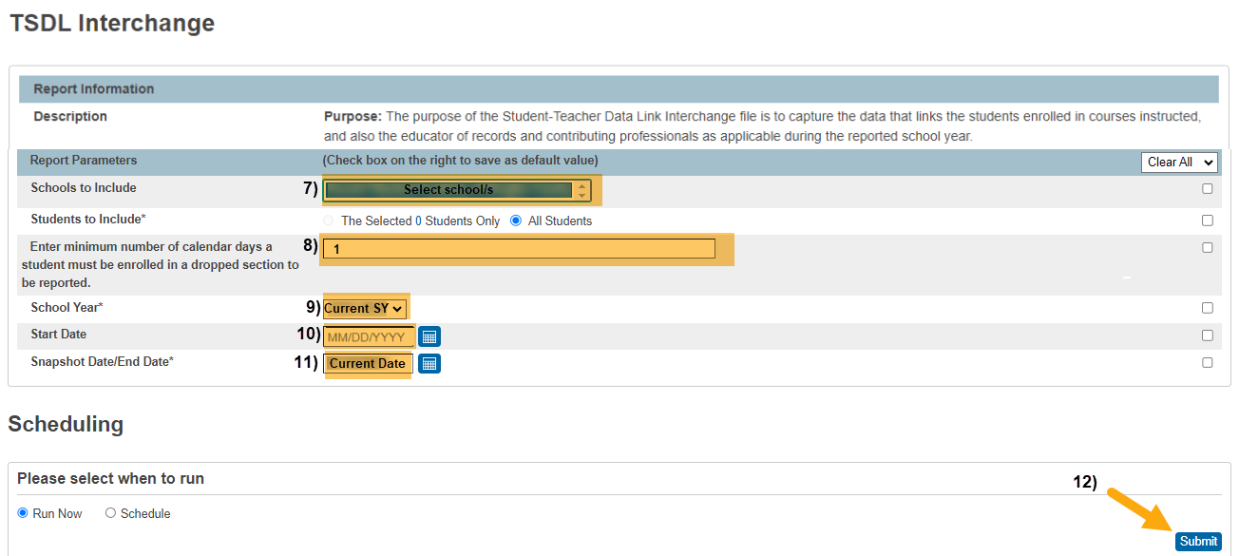

Infinite Campus

Extract TSDL File –

From any calendar year,

Go to: “Index” tab, (New Look View-“Main Menu”)

Select: “CO State Reporting” dropdown, (New Look View-“Reporting”)

Select: “Data Pipeline” dropdown, (New Look View- “CO Data Pipeline”)

Select: “TSDL Interchange”.

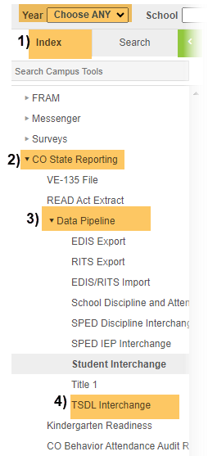
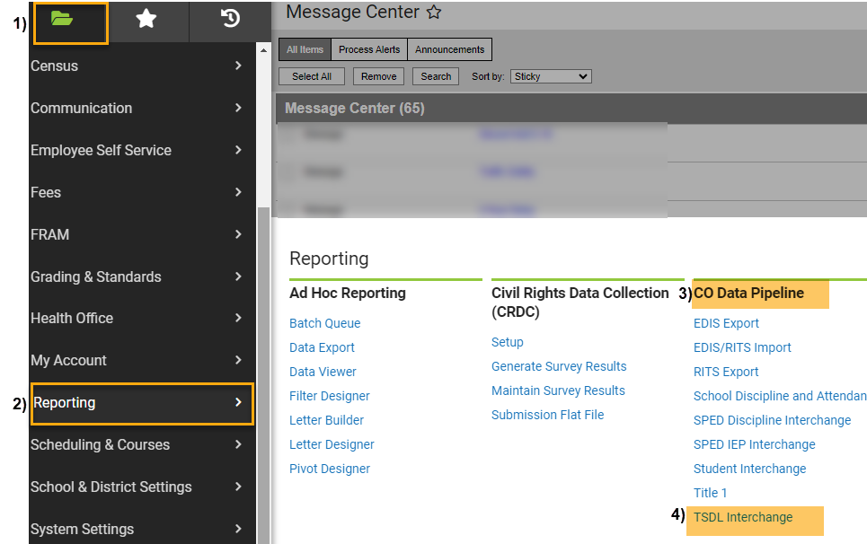
Original View OR “NEW LOOK” View

Under Extract Options:

Ad Hoc Filter: Leave Blank,

Effective Date: Leave as Default Date (Current Date),

Report Legal Name: Check this Box,

Migrant Only: Leave Unchecked,

Report All Credits Granted: Leave Unchecked, (This will auto populate and is needed if migrant status is identified in IC),

Format: Leave as Default “CSV”.
Under Select Calendars:

Choose calendar/s that you would like to include. Use “Shift /Click” to select multiple (Remember for TSDL, you only need to include calendars that include grades 6th-12th),
- Click: Generate Extract.

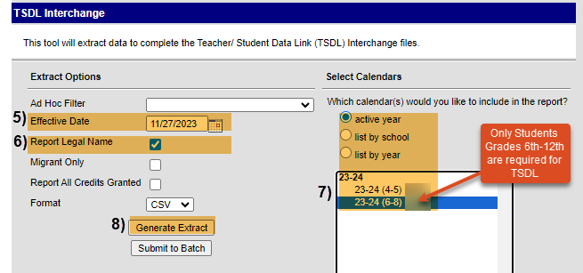

Appendix II: Updating SCED Course Codes in Your SIS

PowerSchool

Update Course Information –
- Select: School
- Select: Calendar Year (Current Year)

Under “Setup”, Select: “School, (NEW VERSION PS – “School Management”)

Scroll to: “Scheduling”, (NEW VERSION PS – “Courses and Programs”)
- Select: “Courses”

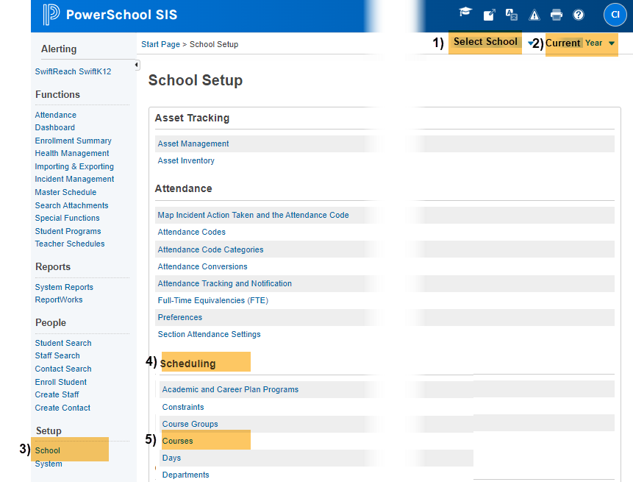
Original View New Version Update
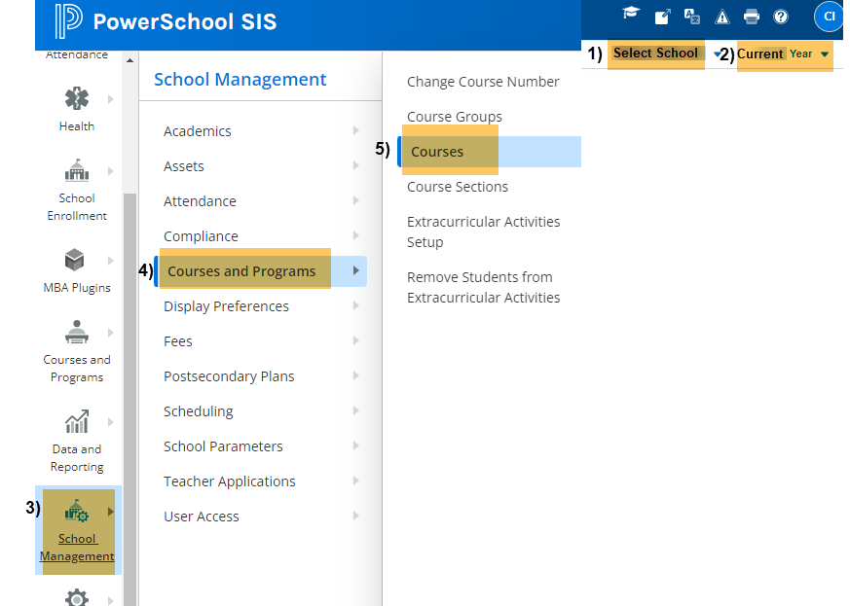

On Course Information Section to update STATE CODE, Credits, and Course Level:

Select: Course to update,
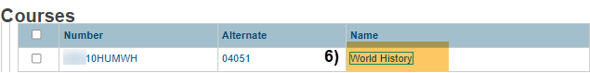
- Enter: State Code. This is a 5-digit State Approved Number (No letters). Find the State Code using SCED Version 11 (or higher) located under “Additional Resources” on https://resources.csi.state.co.us/teacher-student-data-link/,
- Enter: Credit hours. (Ex. 0.50, 0.25, 1.00),
- Enter: Course Level,
- Enter: Credits for high school classes defined by Carnegie Units (Ex. 0.50, 0.25, 1.00) OR Low and High grade offered Kinder – 8th. (ex KG05 for K – 5),
- Click: SUBMIT.
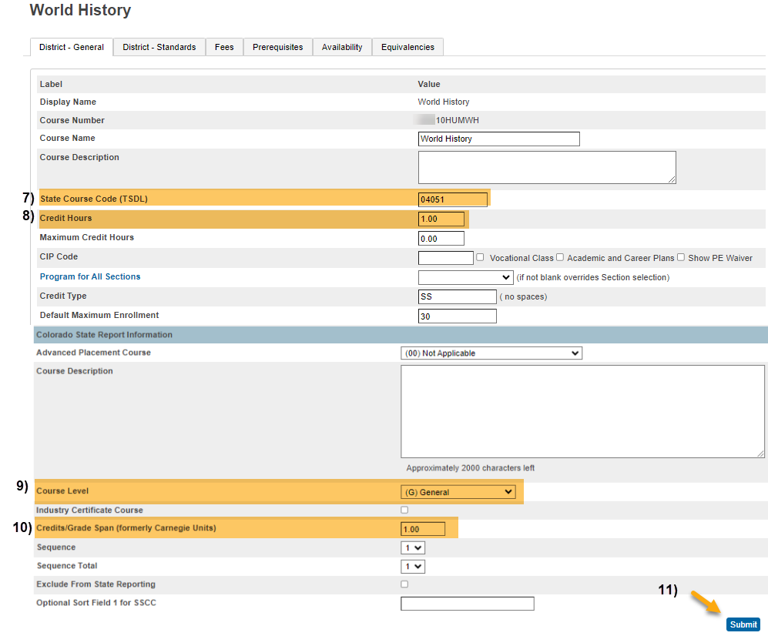

Infinite Campus

Update Course Information –

Choose: Current Year, School, & Calendar,

Go to: “Search” Tab,

Select: “Course/Section” from dropdown,
- Click: “Go”.
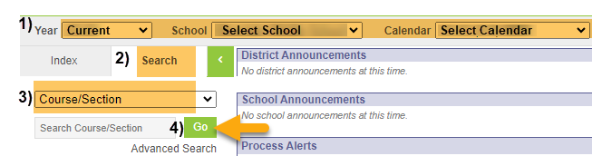
Under Course Information Section to update STATE CODE, Grade Level, Credits, and Course Level:

Select: Course to update,
- Enter: State Code. This is a 5-digit State Approved Number (No letters). Find the State Code using SCED Version 11 (or higher) located under “Additional Resources” on https://resources.csi.state.co.us/teacher-student-data-link/,
- Enter: SCED Subject Area. This is the first 2 digits of the 5-digit State Approved State Code,
- Enter: SCED Course Identifier. This is the last 3 digits of the 5-digit State Approved State Code,
- Enter: Lowest and highest grade offered for this course,
- Enter: Credits for high school classes defined by Carnegie Units,
- Enter: SCED Course Level,
- Click: SAVE.
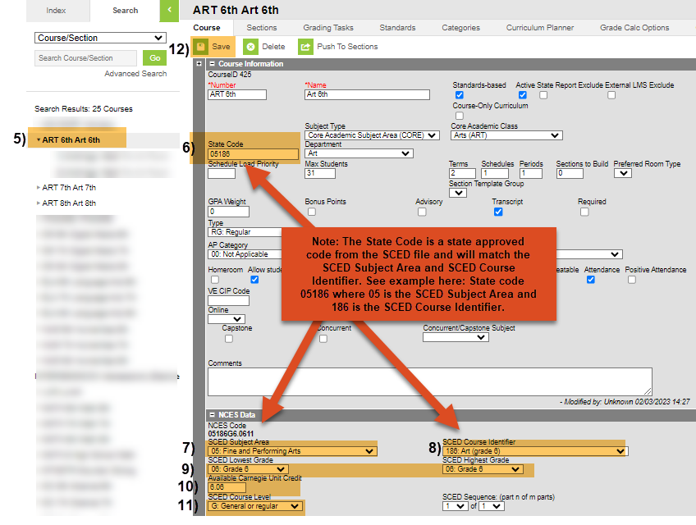
Under Sections to update TERMS:
- Click the course arrow to expand sections for each course,
- Click: Section to update,
- Select: Appropriate Term,
- Click: SAVE.
