Special Education Validations Toolkit
This toolkit contains strategies for validating Special Education data required for the completion of both December Count and SPED EOY collections. The impacted files include the Child and Participation for the SPED EOY and December Count Collections but also the Staff Profile and Staff Assignment files as it relates to staff included in December Count. Any detail marked with a * will flag on the Record Checker, so if that has been completed, the checkbox can be disregarded.

The first section contains the Validation Strategies Checklist and is designed to guide the user through common issues they may encounter and should be utilized as a checklist to validate the accuracy and compliance information being provided within an IEP and related fields.

The second section walks through how to utilize the SPED Record Checker Tool that was implemented over the last couple of collection years. The tool essentially allows the user to paste their initial Child and Participation files prior to initial submission and review potential errors and issues in the data that can be corrected prior to submittal.

If you have questions or suggestions on either of these tools, please reach out to the Data Submissions Team at submissions_csi@csi.state.co.us.

PART I: Validation Strategies Checklist

Both Collections

Demographics
☐ Verify that the student’s Name, DOB, and Gender match what is in RITS.
☐ Ensure that at least one Race field has been populated to reflect the accurate Race of the student*.
☐ Confirm the Student’s District of Residence is accurate based on the geographic district they currently reside in and that 8001 is not being used*.
☐ Ensure the State of Residence is zero filled if District of residence in input*.
☐ Confirm each student’s grade level is accurate and updated for the current school year.
☐ Verify that at least one Disability has been provided for all Students enrolled in a Special Education Program. This should only be zero-filled if the student was tested and found ineligible*.
☐ Ensure that students living out of State but are attending a CSI school have the District of Residence coded as 9999 (not zero-filled).

Attendance, Funding, and Student Counts
☐ Ensure that all students on the Child file have a record on the Participation file and vice versa. The SASID and LASID both need to match on the files.
☐ Check that the Funding Status (Typically 50), SPED Pupil Attendance Information (04), and Start Date have all been completed for students eligible for Special Education Services*.
☐ Verify all newly tested ineligible students eligible are included - but have the Funding Status, Primary Disability, SPED PAI Code, Special Education Hours, and Entry/Exit Dates zero filled.
- The students exiting prior to or enrolling after 12/1 do not necessarily need to be included in the files or must have proper start and end dates.
☐Verify that newly tested students are included and have the Date of Parental Consent, Date Evaluation Complete, and Date of Eligibility meeting completed on the appropriate path*.
☐ Confirm that Date of Exit and SPED Basis of Exit were completed for all students who have exited Special Education. Ensure all dates are zero filled as well.
☐ Ensure that any students with a SPED Basis of Exit of 50 – Expulsions are coded as expelled in the SPED Discipline Collection also.
☐ Review all funding codes of students to ensure all who are eligible are coded with a 50. If not eligible, the student should be coded as 00. Reach out to CSI if you feel another funding code is applicable.

IEP Program Data

☐ Ensure that the Educational Environment is correctly coded based on the age of the student. Students aged 3-5 (not in kindergarten) should be coded 204-212 (209 is typical) and students aged 5-21(kindergarten or higher) should be coded 301-308 (301 is typical).
☐ Verify that all returning students have a 06 reported for the Special Education Referral field and that the path dates are zero filled.
☐ Verify that all new students have a 03 reported for the Special Education Referral field and that the correct path dates have been completed (typically Path 3).
☐ Ensure that all the Delay Code options have been updated to reflect the most recent changes reflected in the File Layout. Make sure the system has been modified to remove old options and add new.
- Submit an explanation to CSI for all students coded with a delay code of 59 in order for CSI to request an exception.
- Ensure all students delayed due to COVID and remote learning have a delay code of a 61 – Not Valid – COVID-19 School Closure. If possible, use 45 for the delay code as that is a valid option.
☐ Confirm that the SPED Program Code is 0000 in almost every case*.

December Count Specific

Attendance
☐ Confirm each student was enrolled and receiving Special Education services on Dec 1^{st.}
- If a student was enrolled but not receiving services on December 1st, adjust Special Education Funding Status to 00.
- If a student was exited prior to December 1st, please update Date of Exit from Special Education and Basis of Exit to ensure this student does not pull into the snapshot.

Staffing
☐ Confirm each special education staff member identified on the student’s IEP has their EDID included in the Primary/Secondary Service Provider EDIDs*.
- Be sure to share this list of EDIDs with your school’s HR data submission contact so they can update their HR submission accordingly.
☐ Identify the grade levels of students on the Participation file that each service provider identified. Make sure those grade levels are the grade levels identified on the Staff Assignment file. School SPED and HR staff need to work closely together to ensure accurate data.
☐ Verify that all Special Education Staff have 80010 listed as their Administrative Unit.
☐ Staff in multiple roles must have both their hours and salary split in each row of data dependent on time spent in each. Hourly pay rates will be the full amount across all rows.
☐ Verify that all Staff with a caseload have the proper licensure to be in that role for at least 50% of the caseload based on disabilities.
☐ Ensure that staff added to Infinite Campus have their EDID added to the Staff Demographics Record tab, otherwise they will not show up on the Participation file. This can be accessed by going to CensusPeopleDistrict Assignment

Students Service Provider(s)
☐ Confirm that the Primary Service Provider’s EDID is included for each staff member working with students. Additional EDIDs can be provided in the Secondary EDIDs.
☐ Make sure that each student listed on the Participation file has at least one service provider identified in the Service Provider columns who has a Job Code of 202 (SPED Teacher) or 238 (Speech-Language Pathologist) identified on the Staff Assignment file.

SPED EOY Specific

Attendance
☐ Confirm all students enrolled and in attendance at any point during the year are included.
- Check students with zero filled exit from the previous year but did not attend have a one-day record. If not, they will receive an SY108 error that will have to be corrected during SY108 clearance phase.
- Ensure all students included on December Count have a record for SPED EOY.
☐ Verify that all students who Exit are reported as such, paying special attention to graduates (90) and dropouts (40). Exit information should match what End of Year is reporting.
☐ Ensure that students who exit Special Education during the year still have their disability coded for State Reporting. This should remain for the entirety of the school year.

Level 2 Error Considerations (December Count and SPED EOY)
☐ Confirm that your school has reviewed all Warnings in your error reports. Warnings can often mean incorrect data.
☐ Review all DC154 Warnings carefully as the student is being reported by another AU as of 12/1. If students were not in attendance that day, update the Exit Date and Type. If the student was there, CSI will reach out to the other district to correct.
☐ Verify the Entry and Exit Dates for students receiving an SY260 error. This indicates another district is reporting the student during the same time. Notify CSI if accurate and the other district will be contacted.
☐ Review all SAM Warnings that staff at your school are receiving for December Count as it indicates licensure or caseload issues. Reach out to CSI with questions as these warnings will need to be addressed.

PART II: Record Checker Tool

Purpose
The Record Checker Tool is an Excel template that helps schools to quickly identify missing data and potential errors by highlighting data cells that could cause errors (see screen shot on following page).

The Record Checker Tool is one downloadable Excel file that can be used to find errors on both the Child and Participation files prior to initial submission to CSI. While the Record Checker Tool cannot flag every possible potential error (examples listed below), using it in conjunction with the Data Validation Strategies Checklist, found on the SPED End of Year and December Count websites, should greatly reduce errors upon initial submission to CSI. Fewer errors leads to fewer submissions needed to achieve error clearance, and less time spent on the overall collection.

This tool can be used for both the SPED End of Year and December Count collections. While CSI encourages schools to use this tool prior to the initial submittal to CSI, schools are welcome to use this tool prior to any submittal to CSI, particularly during the October Count collection if students have been added to the SIS after the initial submittal to CSI. The instructions below describe the steps necessary to utilize this resource successfully.

Instructions
- Extract both the Child and Participation files from your Plan Management System and save as a CSV file with correct naming structure to your computer. For instructions on extracting and naming files, please see the Data Submission Handbook
  - Note: Once downloaded, these files can be opened and reviewed. You will not see the leading zeros on the opened CSV, but the Record Checker Tool is designed to flag issues on the file without leading zeros. This is for ease of use so schools can just open the file and paste rather than opening the CSV file as an Excel before using the template.

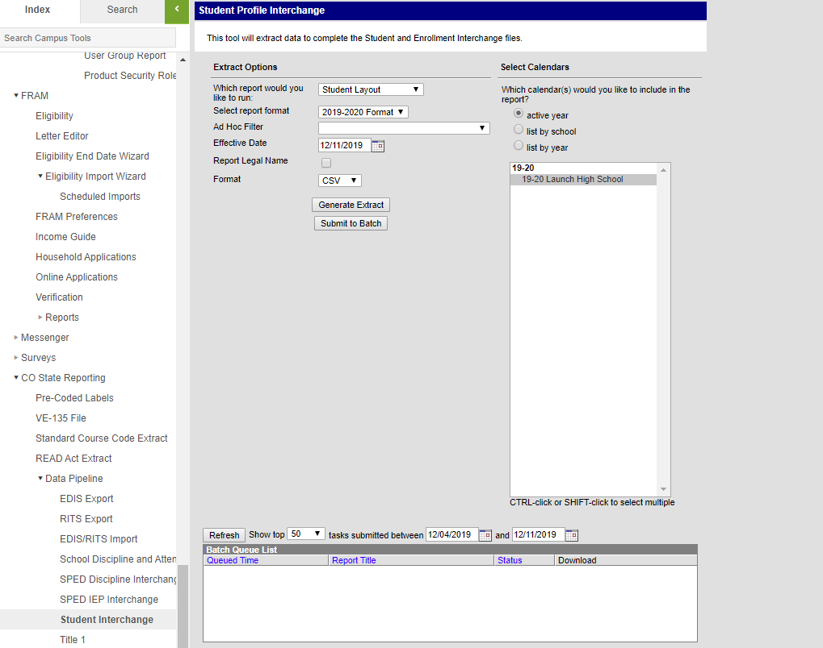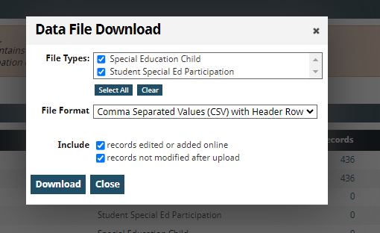

- Download the Record Checker Tool, by clicking on the link or navigating through the CSI End of Year or December Count webpages.

- Save the downloaded tool to your computer for use at any time. Keep in mind that this gets updated annually as changes to the file layouts occur.

- The Record Checker Tool template contains six tabs:
  - Instructions: Shows a listing of instructions and issues that will be flagged
  - Raw Child Data: tab to copy the extracted Child data into
  - Child Error Checks: tab that highlights errors from the ‘Raw Child Data’ tab
  - Raw Participation Data: tab to copy the extracted Participation data into
  - Participation File Issue Check: tab that highlights errors from the ‘Raw Participation Data’ tab
  - Data Overview: Summarizes pasted data and breaks out into several categories.

- Open the Child file. To select all of the file data, click on the triangle in the upper left corner to highlight all data on the worksheet and copy (ctrl+c).
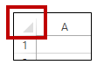
- Open the Record Checker Tool template and on the first tab, Raw Child Data, click cell A1 and ctrl+v to paste the data copied from the SD file.

- Repeat steps 5-6 with the Participation file, coping to the Raw Participation Data tab.

- Once both are pasted, begin the review process of each file by first going to the “Child Error Checks” worksheet. This tab contains pre-built conditional formatting that will highlight any field that will potentially cause an error once the file is submitted and processed.

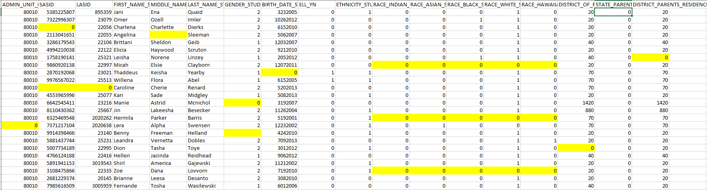

The Record Checker Tool is designed to check several of the fields for issues including:

Highlighted Child Field | Issue Flagged
All Fields | Fields that are completely blank
Administrative Unit Code | Anything other than 80010
Student’s State ID (SASID) | Missing or zero-filled SASIDs
First, Middle, and Last Name | Missing or zero-filled Names
Student’s Gender | Gender not coded either a 1, 2, or 3 for Female, Male, and Nonbinary *
Student’s Date of Birth | Blank or zero-filled Dates of Birth
Student’s Ethnicity | Missing 0 or 1 for Ethnicity
5 Race Detail Fields | All 5 individual Race fields coded as 0
District of Residence | Blank or zero-filled District
State of Parent’s Residence | State not zero-filled when District of Parents Residence is completed
*Message shows how flag looks on check template but does not reflect the leading zero intended in the field.

- Make updates in your Plan Management System to correct the errors highlighted on the Record Checker Tool. Do not make changes directly to the Record Checker Tool.

- Next review the data on the Participation File Issue Check tab. This tab also contains pre-built conditional formatting that will flag and highlight many potential errors to the Participation data including:

Highlighted Participation Field | Issue Flagged
Administrative Unit Code | Students not coded with an 80010 for this field
Student’s State ID (SASID) | Missing or zero-filled SASIDs
First, Middle, and Last Name | Missing or zero-filled Names
Student’s Gender | Gender not coded either a 1, 2, or 3 for Female, Male, and Nonbinary *
Student’s Date of Birth | Blank or zero-filled Dates of Birth
Primary Disability | Missing or blank when the Eligibility and Services is not 4 – Ineligible*
School Code | Missing or zero-filled school codes
SPED Program Code | Missing or not zero-filled
Entry Grade Level | Missing or zero-filled
District of Residence | Students not coded with an 8001 for this field
Pupil’s Attendance Information | Students not coded as a 4 when Eligibility and Services is not 4 – Ineligible*
State of Residence | Field not zero-filled when District of Residence is not zero-filled
SPED Funding Status | Anything other than 50 or 0
Educational Environment | Missing or zero-filled codes or students coded as 208 or 209 who are not in Preschool
Primary Service Provider | Any missing EDIDs or zero-filled students when Eligibility and Services does not equal 4(ineligible)*
Hours of SPED Services | Any missing or zero-filled hours where Eligibility and Services is 4 (ineligible)*
Total School Hours per Week | Missing or zero-filled
Start Date of SPED | Missing or zero-filled when Eligibility and services is 2 (eligible)
End Date of SPED | Missing date or zero-filled when Reason Exited is not zero-filled
Reason Exited SPED | Missing date or zero-filled when End Date of SPED is not zero-filled
SPED Part C Referral | Anything other than 6 or 3 for returning and new students*
SPED Eligibility and Services | Anything other than 2 (eligible) or 4 (ineligible)*
Path 2 Fields (AF-AO) | Anything that is not zero filled.
Path 3 Dates and Delays (AP-AX) | Students coded with valid dates/delays where their SPED Part C Referral is 6 – Returning. Students coded with no dates when their SPED Part C Referral field is 3 – New. Also, any blank values
Path 3 Eligibility and Services | Anything zero-filled when the SPED Part C Referral field is 3 – New. Anything non zero-filled when SPED Part C Referral is 6 – Returning. All blank values
*Message shows how flag looks on check template but does not reflect the leading zero intended in the field.

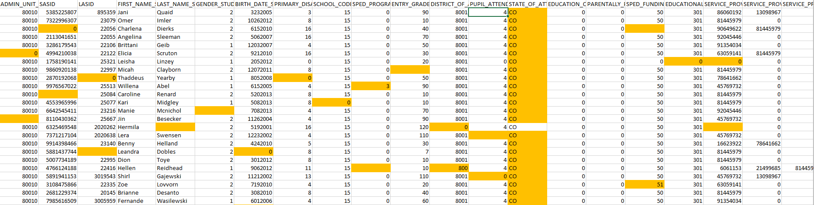

- Make the necessary corrections in your Plan Management System.
- Upon completion, new files can be extracted and pasted into the template to double check all issues have been updated.
- Submit the newly extracted files to FileZilla to complete your initial submission requirement for the collection.

As mentioned, this resource is not designed to catch every error your file may encounter and in some unique circumstances may flag data that is accurate. Be sure to check all flags and if accurate, feel free to leave as is. This may include some unique circumstances where a student needs to be coded as a Path 1 or 2, Contract Tuition scenarios, Funding codes other than 50 among others.

With these few limitations in mind, if The Record Checker Tool is used accurately prior to initial submittal, you should expect to see fewer file errors to correct on your first error reports. This should save the school time and allow for more accurately reported data.

