The following guidance provides a starting point for ensuring key areas related to state reporting are appropriately set up. Schools should make use of the PowerSchool Colorado webpage and PowerSchool support for advance system set up questions.
CSI schools are expected to review their SIS by August 1st each year to ensure the setup expectations outlined below, which directly impact state reporting, are met. Schedules for secondary school students (grades 7-12) should be set up in the SIS by September 1st each year. CSI Data Submissions Team members may audit components of SIS setup each year.
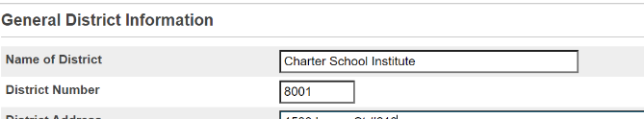  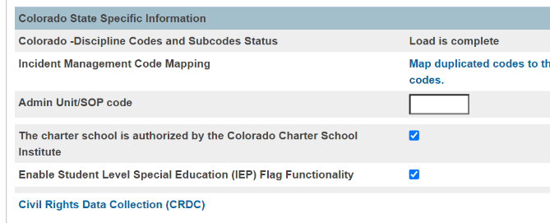 | DISTRICT INFO  Setup>District Setup>District Information> District Info  - Verify that district code is correct.  - Verify This charter school is authorized by the Colorado Charter School Institute checkbox is checked so records are not duplicated in the SD files of students transferred between two CSI schools in one school year.  - When this box is checked PS will remove any student with an Exit Type code of 11 from the SD file. This simply cuts down on SP149 Errors.  - Ensure that the Enable Student Level Special Education (IEP) Flag Functionality is checked as well.  This is a priority for new schools.
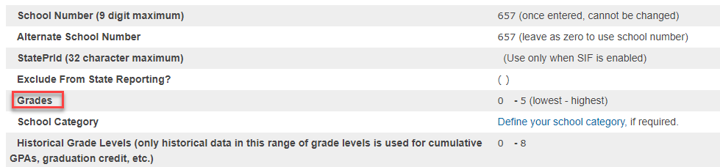 | GRADE LEVELS  District Setup> District Information>Schools/School Info  - Verify that the grade levels are mapped to the correct State Grade Level (Click on appropriate school name if broken out into levels.)  Check Against:  Any expected Grade Level changes for the coming year. (All expected grade changes should be confirmed with CSI in the Spring prior to the change taking effect.)  This is a priority for new schools and schools with grade level changes.
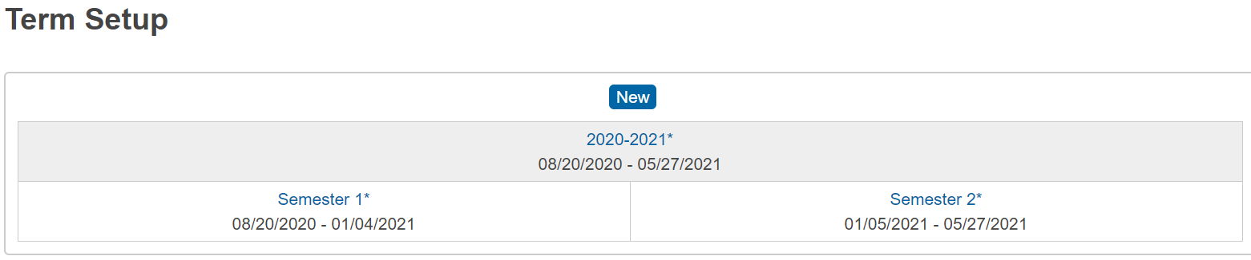  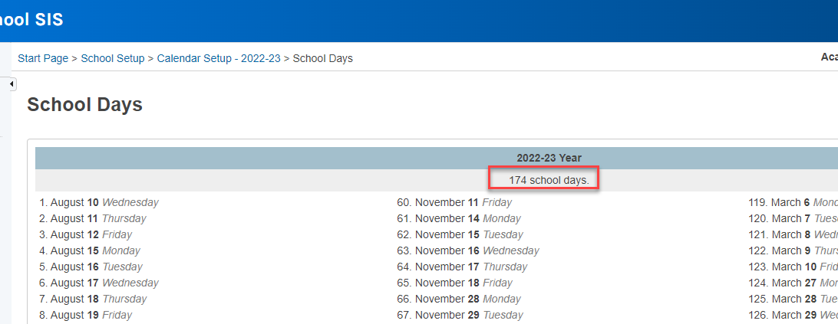 | CALENDARS & TERMS  District Setup>Calendar>Years & Terms>Edit Terms  - Check whether there are >160 days  For reference, schools generally have 160-180 days instructional days. Flag schools with significantly more or less.  Any schools with <160 days must be approved by the state. (All schools operating <160 days/4 day weeks should be confirmed with CSI in the Spring prior to the <160 days/4 day week taking effect.)  References: CRS 22-33-104 1(b)  A school or schools shall not be in session for fewer than one hundred sixty days without the specific prior approval of the commissioner of education.  If CSI does not have district level access, then check at the School level.  Setup>School>Calendaring>Calendar Setup>  Scroll to bottom of page and click on “Verify # of school days in the current term” link (make sure you are in the full year setting for the school (upper right navigation in PS). You should then get a table report that lists each of the days flagged that will be in session with a total count near the top of the report.
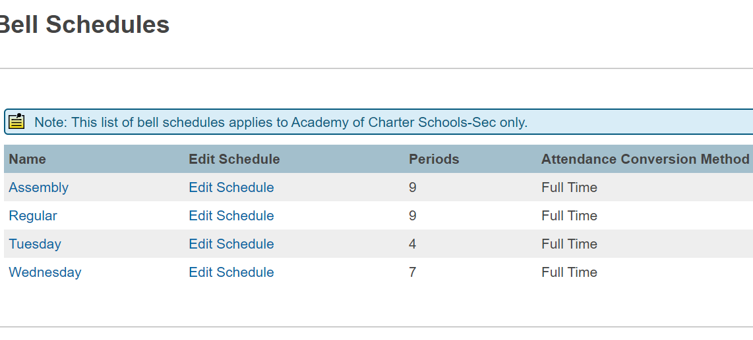 | SCHEDULES  Setup>School>Calendaring>Bell Schedules  - Verify that each bell schedule is assigned an attendance conversion method.  Resources:  - Video in Mastery in Minutes on PowerSource  - How to documents in PowerSource ID – 509
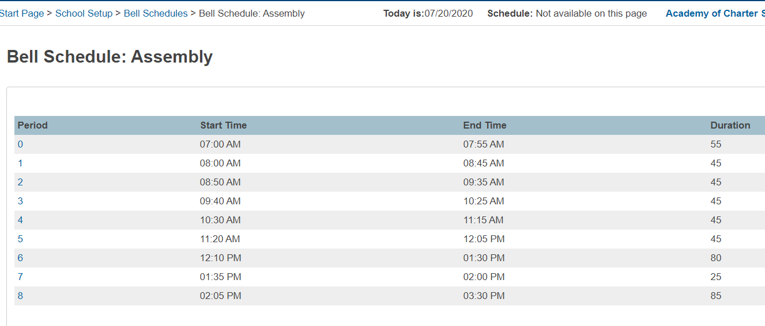 | PERIODS  Setup>School>Calendaring>Bell Schedules>Edit Schedule  - Verify Instructional Minutes, School Day Minutes  - Verify passing periods  - Determine which periods will occur in each bell schedule.  - Determine which periods count towards ADA calculations.  References: October Count Audit Guide  - Passing periods are defined as the time between two classes, and between a class and a lunch period  - Passing periods up to seven minutes may be included in the calculation of full- or part-time funding.  Resources: ID = 346
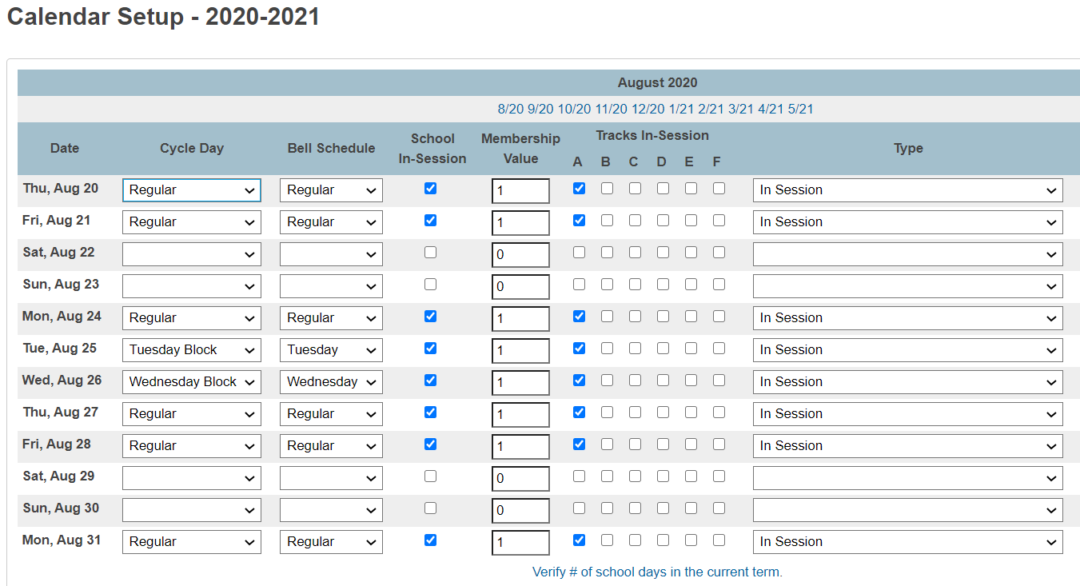 | DAYS  Setup>School>Calendaring>Calendar Setup  - Click on button “Verify Number of School Days in Current Term”  Check Against:  Annual Calendar submitted as part of annual submission  Resources:  - Video in Mastery in Minutes on PowerSource  - How to documents in PowerSource - ID 509
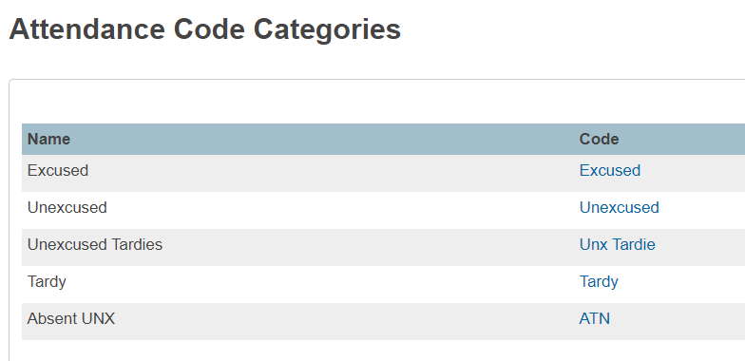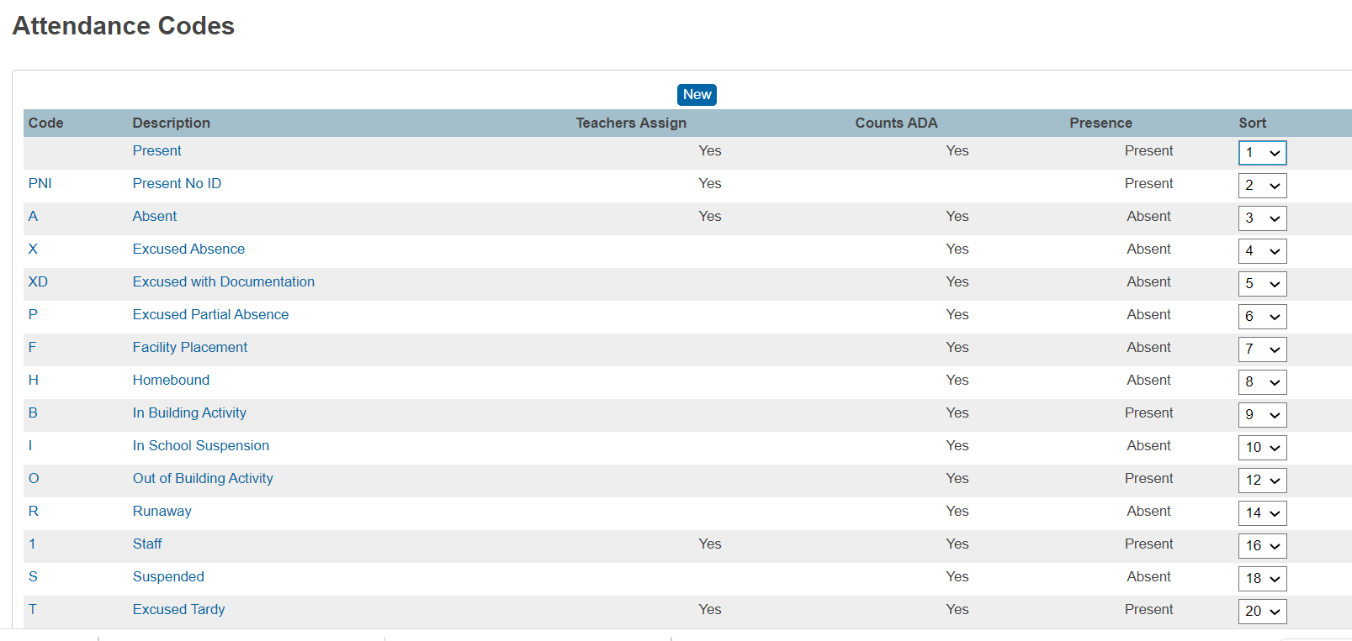 | ATTENDANCE  Setup>School>Attendance> Attendance Code Categories>Click on a Code  When creating a new year term, PowerSchool copies the attendance codes and categories from the previous school year, eliminating the need to recreate attendance codes and code categories from scratch.  Attendance Categories  - You only need 3 attendance categories: Tardy, Excused, Unexcused.  - Confirm that Expulsion and Suspension codes are marked as ‘Excused’ absence.  Setup>School>Attendance Code Categories>Click on a Code  When creating a new year term, PowerSchool copies the attendance codes and categories from the previous school year, eliminating the need to recreate attendance codes and code categories from scratch.  References: 1 CCR 301-78  - Absences due to suspension or expulsion of a child must be considered excused absences.  - For Department reporting purposes, a student who is absent more than 50 percent of any Attendance Period during a scheduled school day shall be considered absent for that entire recorded and reported period.  - For Department reporting purposes, a student who is present 50 percent or more of any Attendance Period during a scheduled school day shall be considered present for that entire recorded and reported period.  District Start Page>District Setup>Attendance Tracking & Notification  Ensure the Calculation Year is set for each school. This must be updated each year; it does not copy over from the prior year. (Failure to do so may lead to students meeting the definition of truant but not showing up as truant in the SSA file.)  Resources:  - Video in Mastery in Minutes on PowerSource  - How to documents in PowerSource - ID = 8223  - PowerSchool Colorado Attendance Setup
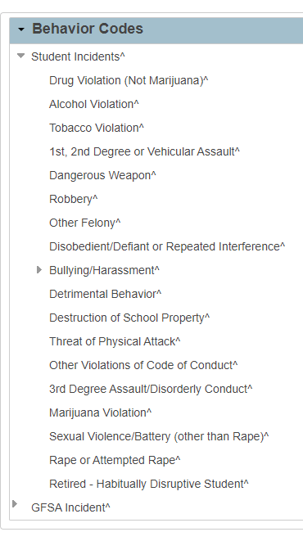 | BEHAVIOR EVENT CODES  District Setup>Discipline and Log Entries> Incident Management Setup>Code & Subcode Setup>Behavior Codes  Event Types  - Verify that event types are set up for each ‘State Event Code’  Check Against:  State reportable behavior resolution codes in Discipline data collection.  References: School Discipline and Attendance File Layout  - To access a list of state reportable events
BEHAVIOR RESOLUTION CODES
District Setup>Discipline and Log Entries> Incident Management Setup>Code & Subcode Setup>Behavior Codes
- Verify that action codes are set up for each ‘State Resolution Code’

References: School Discipline and Attendance File Layout
- To access state reportable resolutions
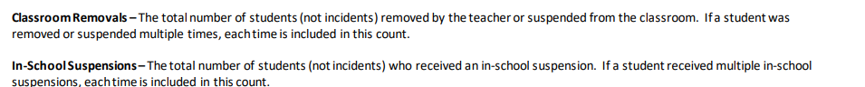  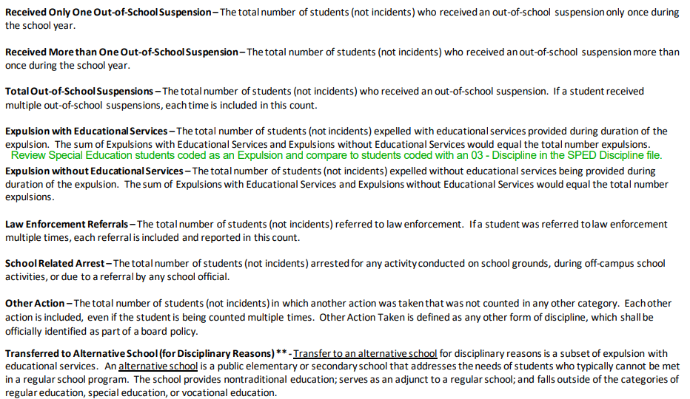 | RESOLUTION CODES (cont.)  District Setup>Discipline and Log Entries> Incident Management Setup>Code & Subcode Setup>Behavior Codes  Resolution coding can be confusing if comparing to the File Layout as they are reflected with 11 coding options, but the layout does not number them as such.  The 11 coding options are actually listed as separate fields on the layout (see screenshot) but do not show the numbered coding, which makes it difficult to differentiate.  The best option to ensure all are included is to open the Action Codes in PowerSchool along with some retired options. Review all non-retired options with a carat (^) to ensure they match up with the listed options on the file layout. You can take this a step further and look at the previous year’s Discipline by Student Demographics template and compare the listed action codes from the file directly. PowerSchool generally does a good job of keeping these updated and available for usage as long as you are on the most current version. All options PS adds will be listed options available to you, but just ensure all action types are included in the code and subcode setup.
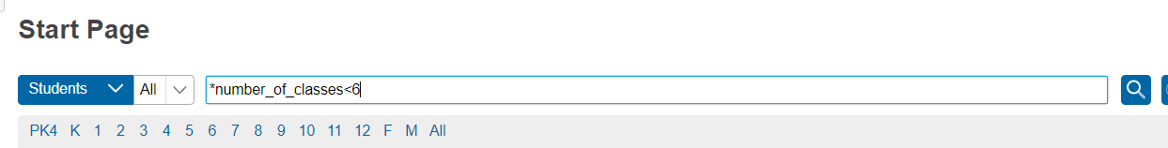  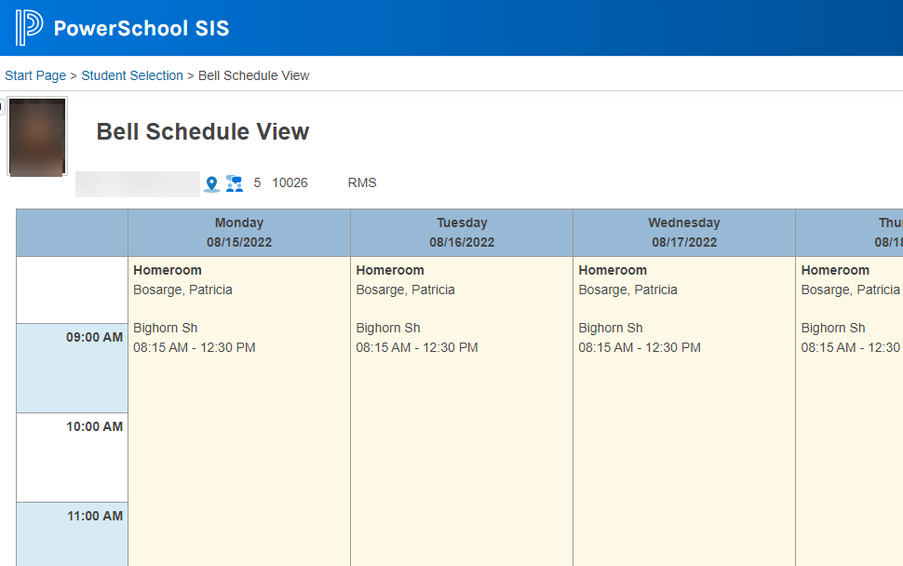 | Schedules for secondary school students (grades 7-12) should be set up in the SIS by September 1st each year.  STUDENT SCHEDULES  Start Page>Search  Confirm that students generally look scheduled into courses for the first half of the year (i.e., Q1-2 OR Sem 1, OR Tri 1-2). You can simply check a few student records. If all students (or an anomalous number of them) had zero classes scheduled, then you would want to reach out to the school to see why.  One way to do this is: On the Start page, click on a grade level or All to display the list of students. Then, click on a student listed and the view of the record should default to the Bell Schedule View. If not, then click on that option under Scheduling to the left. Check that the view is showing the student listed in some classes like the example to the left.

