The following guidance provides a starting point for ensuring key areas related to state reporting are appropriately set up. Schools should make use of the IC Knowledge Base through the links below and IC support for advance system set up questions.
CSI schools are expected to review their SIS by early August each year to ensure the setup expectations outlined below, which impact state reporting, are met. CSI Data Submissions Team members may audit components of SIS setup each year.
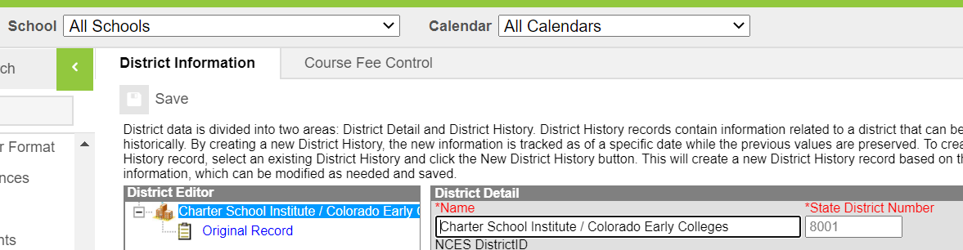 | DISTRICT INFO  System Administration>Resources>District Information  If you don’t see this option, ensure ‘All Schools’ is selected in the School dropdown for networks with multiple schools on a system  Check for 8001 district code
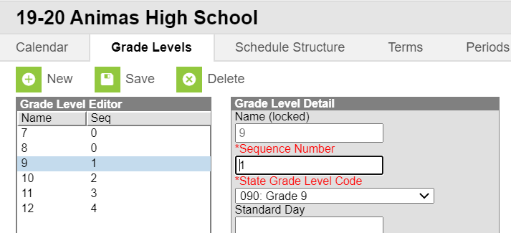 | GRADE LEVELS  System Administration>Calendar>Grade Levels  Verify that the grade levels are mapped to the correct State Grade Level  Check Against:  Any expected Grade Level changes for the coming year. (All expected grade changes should be confirmed with CSI in the Spring prior to the change taking effect.)  https://kb.infinitecampus.com/help/grade-levels
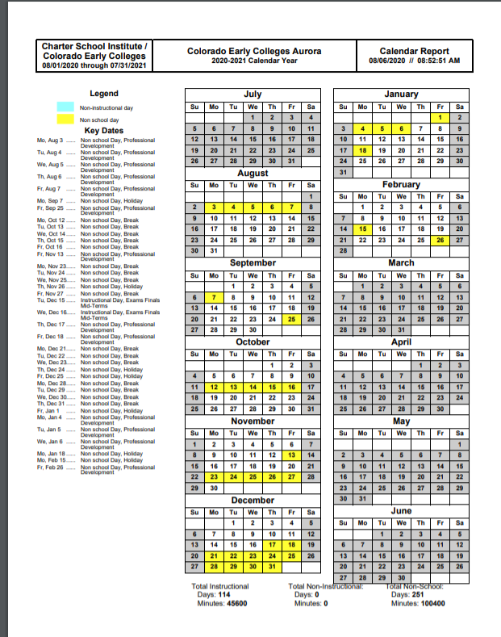 | CALENDAR  System Administration>Calendar>Days>Print  Check whether there are >160 days  For reference, schools generally have 160-180 days instructional days. Schools with significantly more or less may have set up issues.  Any schools with <160 days must be approved by the state. (All schools operating <160 days/4 day weeks should be confirmed with CSI in the Spring prior to the <160 days/4 day week taking effect.)  References: CRS 22-33-104 1(b)  A school or schools shall not be in session for fewer than one hundred sixty days without the specific prior approval of the commissioner of education.  https://kb.infinitecampus.com/help/days (Calendar Days Report)
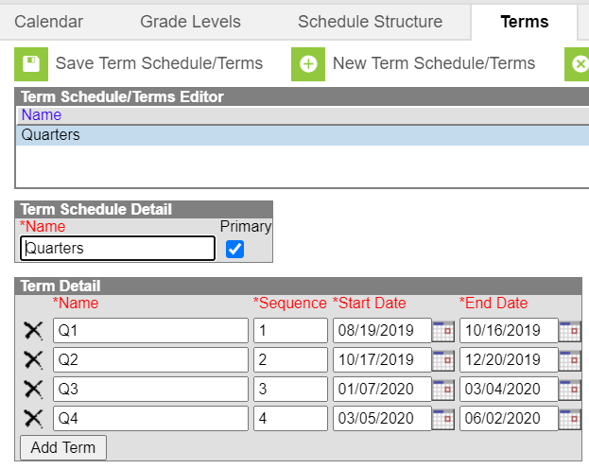 | TERMS  System Administration>Calendar>Terms  Verify term start and end dates  https://kb.infinitecampus.com/help/terms
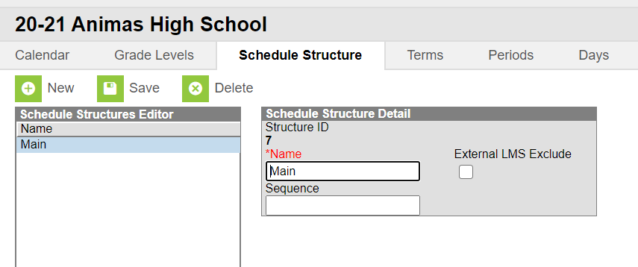 | SCHEDULES  System Administration>Calendar>Schedule Structure  Click the schedule dropdown to view each schedule.  Consider whether there may need to be one for elementary, middle, high, homeschool.
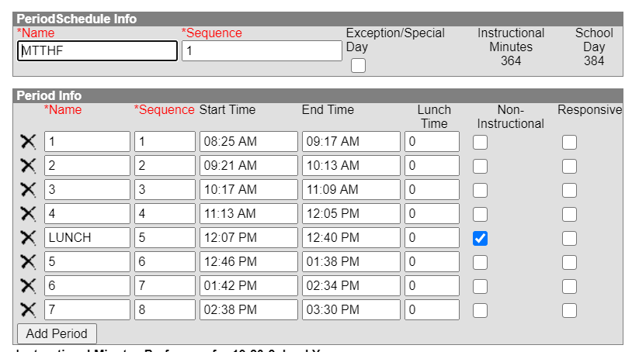 | PERIODS  System Administration>Calendar>Periods  Verify Instructional Minutes, School Day Minutes  Verify passing periods  Mark any periods that are non-instructional  Verify that lunch is noted either in lunch time or as non-instructional  References: October Count Audit Guide  - Passing periods are defined as the time between two classes, and between a class and a lunch period  - Passing periods up to seven minutes may be included in the calculation of full- or part-time funding.  https://kb.infinitecampus.com/help/periods
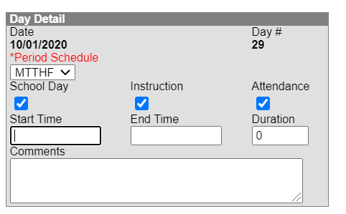 | DAYS  System Administration>Calendar>Days  Change Period schedule if needed  Spot check a couple days, both school days and known vacation days (ex: Labor Day will likely be a day off-confirm that’s the case on the calendar).  Instruction and Attendance should be unchecked if classes do not meet  https://kb.infinitecampus.com/help/days
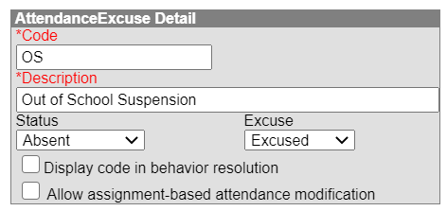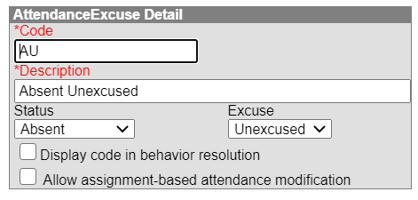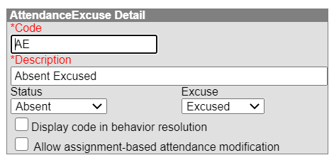  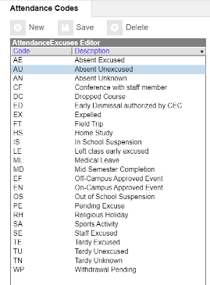 | ATTENDANCE  System Administration> Attendance> Attendance Codes  Excuse Codes  Verify ‘Status’ and ‘Excuse’ settings for Absence Excused, Absence Unexcused. If Suspension is an existing code, check that it’s Absent Excused.  ‘Display code in behavior resolution’ allows user to Update attendance when assign behavior resolutions  References: 1 CCR 301-78  - Absences due to suspension or expulsion of a child must be considered excused absences.  https://kb.infinitecampus.com/help/attendance-admin
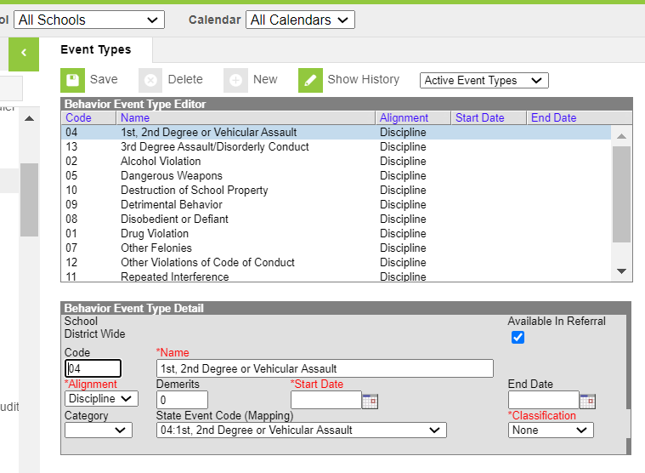 | BEHAVIOR EVENT CODES  Behavior >Admin>Event Types  Note: Be sure you are in the All Schools dropdown in case the school has mapped state reportable events and resolutions at the district level  Verify that event types are set up for each ‘State Event Code’  There are 21 reportable codes (since we use this for CRDC reporting, too) and all should be set up in the system. (Note, codes go up to 22.)  Check Against:  State reportable behavior resolution codes in Discipline data collection.  References: School Discipline and Attendance File Layout  - To access a list of state reportable events  https://kb.infinitecampus.com/help/event-types
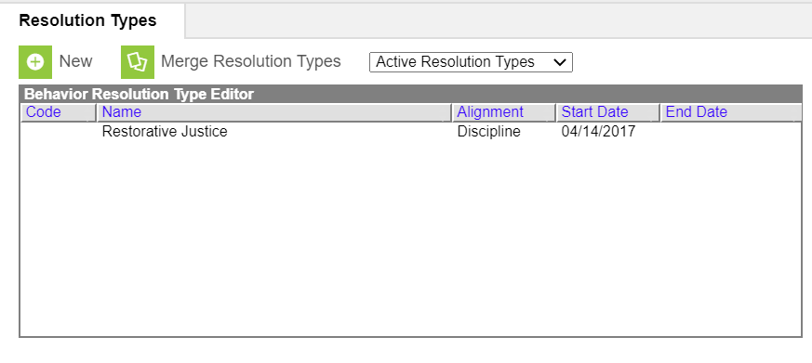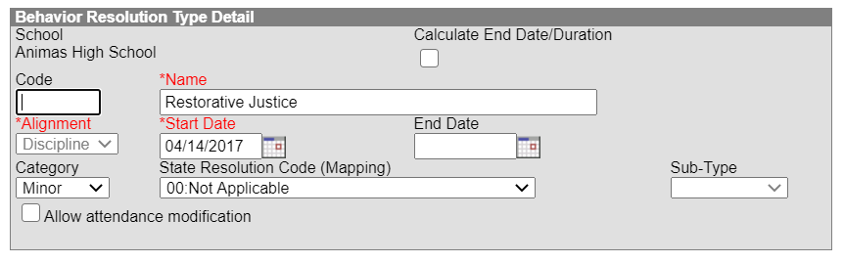 | BEHAVIOR RESOLUTION CODES  Behavior>Admin>Resolution Types  Note: Be sure you are in the All Schools dropdown in case the school has mapped state reportable events and resolutions at the district level  Verify that resolution types are set up for each ‘State Resolution Code’ There are 11 reportable codes  If ‘Allow attendance modification’ is  checked users can select from attendance  excuse codes - see Attendance section above  References: School Discipline and Attendance File Layout  - To access state reportable resolutions (01-11).  https://kb.infinitecampus.com/help/resolution-types
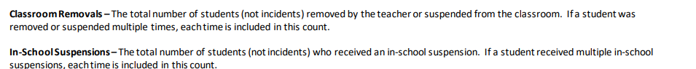  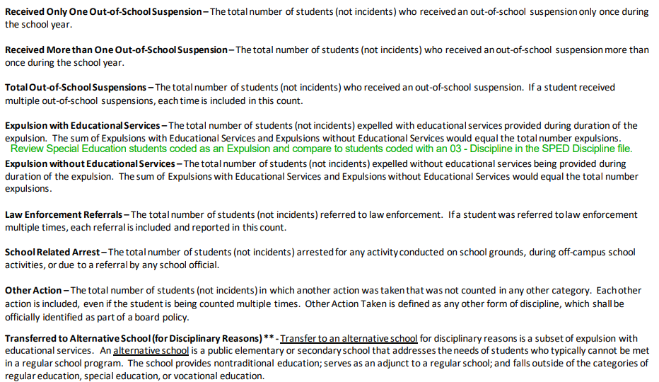  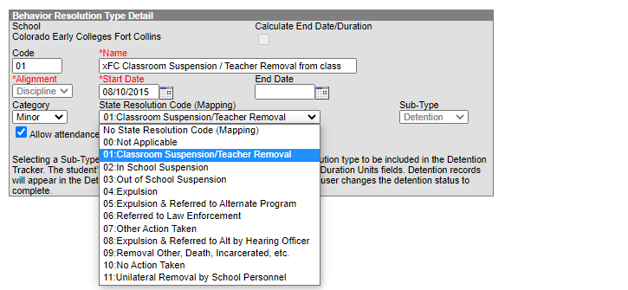 | RESOLUTION CODES (cont.)  Behavior>Admin>Resolution Types  Resolution coding can be confusing if comparing to the File Layout as they are reflected with 11 coding options, but the layout does not number them as such.  The 11 coding options are actually listed as separate fields on the layout (see screenshot) but do not specify any actual numbered codes, which makes it difficult to differentiate.  The best option to ensure all are included is to open up an behavior in IC and click on the State Resolution Code (mapping) dropdown. You will see this lists all the 11 options that should be added and mapped in your Behavior Resolution setup. You can compare those with both the File Layout fields listed and the previous year’s Discipline by Student Demographics template. Be sure no new ones have been added for the current school year.  Ensure all the options are available in the Resolution Types administration section.
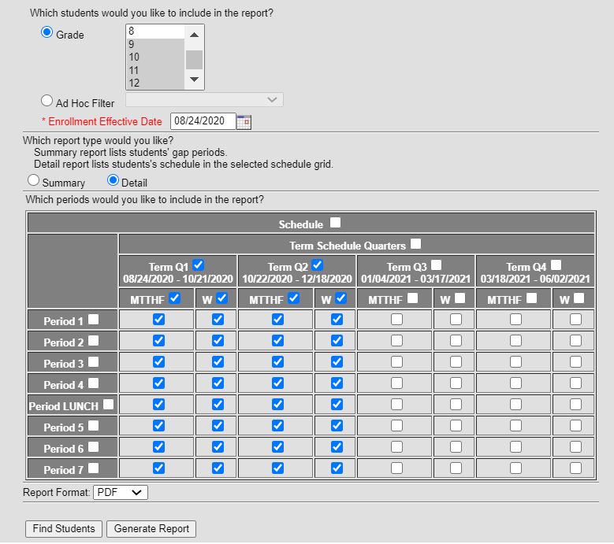 | STUDENT SCHEDULES  Scheduling>Student Gap Scheduler  Confirm that students generally look scheduled into courses for the first half of the year (i.e., Q1-2 OR Sem 1, OR Tri 1-2)  https://kb.infinitecampus.com/help/student-gap-scheduler

