October Count

Extracting the SD Files in PowerSchool (PS)

Student Demographic (SD) File
- Select School: (Some schools will choose “District Office” if pulling data for multiple schools)
- Select the Calendar Year: Current Year

Go to: “Reports”, (NEW VERSION – “Data and Reporting”)

Select: “System Reports, (NEW VERSION – “Reports”)

Go to: “State” tab, (NEW VERSION – “Compliance Reports”)
- Under Interchanges, Select: “Student – Demographic Data”

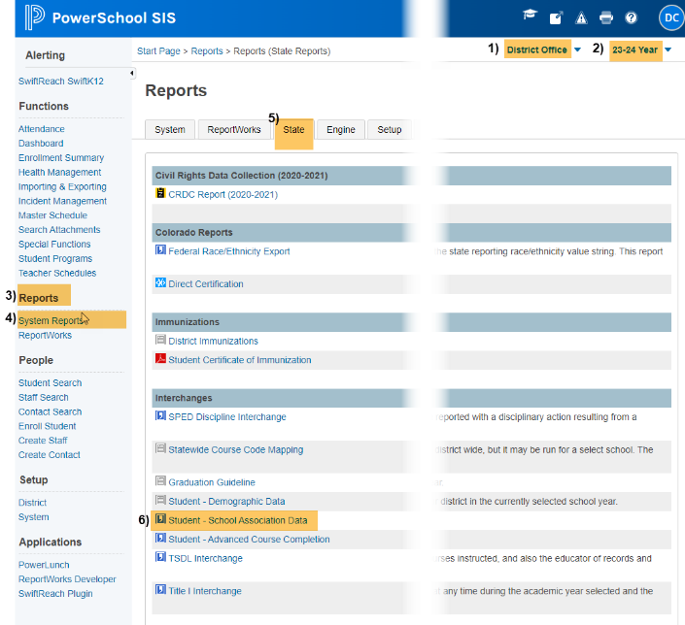
Original View New Version Update
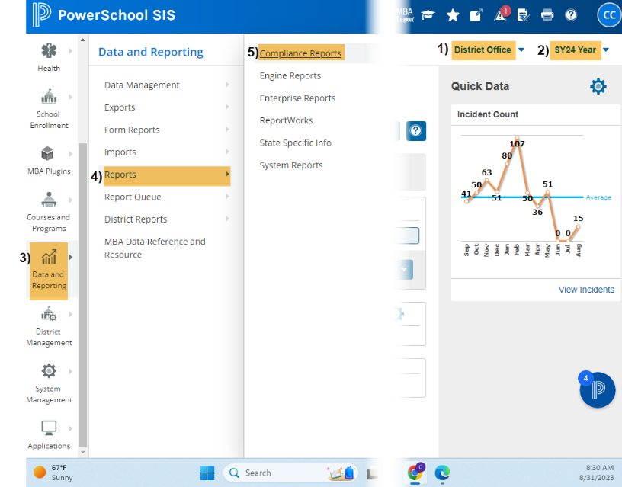

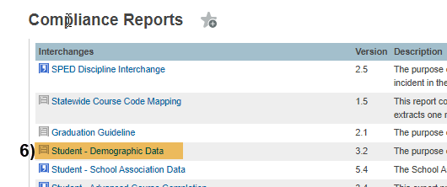

Under Report Parameters:

Select Schools: Choose school/s that you would like to include. Use “Shift /Click” to select multiple,

Select Students: Leave as Default “All Students”,

Point in Time Date: Leave Blank (No Date),

Lunch Status Date: Leave Blank (No Date),

Use Lunch History Data: Leave as Default “Yes”,

Click: Submit

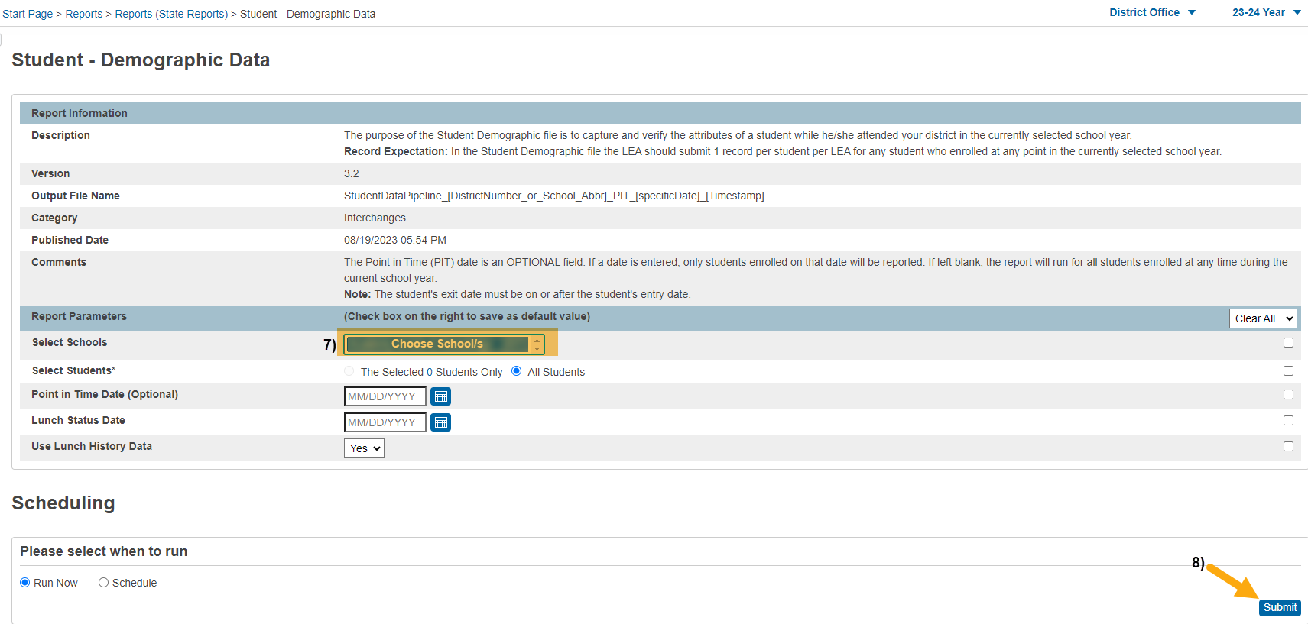
When submitting files to CSI, do NOT open the downloaded file directly and resave, or it will lose critical leading zeros! Instead, save the file first. Then open or submit the saved file.
Submission Steps:
- Use the Record Check Tool (RCT) prior to an initial submission,
- Save file using the following format: SchoolCode_SchoolAbbreviation_SD_MMDDYYYY (no spaces),
- Upload to: G-Drive>Submissions>October Count>(Choose Year)>Files to Run,
- Notify the Data Team of the submission by emailing: Submissions_CSI@csi.state.co.us.

*See resources:
- For more on naming files:https://resources.csi.state.co.us/data-submissions-library/:
- Training Submissions Process / “Step 3: Extracting the Files and Submitting to CSI”
- For SD details: https://resources.csi.state.co.us/october-count/: “Student Demographic File Layout”
- For SSA details: https://resources.csi.state.co.us/october-count/: “Student School Association File Layout”
- For RCT: https://resources.csi.state.co.us/october-count/:“October Count Record Checker Tool”
- For converting CSV to Excel, Excel Filters, etc: https://resources.csi.state.co.us/data-submissions-library/: “Excel for Data Submissions Contacts (Part 1)”

For More Quick Guides:
https://resources.csi.state.co.us/october-count/

- October Count – Extracting SD Files in IC
- October Count – Extracting SSA Files in IC
- October Count – Using the RCT

- October Count – Extracting SSA Files in PS
- October Count – Extracting TitleI Files in PS

