October Count

Extracting the SD Files in Infinite Campus (IC)

Student Demographic (SD) File – Known in IC as “Student Layout”
Note: The SD file is titled: “Student Layout” in IC

Go to: “Index” tab, (New Look View-“Main Menu”)

Select: “CO State Reporting” drop down, (New Look View-“Reporting”)

Select: “Student Interchange”.
You can do this from any calendar year.
IC Original View OR IC “NEW LOOK” View
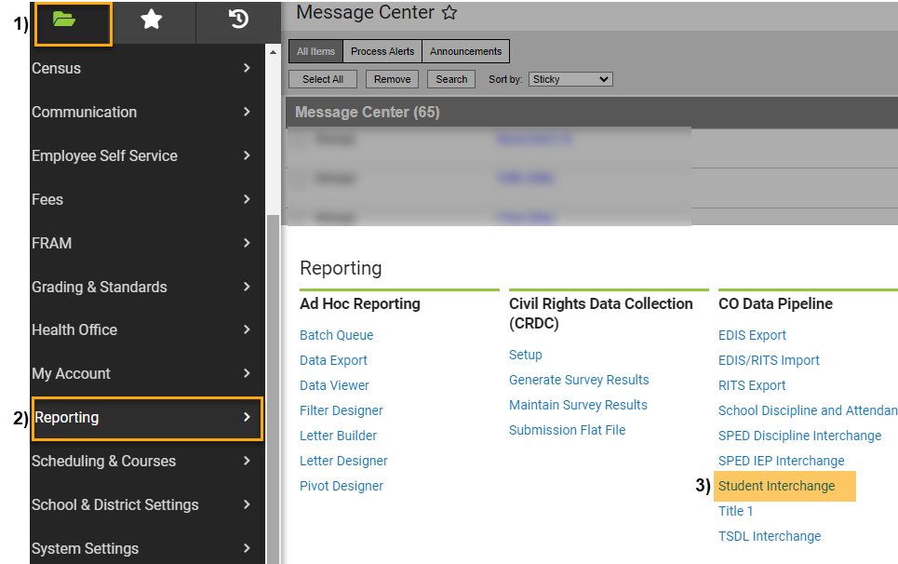
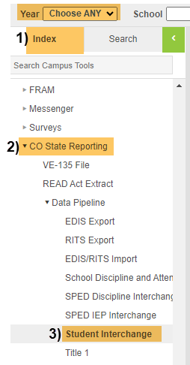

Under Extract Options:

Report Type: Select “Student Layout” from the dropdown,

Report Format: Select Current School Year Format,

Ad Hoc Filter: Leave Blank,

Effective Date: Leave as Default Date (Current Date),

Report Legal Name: Check this Box,

Format: Leave as Default “CSV”.

Under Select Calendars:

Choose calendar/s that you would like to include. Use “Shift /Click” to select multiple,
- Click: Generate Extract.

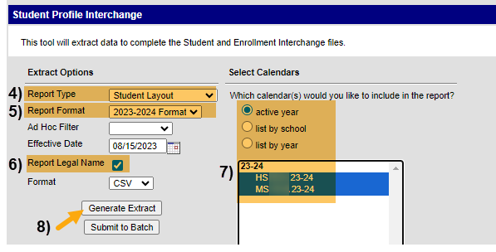
When submitting files to CSI, do NOT open the downloaded file directly and resave, or it will lose critical leading zeros! Instead, save the file first. Then you can open and/or submit the saved file.
Submission Steps:
- Use the Record Check Tool (RCT) prior to an initial submission,
- Save file using the following format: SchoolCode_SchoolAbbreviation_SD_MMDDYYYY (no spaces),
- Upload to: G-Drive>Submissions>October Count>(Choose Year)>Files to Run,
- Notify the Data Team of the submission by emailing: Submissions_CSI@csi.state.co.us.

*See resources:
- For more on naming files:https://resources.csi.state.co.us/data-submissions-library/:
- Training Submissions Process / “Step 3: Extracting the Files and Submitting to CSI”
- For SD details: https://resources.csi.state.co.us/october-count/: “Student Demographic File Layout”
- For SSA details: https://resources.csi.state.co.us/october-count/: “Student School Association File Layout”
- For RCT: https://resources.csi.state.co.us/october-count/:“October Count Record Checker Tool”
- For converting CSV to Excel, Excel Filters, etc: https://resources.csi.state.co.us/data-submissions-library/: “Excel for Data Submissions Contacts (Part 1)”

For More Quick Guides:
https://resources.csi.state.co.us/october-count/

- October Count – Extracting SSA Files in IC
- October Count – Extracting TitleI Files in IC
- October Count – Using the RCT
- October Count – Extracting SD Files in PS
- October Count – Extracting SSA Files in PS

