Staff Interchange Record Checker – SP and SA

Purpose
The purpose of the HR Record Checker Tool is to allow schools to review missing data and see potential errors on both the Staff Profile (SP) and Staff Assignment (SA) prior to initial submission for Human Resources Collection. These errors can be corrected within your Starting Point files or HR System, which will lead to less errors upon initial submission. The goal behind this Excel spreadsheet is to identify common errors or areas where data entry may have not been completed and is not designed to flag every potential error the files may receive. If used in conjunction with the Data Validation Strategies Checklist, the school should receive less errors upon initial submission leading to less submissions to error clearance and less time spent on the overall collection. The instructions below describe the steps necessary to utilize this resource successfully.

Instructions
- Extract both the SP and SA from your HR System or utilize the Starting Point files in Google Drive and make the necessary updates for the current year. For instructions on necessary updates, see the HR Collection trainings. Save the file to your computer with the correct naming structure.
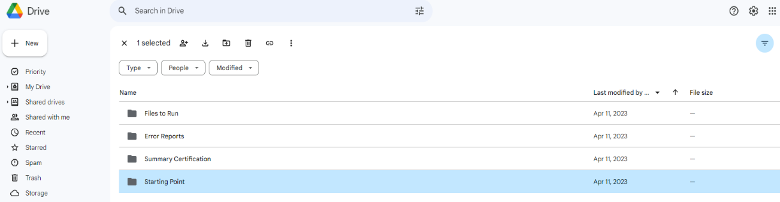

- Once files are both saved correctly and opened, navigate to the CSI HR website or resource email that contains the Excel conditionally formatted Record Checker template and open. This template contains five tabs with two being for the raw data files that were just opened.

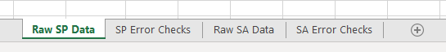
- Once all three files are opened, navigate to the SP file and click on the triangle in the upper left corner to highlight all data on the worksheet and copy.
- Expand the HR Record Checker and paste all data into the Raw SP Data tab, which should be the first worksheet listed.
- Next, copy the entirety of your SA file and paste that into the corresponding Raw SA Data tab within the templated document.
- Once both are pasted, you can begin the review process of each file by first going to the “SP Error Checks” worksheet. This tab contains prebuilt conditional formatting that will highlight any field that will potentially cause an error once file is submitted and processed. The file is designed to check several of the fields for issues, for example:
  - District Code/Admin Unit, EDID, Gender, and Date of Birth (among others) values missing or zero filled
  - All Race fields are missing or zero filled for any given staff
  - Incomplete or inaccurate District/State of Residence fields
  - Probationary Status field not 00 or 03
  - Highest Level of Education is greater than 15, but Institution or State Code is zero filled
  - All other fields are blank when should have data or be zero filled

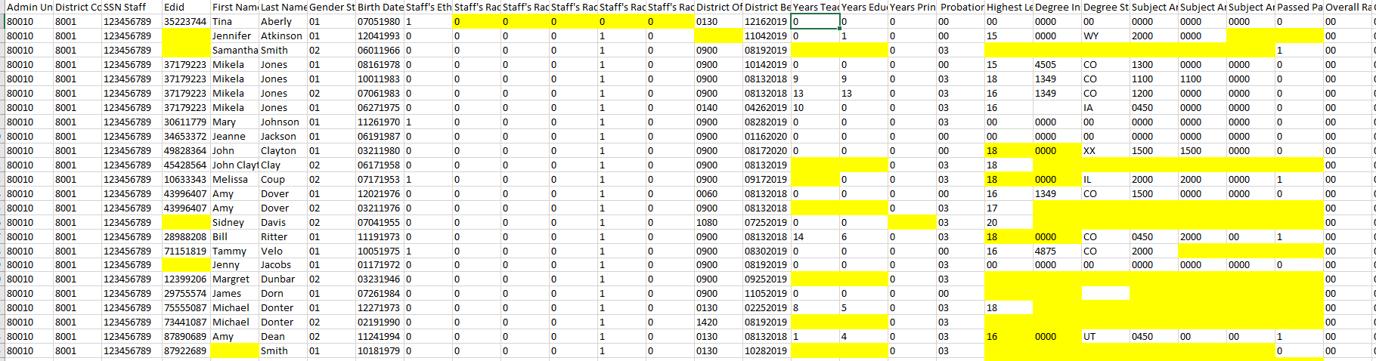

- Once all data accuracy issues for the SP file have been checked and updated in your SIS, navigate to the “SA File Issue Checks” tab to review issues on that file.
- This tab also contains prebuilt conditional formatting that will flag and highlight any potential errors to the SA data. An example list of issues flagged is below but is not a comprehensive list.
  - Admin/District Code, EDID, Gender, and Date of Birth (among others) values missing or zero filled
  - SPED Program Code not zero filled
  - Job Classification Code blank or zero filled
  - Start Date of Assignment blank or zero filled
  - Contract days blank, zero filled, or greater than 285 days
  - The Hours Worked per Day field is blank, less than 20 minutes or greater than 10 hours
  - Hourly Pay and Salary both zero filled or both blank
  - Grant/Project Funding Source not 0000, 0001, or 3000
  - Teaching Subject Area is zero filled with a Job Classification of 201-206
  - The Admin Instructional Area is 0001 when the SPED Flag is 1 or the Job Classification is 202/238 for SPED Teacher and SLP
  - The Demonstrates In-Field Status field is zero filled when the staff person is coded as a Teacher

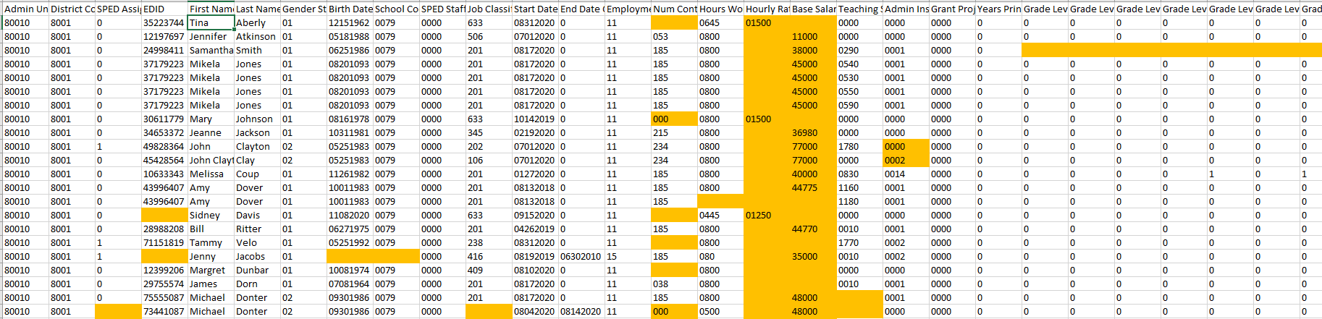

- Once all issues are identified and reviewed, navigate to your Starting Point Files or HR system and make the necessary corrections.
- Upon completion, new files can be extracted, or Starting Point files can be submitted to CSI for processing. Submit the files to Google Drive and email the Submissions Inbox (submissions_csi@csi.state.co.us)

