Wellness Club
When faced with change and challenge, we have options.

Overview
Wellness is the “act of practicing healthy habits on a daily basis to attain better physical, mental, and health outcomes so instead of just surviving, you're thriving” (Pfizer, 2022). Most importantly, wellness is directly associated with an individual’s overall health, which is “a state of complete physical, mental, and social well-being and not merely the absence of disease or illness” (World Health Organization, 2022). While individual wellness affects academic success and overall wellbeing, wellness does not occur in a bubble.

The Wellness Club is created with community in mind - to assist school communities in further connecting and learning with students in this capacity.

This program offers a delivery framework and collections of content on specific topics, or themes, associated with social and emotional growth and development. Each topic module is structured with content and opportunities available for various school community members to participate and share in the learning (e.g., students, teachers, staff, student families, and the local community).

Evidence-Based Practice

Social-emotional learning is shown to improve positive academic and life outcomes for both youth and adults. It’s been proposed that social-emotional learning (SEL) is comprised of five primary skills:
- self-awareness
- self-management
- responsible decision-making
- relationship skills (e.g., communication)
- social awareness

The SEL skills practiced in each module are indicated in the menu below, and in each module. For more information on SEL, current research, and the CASEL framework, please visit https://casel.org/fundamentals-of-sel/.

Getting Started

Module Topics

The topics selected for the wellness modules were picked with the school calendar, school needs, and students’ developmental process in mind.

While content has been curated for each topic, we hope you will find inspiration in what is available and consider adjusting what is presented to best fit your own school community

To Start:
- Review the Topic Menu (below).
- Click on the header of the desired topic.
  - The hyperlink leads to a separate document that contains the module outline and content.
  - You can quickly copy, paste, and share most content items in various communication modalities.

Module Delivery

Each module follows a similar framework and requires 1-2 weeks for successful delivery (Table 1).
- If you want to extend a topic, you can distribute this content across an entire month.
- We do not recommend doing all the content items within one week.

Table 1. Suggested delivery days within an individual module
During Intervention | Send out…
Monday | Social Media Post
Monday | Quote
Monday | Silly Activity #1
Tuesday | Physical Activity
Tuesday | Article for Parents (newsletter entry)
Wednesday | Podcast/TedTalk
Wednesday | Article for Staff
Wednesday | Silly Activity #2
Thursday | Health Information
Thursday | Spiritual Activity
Friday | Social Activity
Friday | Challenge for Parents
Friday | Resource Spotlight
Final Day of Intervention | Send out…
Monday | Learning Reflection Activity

Other Ways to Get People Involved

Social Media Days (Download Here) Good News Corner Add a Dash of Fun

Topic Menu
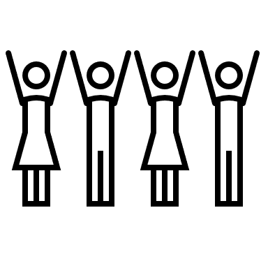

Connecting (Click to download Guide)
Starting new things is always tough, and the best way we can support students is through connection. We all need connection. According to Maslow’s Hierarchy of Needs, besides food, water, and safety, love and belonging are the most important needs we must fulfill.

SEL Skills Practiced: Suggested Delivery Month: August
- Self-Awareness
- Relationship Skills
- Social Awareness

developing (click to Download Guide)
Data tells us that discipline infractions are most likely to occur at the beginning and end of the year because students aren’t used to routine and behavior. Getting used to new routines, rules or environments always takes a period of adjustment.

SEL Skills Practiced: Suggested Delivery Month: September
  - Self-Awareness
  - Self-Management
  - Responsible Decision-Making

Resilience (click to download guide)
When things are rough and we’re not sure we’re going to make it through the year…Let’s practice resilience! It’s the process and outcome of successfully adapting to difficult or challenging life experiences, especially through mental, emotional, and behavioral flexibility.

SEL Skills Practiced: Suggested Delivery Month: October
  - Self-Management
  - Responsible Decision-Making

Gratitude (Click to download guide)
Gratitude isn’t just saying thank you. It’s the practice of appreciating what is around us. It’s scientifically proven to be good for us, all of us, all year long.

SEL Skills Practiced: Suggested Delivery Month: November
  - Self-Awareness
  - Social Awareness
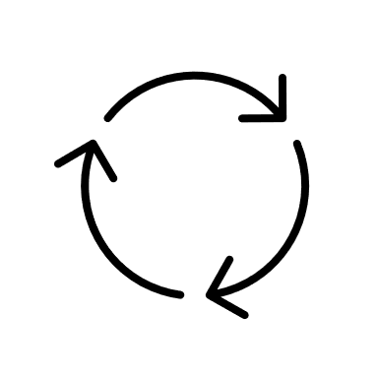

Reflecting (Click to download guide)
Reflection is a skill that we get to practice as humans, and not for the faint of heart. A healthy self-reflection process takes bravery and it rarely seen in our everyday lives.

SEL Skills Practiced: Suggested Delivery Month: December
  - Self-Awareness
  - Self-Management

Starting Anew (Click to Download)
Starting fresh can be scary, and we don’t have to wait for the beginning of the year to give ourselves a fresh start.

SEL Skills Practiced: Suggested Delivery Month: January
  - Self-Awareness
  - Self-Management
  - Responsible Decision-Making
  - Relationship Skills
  - Social Awareness

Caring (Click to Download)
Practicing caring and showing love for one another is one of the greatest gifts we can give each other. Practicing self-love and caring is the greatest gift we can give ourselves.

SEL Skills Practiced: Suggested Delivery Month: February
  - Self-Awareness
  - Relationship Skills
  - Social Awareness

Resting (Click to Download)
Do we actually know how to rest? Do we know how to practice resting without feeling guilty?

SEL Skills Practiced: Suggested Delivery Month: March
  - Self-Awareness
  - Self-Management

Boundaries (Click to Download)
Being in a community, it’s important to be able to advocate for yourself and respecting other people’s ability to advocate for themselves.

SEL Skills Practiced: Suggested Delivery Month: April
  - Self-Awareness
  - Self-Management
  - Responsible Decision-Making
  - Relationship Skills
  - Social Awareness

Balance (Click to Download)
Even when there’s so much that’s being placed on you and you feel like there’s no way to accomplish what’s in front of you, how can you still work on balance?

SEL Skills Practiced: Suggested Delivery Month: May
  - Self-Awareness
  - Self-Management
  - Relationship Skills
  - Social Awareness

