Using G-Drive to Securely Share Data

Contents
Overview 1
Data Privacy and PII 1
Google Accounts 1
Shared Folders 2
Tips & Troubleshooting 2
Help Resources 2
Unable to Log Into Account 2
Shared Folder not Visible 2
Downloading Files 3

Overview
The Charter School Institute uses Google Drive (G-Drive) for securely exchanging information with its schools. (CSI Departments may have additional systems they use for securely exchanging information—please reach out to your CSI contact if you have questions about the appropriate system to use.)

Data Privacy and PII
Schools should exchange all sensitive data with CSI, including files with Personally Identifialble Information (PII) through G-Drive. Student and staff data, including information such as name (for students only; not staff), address, birthdate, SSN and other sensitive demographic data that can be associated with a specific person, should never be sent through email because it is not secure and the data could be compromised.
This document provides specific details on using G-Drive. See the current year CSI Data Submissions Handbook under the Data Privacy and Security header for more general information on the exchange of collection data with CSI.

Google Accounts
CSI can only share G-Drive folders to school contacts with active Google (Gmail) accounts who have been officially designated by their school as needing access to specific folders as part of their job responsibilities.
For example, access to the Human Resources (HR) folder is highly confidential and will require special confirmation from a school leader or their designated representative.
Each school contact will need their own individual Google account. School contacts will not be able to use a group Google email address.
A Google Workspace (formerly G-Suite) account through your school would be preferable to a free personal Google account.
- Most CSI schools have Google accounts synced to their school network email addresses already.
If you are unsure if your school email address is associated with your Google account, then check with the tech support at your school or go to Find out if you have a Google Account.
- If you do not already have a Google account and your school is not set up to use Google Workspace for school staff, then you will need to sign up for a free, personal Google version account at https://accounts.google.com/signup.
The sign-up page will allow you to use a current email address (ideally, your school email address), which we highly recommend. Watch this short video that demonstrates how to do this.
Important Note: When using the free, personal version of Google, you should not store files with PII within the local folder drive (typically called “My drive”) because storage of PII on a personal drive version violates the Google Terms of Service. Be sure to only store files with PII when logged into that version within the G-Drive exchange folders that CSI will share with you (typically under the “Shared with me” menu option).

Shared Folders
There are several separate folders available for each school that can be shared with approved school contacts (i.e., for submissions contacts, they may see the following separate folders: Submissions, HR, SASID, READ, etc.).
Once CSI has confirmed permission for a school contact to access a specific shared folder in G-Drive, then the following will take place:
- CSI will share the folder with the approved contact using the Google account email address provided. (All folders shared will be under that single Google account—separate accounts are not needed to access each folder for a user)
- An email notification will typically be generated to the contact identifying the specific shared folder.
- Shared folders should appear in Google Drive under “Shared with me” when a user is logged into their Google account. (Specific folders shared with users could vary from this screenshot)
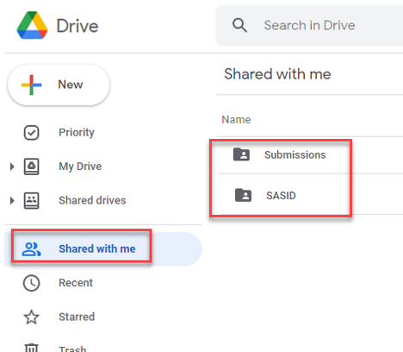
- Contacts can simply drag and drop collection related files into each shared folder in the original format.
- Data collection files should remain in the native xlsx or csv format and not converted to Google Sheets.
- Files can be retrieved from Google Drive by download (see next section for a walkthrough). It does not work to drag and drop files from Google Drive. Please be sure to notify CSI staff when contacts no longer need access to shared folders, so that we can disable the access for those account holders.

Tips & Troubleshooting

Help Resources
Google Drive Help is the best starting place to find links to specific help topics like getting started, logging into your account, sharing, using multiple accounts, etc.

Unable to Log Into Account
CSI is not able to help school staff members with their passwords since their accounts are outside of our Google Workspace for Educators instance. Schools need to work with their own IT support if they are not able to reset their password or have any other troubles with their accounts. School staff could try reviewing the Google help for account log in issues before reaching out to their IT.

Shared Folder not Visible
- CSI may not have shared the folder with you. Check with your school first to make sure that you are cleared to access the folder. If you are, then email CSI at submissions_csi@csi.state.co.us requesting access to the folder. Depending on the circumstances, CSI may need to confirm permission from your school.
- Check to make sure that you are logged into the correct Google email account provided to CSI. It’s fairly common for users to be logged into a different account.
  - It is possible to remain logged into multiple Google accounts at once. For help, see this Google resource on signing in and switching between accounts.

Downloading Files
You cannot drag and drop files from shared folders in G-Drive to your computer. They must instead be downloaded.
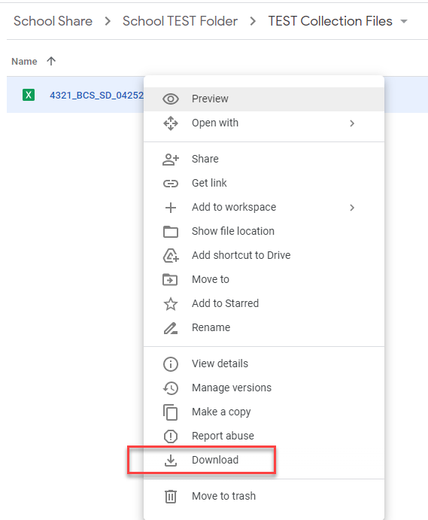
- To download a file to your computer, simply right click on the file and then pick the Download option as shown in the screenshot to the right.

- Once you click that option, the download will typically happen automatically where the file will be saved into your computer’s Download folder. If you have permission to make changes to your browser setting, then you can change how downloads are handled.
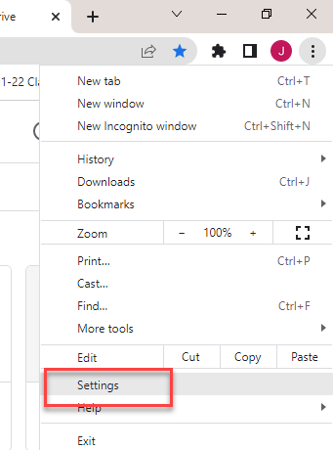
- To make changes to the Download process in the Chrome browser, click on the vertical ellipse icon in the upper right corner, and then click the Settings option.

- Expand the Advanced option on the left side of the Settings window that opens if it is not already expanded (click on the little arrow to expand), then pick the Downloads option.

- In the window that pops up in the right pane, click on the Change button and navigate to where you would like files to download to (be aware that this will affect all files you download while on the internet and in G-Drive; you cannot make setting changes for individual webpages or shared folders).
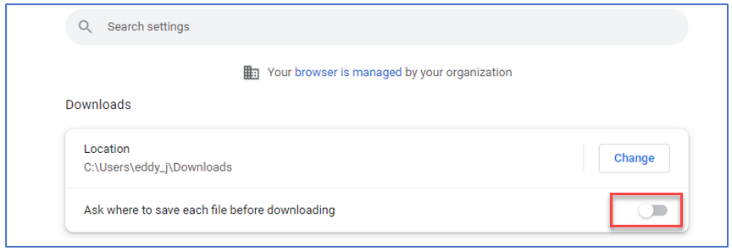
If you would like to have a prompt window that will ask where you like to save a file each time you download, then toggle on the switch by “Ask where to save each file before downloading” (this will turn blue once active).
- When you follow the download process, Excel and csv files will stay in the format that they were uploaded in.
- If you wanted to work with a file in Google Sheets instead of Excel or CSV, then there is an “Open With” option when you right click on files in G-Drive to open the files in Google Sheets. Once the file opens, you can edit it but it will not change the original Excel file stored in G-Drive. To save changes to the Google Sheet version you opened, you would need to pick the “Save as Google Sheet” option under the File menu when it is opened, which will save it as a new Google Sheet file in G-Drive.
As mentioned in the Shared Folders section above, data collection files should remain in the native xlsx or csv format and not converted to Google Sheets.

