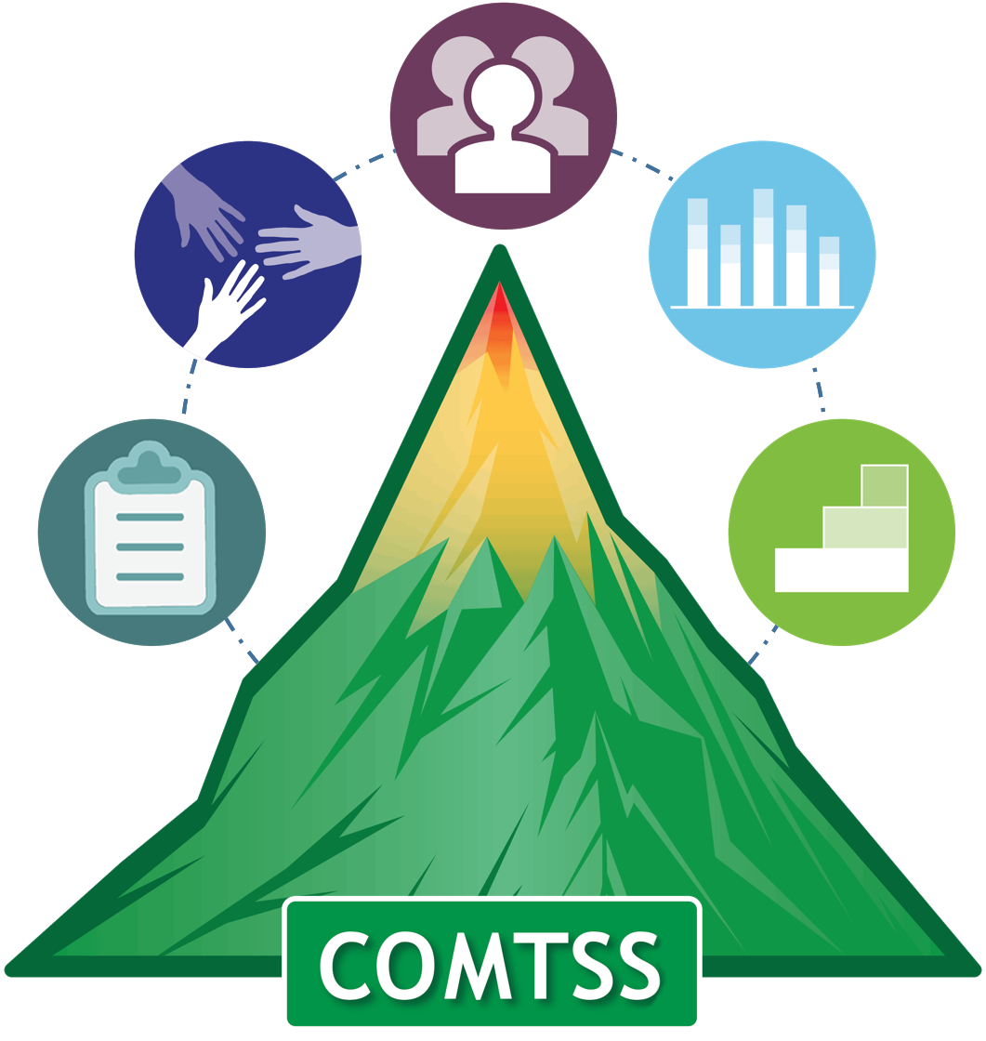

Meeting: | Super Great Academy MTSS meeting
Date: |  | Time |  | Location:
Meeting Lead:
Meeting Participants: | MTSS team Roles:  - Facilitator: Patricia Sandoval  - Time Keeper: Ernest Smith  - Notetaker: Oliver de Lorenzo  - Action Planner: Mandi O’Roule
Data/Evidence to review:
Meeting Objectives:
Meeting Norms:

Time |  | Agenda Item | Resources | Notes (be sure to include communication to those not at the meeting who need to know the results) |  |  |  |  |  | Actionable Steps  (Who will do what, by when)
Next Meeting Date: |  |  |  |  | Time: |  |  |  | Location: |  | Board Room
Evaluate the Meeting Fist to 5:( 0- being not well spent, 5 being time well spent) |  |  |  |  |  |  |  | How can we improve at the next meeting?
Score: |  |  | Notes:

