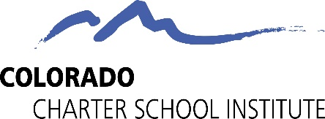

Professional Standards Resources

Colorado Department of Education: https://www.cde.state.co.us/nutrition/nutritrainings

Institute of Child Nutrition: https://theicn.org/training-2/

USDA Professional Standards: https://professionalstandards.fns.usda.gov/content/child-nutrition-programs-training-resource-center click on find a training, then click on website.

School Nutrition Association: https://schoolnutrition.org/learning-center/ you do need a membership to view most of these resources.

