# fruit component

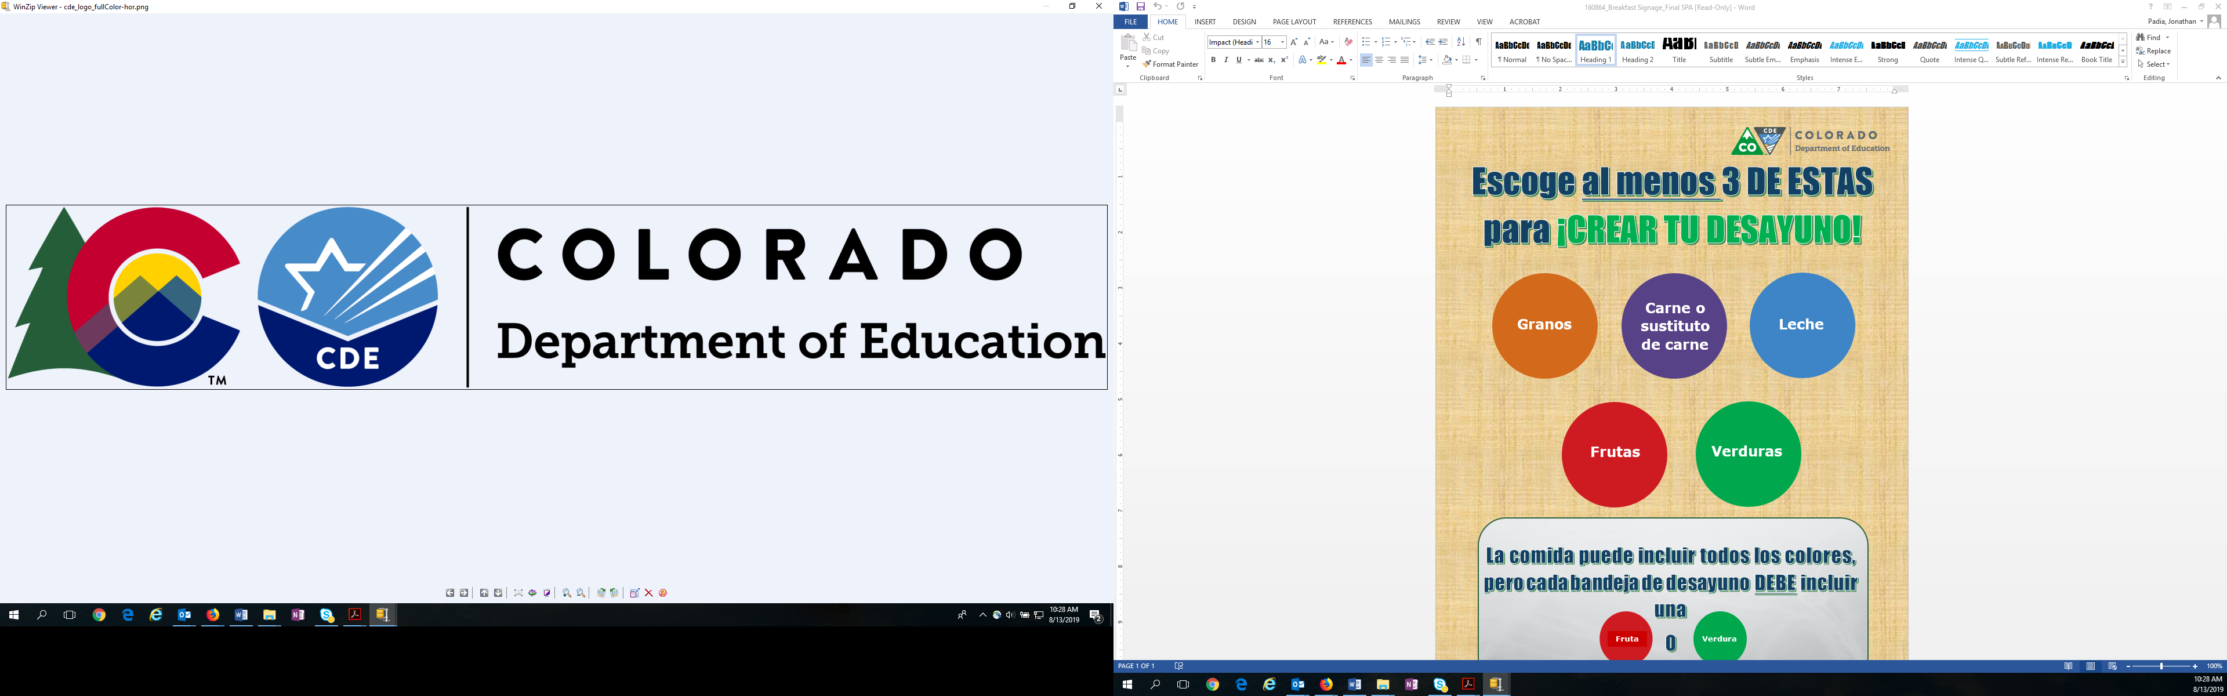

**Choose at least 3 COLORS to CREATE YOUR LUNCH PLATE!**

**Milk**

**Grains**

**Meat or**

**Meat Alternate**

**Fruits**

**Vegetables**

**Vegetable**

**The number of items may vary, but each lunch tray MUST include a**

**Or**