SPECIAL EDUCATION PARAPROFESSIONAL HANDBOOK

Adapted by: Matt Hudson
Director Special Education
Updated: August 2023

Table of Contents

Special Education Basics 3
Paraprofessional- Importance and Expectations 3
Guiding Principles for Special Education Paraprofessionals 3
Special Education Paraprofessionals, are expected to: 3
Individualization 4
Confidentiality 4
Due Process 6
Role Clarification 7
The Teacher and Paraprofessional 7
The Role of the Teacher 7
The Role of the Paraprofessional 8
Assisting with Data 9
Accommodations and Adaptations 9
Types of Adaptations: 10
Promoting Student Independence 10
Behavior Management 11
Problem Behavior Prevention: 11
Addressing Problem Behavior 12
Teaming and Collaboration 13
Disability Categories 14
Commonly Used Acronyms and Initials 15
References 16
Acknowledgement of Reviewing Document 17

Special Education Basics

Paraprofessional- Importance and Expectations

Paraprofessional working with students with disabilities play an important and challenging role within the school. The Individuals with Disabilities Education Act (IDEA) and Colorado’s Exceptional Children’s Educational Act (ECEA) emphasize inclusion of students with disabilities into the general education classrooms and community environments. These requirements have increased the need for paraprofessionals. Along with the increased demand for paraprofessionals came the necessity for training and professional development.

This handbook is intended to be a guide to aid school training and support to ensure that they have qualified paraprofessionals. A qualified paraprofessional is defined as a person who has received special education and intervention related training(s) and/or regular supervision from a special education teacher and/or team leader. This handbook is to supplement any additional training provided by the school. Please consult your supervising teacher, and/or your principal if you have professional development needs that you would like to pursue to best perform your job duties.

Guiding Principles for Special Education Paraprofessionals

Paraprofessionals are respected and supported as integral team members responsible for assisting in the delivery of instruction and other student related activities.

- The entire instructional team participates within clearly defined roles in a dynamic changing environment to provide an appropriate educational program for students. Teachers and others responsible for the work of paraprofessionals need to have the skills necessary to work effectively with paraprofessionals.

- By recognizing paraprofessionals' training, responsibilities, experience, and skill levels, they are placed in positions for which they are qualified, which effectively and efficiently use their skills to enhance the continuity and quality of services for students.
Administrators exercise leadership by recognizing paraprofessionals as educational partners.

Special Education Paraprofessionals, are expected to:
- Maintain confidentiality about all personal information and educational records concerning students and their families.
- Respect the legal and human rights of the students and their families.
- Follow school policies for protecting the health, safety, and well-being of students.
- Follow directions of teachers, other supervisors, and related service providers.
- Maintain a record of regular attendance, arrive and depart at specified contract times, and notify appropriate personnel when you must be absent.
- Check email at least once daily to stay informed and current on related information.
- Demonstrate honesty, dependability, integrity, and a willingness to learn.
- Demonstrate respect for cultural diversity and individuality of all students.
- Follow the chain of command for various administrative procedures.
- Demonstrate a willingness to participate in opportunities for continuing education.

Paraprofessionals have a difficult yet rewarding position within education. They influence positive changes in academic achievement and behavior. Their interest in students and assistance to teachers is invaluable.

Individualization

Each student who qualifies for special education services has an Individual Education Program (IEP) written specifically for them yearly, at a minimum. The IEP is developed through a team process and is designed to meet the needs of the student with a disability. The intent of the Individualized Education Program is to ensure that each child can take part in an educational program that will assist and support the student to learn, live, work, play, and make friends in the community. An essential part of this program must be to assist the student in participating in the same settings as other students of the same age.

The IEP summarizes a student’s present level of academic achievement and functional performance, and it also includes:
- specific goals with a beginning and anticipated ending measure,
- a list of specific staff who will provide student supports and services,
- the amount of time each service provider needs to instruct the student,
- when and how often progress will be reported to parents,
- accommodations and modifications that need to be made to teach the student, provide support to the student, and assess the student, and
- Any specific needs the student has for equipment, transportation, or behavior support.

Always consult your supervising teacher if you have questions about the students you support and/or their plan.

Confidentiality

As part of the job, a paraprofessional will have access to personal information about students and their families. Both the student and the family have an absolute right to expect that all information will be kept confidential and made available only to personnel in the school or another agency who require it to ensure that the rights, health, safety, and physical well-being of a student are preserved.

Confidentiality must be maintained according to the federal laws, state regulations, and Charter School Institute policies. Only people who are responsible for the design, preparation, and delivery of education and related services will have access to student records. Other teachers, school staff, well-meaning friends, neighbors, or acquaintances should not have access to information about a student's performance level, behavior, program goals, objectives, or progress.

Information that a student and his/her family have the right to expect staff to respect the privacy of includes information such as but not limited to:
- the results of formal and informal assessments,
- social and behavioral actions,
- performance levels and progress,
- program goals and objectives,
- financial and other personal or family information,
- use of medications, and
- health Information.

Paraprofessionals should share concerns regarding the well-being and safety of a student with administration, the student's teacher, or a staff member who is designated to play a role in the protection and welfare of the student, and no one else.

Confidentiality is one of the most critical and important aspects of your job as a paraprofessional. It is your legal responsibility to observe both the rights of individuals with disabilities and of parents in regard to data privacy.

Follow these guidelines where issues of confidentiality are concerned.
- Never refer to other students by name in another staffing or conference or with other parents.
- Don't share specific information about an individual's program or unique needs in the lounge or out in the community.
- Take questions you have about the organization's policies on confidentiality to your supervising teacher or administrator.
- Access individual records for the sole purpose of being more effective in your work with the individual.
- Go through the proper channels to access confidential information. Make sure you're authorized to do so.
- If you question policies and procedures used with an individual, discuss this privately with your supervising teacher or administrator. There is often confidential information that directs specific programming of which you may not be aware.
- Speak and write responsibly when passing on information. Be aware of who might hear you or read what you have written. Be especially careful when using email concerning students and staff.

Due Process

Due process is a term used for the rules and procedures special education staff need to follow when working with students with disabilities. These rules and procedures come from federal laws, state laws and case laws. They include the process for assessing students initially for special education and reassessing students every 3 years who continue to have needs for specialized services. They also include when progress notes are written, the specific services students qualify for, the primary category they qualify under, and the times schools are required to inform parents and get their permission.

The purpose of due process rules and procedures is to provide the specialized services the student needs to make progress in special education and in the general curriculum, while protecting the student’s and parent’s legal right to be a part of the process.

Student and parent rights are protected under due process and these rights are clearly documented in the Procedural Safeguards Notice given to parents a minimum of one time per year. Please connect to the link below for details.

Role Clarification

The Teacher and Paraprofessional

The roles of the teacher and the paraprofessional should complement each other. In most cases, the teacher is not the paraprofessional’s evaluator. This typically is the role of the building principal with feedback provided by the supervising teacher. The supervising teacher(s) is the paraprofessional’s supervisor regarding the education of children.

Teachers and paraprofessionals are partners in education, working together to provide the best educational experience possible for each student. The special education paraprofessional's role is to assist the teacher and allow more effective use of the teacher's abilities and professional knowledge. The teacher must function in a leadership role. It is the teacher's responsibility to assure that the students are moving toward achievement of individualized goals and objectives and to follow due process procedures.

Paraprofessionals serve under the direction and supervision of the teacher to assist in carrying out the individualized education program (IEP). In order for paraprofessionals to provide direct instruction to the student, teachers must plan and prescribe the learning environment and instruction for the student. Teachers are responsible for training paraprofessionals in the specifics of the instruction, evaluating student progress and monitoring the effectiveness of the paraprofessional's implementation of the strategies, drill, and practice.

Defining roles of the teacher and the paraprofessional is an important element of a successful program. Identification of teacher and paraprofessional roles ensures adherence to ethical and legal requirements and serves as a guide in supervision and evaluation. Actual delivery of instruction to the student is done by the teacher and drill and practice may be carried out by the paraprofessional under supervision of the teacher.

The Role of the Teacher

- Assess the student’s entry level performance.
- Plan instruction for individual students.
- Implement the goals and objectives of the individualized education program.
- Supervise and coordinate work of paraprofessional and other support staff.
- Evaluate and report student progress (this may include feedback from the paraprofessional(s) that work with the student, and others).
- Involve parents in their student’s education.
- Coordinate and manage information provided by other professionals.
- Set an example of professionalism in execution of teacher responsibilities.
- Establish good communication practices with students and staff.
- Provide consistent feedback to assist the paraprofessional in refining skills.
- Share pertinent IEP information with paraprofessionals including goals, accommodations, behavior plans, behavior interventions, and health care plans.
- Communicate the needs of each student to the paraprofessional.
- Participate in ongoing communication regarding behavior management.
- Assign the paraprofessional responsibilities which facilitate the teacher’s ability to provide more direct student instruction.
- Assist the paraprofessional in defining his/her position.

The Role of the Paraprofessional

- Reinforce learning in small groups or with individuals while the teacher works with other students.
- Become familiar with and address (or follow through with) pertinent IEP information such as goals, accommodations, and behavior plans along with identified strategies in behavior plans.
- Support student in the general education setting as directed by the special education or general education teacher.
- Follow schedule as outlined by the teacher (schedules are developed in accordance with LRE).
- Provide assistance with individualized programmed materials.
- Assist individual students in performing activities initiated by the teacher.
- Monitor student health and safety.
- Monitor student progress as directed.
- Assist the teacher in observing, recording, and charting behavior.
- Assist the teacher with crisis problems and behavior management.
- Be an additional set of ears and eyes to keep students safe.
- Supervise students in the hallway, lunchroom, and playground.
- Assist with supporting the physical needs of students, including but not limited to toileting, feeding, dressing etc.
- Complete forms that track data and/or provide supports.
- Assist in monitoring supplementary work and independent study.
- Score objective tests and papers and maintain appropriate records for teachers.
- Perform clerical tasks.
- Assist in preparation of instructional materials including but not limited to creating flash cards, charts, worksheets, computer projects etc.
- Work with the teacher to develop classroom schedules.
- Assist with field trips, outings, drills etc.
- Support teachers with general classroom activities when appropriate (ex. hand out or collect papers).
- Supervise free play activities.
- Attend in-services and workshops.

Assisting with Data

Teachers are required to keep specific data on each goal in the student’s IEP. Each teacher has methods of keeping track of the data and you can assist with collecting accurate data. Much of the information needed by the team to determine whether students are gaining new skills is acquired by careful observation and good record keeping. In addition, observation will keep the team posted on whether the individuals are learning and using the functional skills necessary to let them achieve the objectives and long-term goals that are outlined in the IEP.

Teachers may ask you to assist with checklists, written behavior records, noting specific comments students’ have made, noting students’ likes and dislikes, recording how often or how long a concerning behavior occurs, and noting social connections in the general education classroom. Your supervising teacher will give clear directions when assisting with data collection.

Paraprofessionals may be required to keep a log of student services in the school’s student information system. If you are required to log service times and activities, the special education teacher will provide you with training.

Accommodations and Adaptations

Children with disabilities assigned to a regular classroom should have every opportunity to participate in all activities that are appropriate. The goal of adaptation is to provide all students with the opportunity to participate to the maximum extent possible in the typical activities of the classroom. Ensuring that students with disabilities are active learners, in contrast to passive observers or parallel learners (with a whole different educational experience), is essential.

To ensure continuity, it works well for students to receive group instruction in the regular classroom whenever possible rather than experiencing the disruption of leaving the classroom for another location. The special education teacher needs to consider what students can do independently, what they can do with adapted or modified curriculum, what they could do with peer assistance, and what they can do with paraprofessional assistance inside the regular classroom setting. At times, due to a student’s distractibility, functional academic skills, social skills, and/or frustration level, students may need to have special services delivered outside of the regular classroom.

A paraprofessional may be assigned to modify or adapt curriculum inside the regular classroom to assure success for students with disabilities and is one way of providing a least restrictive environment. A licensed teacher must direct this.

Types of Adaptations:

- Size-Adapt the number of items that the learner is expected to learn or complete.
- Time-Adapt the time allotted and allowed for learning, task completion, or testing.
- Level of Support-Increase the amount of personal assistance with a specific learner (e.g., assign peer buddies, paraprofessionals, peer tutors, or cross-age tutors).
- Input-Adapt the way instruction is delivered to the learner (e.g., Use different visual aids, plan more concrete examples, provide hands-on activities, place students in cooperative groups).
- Difficulty-Adapt the skill level, problem type, or the rules on how the learner may approach the work (e.g., Allow the use of a calculator to figure math problems; simplify task directions; change rules to accommodate learner needs).
- Output-Adapt how the student can respond to instruction (e.g., Instead of answering questions in writing, allow a verbal response, use a communication book, allow students to show knowledge with hands on materials, or via technology).
- Participation-Adapt the extent to which a learner is actively involved in the task (e.g., In geography, have a student hold the globe, while others point out locations).
- Alternate Goals-Adapt the goals or outcome expectations while using the same material (e.g., In social studies, expect a student to be able to locate just the states while others learn to locate capitals as well).
- Substitute Curriculum-Provide different instruction and materials to meet a student's individual goals (e.g., During a language test one student is learning computer skills in the computer lab).

Promoting Student Independence

Students with disabilities are included in the general education setting and special education setting based on the IEP team’s decision. When you are assisting students in the general education classroom, keep in mind that the student is there to fully learn as much as possible. Learning includes being as independent as possible when finding materials, doing assigned tasks, and managing their relationships while in class. The student’s case manager will give you a good idea of the amount of assistance the student needs in the classroom. Try to give the student assistance keeping in mind that they may be sensitive to your help in front of other students. Students may need assistance with new tasks, while the goal is for students to need less assistance with routine tasks once they are learned. A good rule of thumb is not to do something for a student that they can do for themselves, and to make it a goal to increase independence incrementally.

Behavior Management

The key to successfully managing the classroom or a small group of students is prevention of problem behaviors. Discuss your role in supporting students with your supervising teacher to collaborate on keeping the classroom or small group running smoothly in order to provide students with the optimum learning environment.

Problem Behavior Prevention:

- Daily schedule—Supporting a consistent schedule helps to decrease the likelihood of problem behaviors. Unexpected changes may cause anxiety.
- Classroom rules—Support of rules and procedures helps keep expectations consistent for students.
- Positive Reinforcement –Tell a student when they are displaying appropriate (replacement) behavior and congratulate them or help them recognize how their behavior is helping themselves and/or others learn.
- Respect for students—Like and respect students as individuals. Even when students misbehave, effective classroom managers make it clear that students are valued.
- Appropriate expectations—Assist students only as needed. All students can learn and achieve.
- Model good behavior- Be positive and respectful to students and always remain professional. Students notice your behavior.
- Be observant- Be aware of students' positive actions and let them know you notice their behavior. Position yourself in the room so you can readily monitor the events occurring in the classroom. Be sure to report behavior changes to your supervising teacher.
- Preparation-Know your schedule and be prompt. Help your students arrive to class and begin work as assigned.
- Assist in developing peer relationships in special education, general education, the hallway and on the playground.
- Reinforce a positive self-concept in the student- Be positive and think the best of them and their intentions, notice when they are kind, hurt, etc. Encourage them to problem solve and be friendly to other students.
- Watch for things that promote or interfere with student learning –Help identify what supports or gets in the way of the student’s ability to focus. Are there tools that aid in their learning? Encourage the student to advocate for the inclusion of things that promote their learning or the removal of things that interfere with their learning.
- Allow for adequate response time-Students with disabilities often need additional time for responding to questions. If not given enough response time it may cause anxiety or angry feelings.

Addressing Problem Behavior

When problem behavior occurs:
- Redirect to the assigned task.
- Assist with academic tasks to support completion.
- Maintain proximity to the student - sit or stand close to the student.
- Increase focus time – give the student individual time with you to process concerns.
- Use a signal or cue to redirect students.
- Talk to the student in private when possible.
- Get assistance from the teacher or other school staff if needed.
- Keep good notes of what happened to report to the teacher.

Teaming and Collaboration

Working together as a team is critical for meeting the needs of students. The goal of the teacher-paraprofessional team is to provide an instructional program to meet the goals for each student in such a manner that students' success is maximized. The teacher is responsible for assessing, designing, developing, and evaluating the instructional program. The paraprofessional provides resources and skills to assist and support the instructional program. Thus, the strength of education programming lies not in the individual but in the team.

Effective communication is both a formal process of regularly scheduled meetings and informal process of spontaneous and flexible discussions relative to daily instruction. When teachers and paraprofessionals keep their discussions focused on their students' instructional program and their students' interests, their communication is more likely to support the educational environment they are both engaged in creating.

Working as a team requires that each member of the team understand and appreciate the strengths everyone brings to the working relationship. Communication serves as the foundation for teaming. It involves the exchange of information between parties and should help both parties assist the student in learning. Effective communicators reach out beyond themselves to the people with whom they are working. Good communication is "other-focused," not "self-focused.” Much of the failure to communicate can be blamed on failure to understand and respect people's feelings, an unwillingness to cooperate, or a needless show of authority.

Lead teachers should provide a copy of each student's IEP Snapshot, Behavior Intervention Plan (BIP) and Individual Health Care Plan (IHP) when applicable. The lead teacher and paraprofessional(s) should review these documents together to ensure an understanding of what each student needs in the way of accommodations, services, and goals. Understanding supplemental plans is also very important so that each person on the team feels equipped to support each student.

Disability Categories

Those persons from three to twenty-one years of age who, by reason of one or more of the following conditions, are unable to receive reasonable benefit from general education without supports and services.
- Autism Spectrum Disorders - ASD
- Deaf-blindness – DB
- Developmental Disability - DD
- Hearing Impairment, Including Deafness – HI/D
- Infant/Toddler with a Disability
- Intellectual Disability - ID
- Multiple Disabilities - MD
- Orthopedic Impairment – OI
- Other Health Impaired - OHI
- Serious Emotional Disability - SED
- Specific Learning Disabilities - SLD
- Speech or Language Impairment - SLI
- Traumatic Brain Injury (TBI)
- Visual Impairment, Including Blindness – VI/B

View the full definitions of each category.

Commonly Used Acronyms and Initials

AA -Achievement Age
ADA -American Diabetes Association
ADHD -Attention Deficit/Hyperactivity Disorder
AE -Age Equivalent
ASD -Autism Spectrum Disorder
ASL -American Sign Language
BIP -Behavior Intervention Plan
CA -Chronological Age
CDE -Colorado Department of Education
CEU -Continuing Education Units
CP -Cerebral Palsy
CPR -Cardio-Pulmonary Resuscitation
DD -Developmental Disabilities or Developmentally Delayed
DHHS – Department of Health and Human Services
DVR -Division of Vocational Rehabilitation
ECSE -Early Childhood Special Education
ELL -English Language Learner
ESY -Extended School Year
FAPE -Free Appropriate Public Education
FTE -Full Time Equivalent
FY -Fiscal Year
GT -Gifted and Talented Education
GE -Grade Equivalent
GED -General Education Diploma
ID -Intellectual Disability
IDEA -Individuals with Disabilities Education Act
IEP -Individualized Educational Program
K-12 -Kindergarten through Grade Twelve
LD -Learning Disabilities
LEP -Limited English Proficiency
LRE -Least Restrictive Environment
OCD -Obsessive-Compulsive Disorder
ODD -Oppositional Defiant Disorder
OHI -Other Health Impairment
OT -Occupational Therapist; Occupational Therapy
PARA -Paraprofessional
PT -Physical Therapist or Physical Therapy
SED -Serious Emotional Disability
SLI -Speech-Language Impairment
SLD -Specific Learning Disability
TBI -Traumatic Brain Injury
TO, -T-O Time Out; Time-Out
VI -Visually Impaired

References

Special Education Paraprofessional Handbook, by Lisa Roelofs, Zumbro Education District, June of 2010.

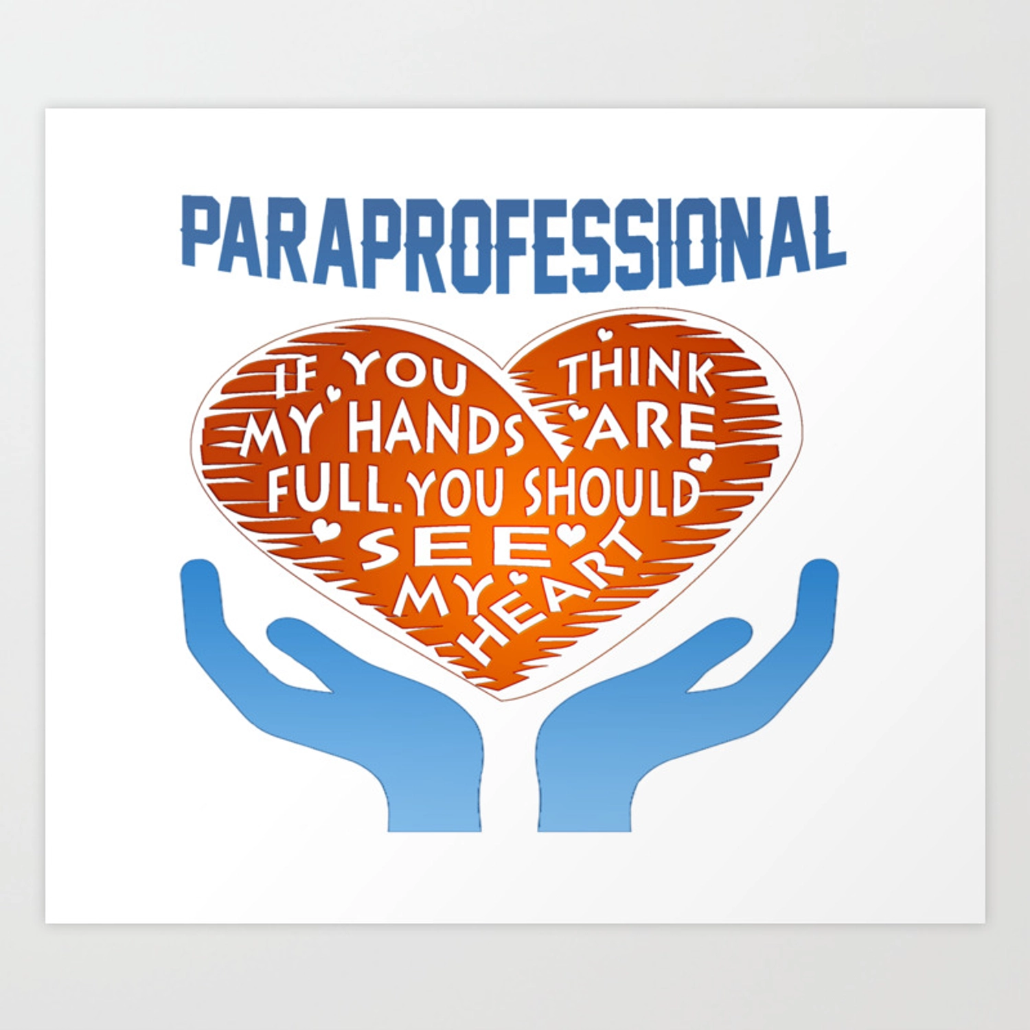

Acknowledgement of Reviewing Document

By signing below, I , acknowledge that I have reviewed the Colorado Charter School Special Education Paraprofessional Handbook. I understand that I am responsible for knowing the information in this handbook. I also understand that it is my responsibility to ask any clarifying questions or for further explanation of information with my supervising teacher and/or principal. If I have concerns about my role, I understand that I should first discuss these with my supervising teacher, and then with my principal if my concerns continue.

Paraprofessional Signature Date

Supervising Teacher’s Signature Date

Principal’s Signature Date Received

