2023-2024 CSI October Count

Audit Handbook

This document contains instructions for all CSI schools to follow to meet the requirements of the CSI internal audit for the October Count collection for the current school year.

Last updated October 10, 2023

Contents
General Overview 2
Goals for CSI Internal Audit 2
Timeline 3
October Count Dates 3
Alternative Count Date Requests 3
General Timeline for CSI Internal Audit 3
October Count Submission Deadlines 4
October Count Audit Deadlines 4
Supporting Documentation 6
Resources 7
Appendix 8
I: Audit Supporting Documentation Checklist 8
Overview 8
II: SIS Attendance, Enrollment, and Schedule Report 26
Infinite Campus Report Extracts 26
PowerSchool Report Extracts 29
III: Crosschecking Funding Eligibility with Student Schedules 34
PowerSchool Instructions 34
Infinite Campus Instructions 35
IV: Free and Reduced Lunch Eligibility Checklist 37

General Overview
The Colorado Department of Education requires that all school districts have an internal audit process in place to ensure accurate reporting of eligible students and their corresponding funding levels in the Student October Count data submission. The internal audit process also ensures that all required supporting documentation as defined in the CDE Audit Resource Guide and as provided by CSI schools is complete and submitted on time.

Goals for CSI Internal Audit
- Report accurate data
- Secure maximize potential funding
- Avoid repayment of funds back to the state
- Reduce burden on schools

Timeline

October Count Dates

Pupil Count Grades | Pupil Count Date | 11-Day Count Window
PK-12 | Monday, October 2, 2023 | Monday, Sept 25 – Monday, Oct 9
Beginning in SY23-24, schools should report all PK students receiving services in the October Count collection (regardless of UPK funding status), but pupil count funding is no longer available for PK.

Alternative Count Date Requests
All schools need to use the official count date and count window dates unless approved for alternative count dates. If your school plans to use a count date or count window other than the ones shown in figure above, then you will need to request those. CSI will email all schools with instructions in August with details on requesting alternative count dates.

Email requests to submissions_csi@csi.state.co.us
No later than September 7, 2023
Include alternative count date and/or window and rationale.

General Timeline for CSI Internal Audit

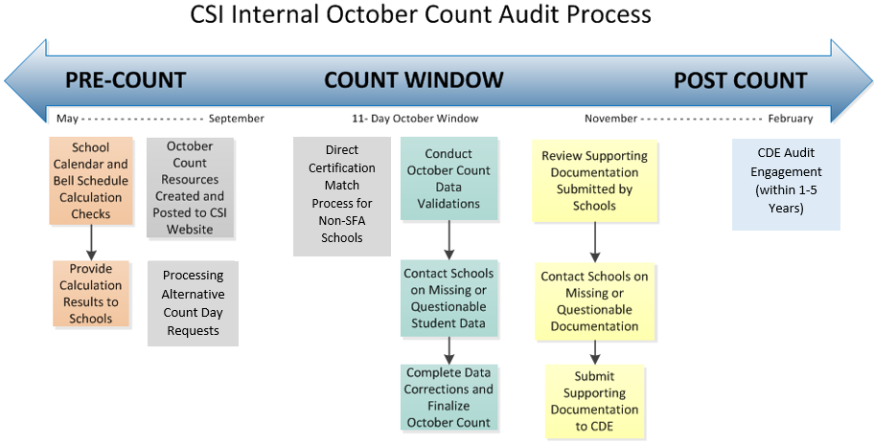

October Count Submission Deadlines
For a list of intital file submission dates, error clearance deadlines, and summary report review phase deadlines, please see the current year Data Submissions Calendar on the CSI website under the Data Submissions Library, General Data Submissions Resources, then see the Data Submissions Calendar (PDF) link.

October Count Audit Deadlines
A few key audit dates will be listed in the Data Submissions Calendar. Other important dates related to the audit to highlight are listed below and are subject to change during the collection. If a deadline below falls on a weekend, then the due date is usually the Friday before.
Deadline Date | October Count Audit Event
9/7/2023 | Deadline to request alternative count date and/or window (see section above)
9/19/2023 | Deadline to submit McKinney-Vento (homeless forms) to CSI for approval prior to count day (be sure to continue submitting forms as new students are identified past this date)
9/30/2023 | ALP approval deadline for early access students.
10/2/2023 | Count Day—Deadline to submit student schedules (for secondary schools) by end of day (see Appendix)
10/16/2023 | Deadline to submit majority of audit supporting documentation (see Appendix)
11/2/2023 | October Count summary report signed certification deadline (schools must complete their data review and submit final data changes)
11/6/2023 | Deadline to submit all other audit supporting documentation AND signed Audit Supporting Documentation Checklist (see Appendix)
11/11-14/2023 | CDE Duplicate Phase (window of time to resolve duplicates claimed for funding by multiple districts)

Supporting Documentation
As part of the annual CDE audit and the CSI internal audit, all schools are required to submit supporting documentation to verify proof of funding levels claimed for students reported in the October Count collection.
All schools should use the Audit Supporting Documentation Checklist located in Appendix I. A standalone version of the checklist has also been added to the October Count webpage under the Audit Guides section.
Supporting documentation on student attendance, enrollment, and schedules (the latter is typically for students with passing periods) is a primary component of the internal audit and is found in Section I of the checklist. Guidance on extracting SIS electronic attendance, enrollment, and schedule reports is available in Appendix II.

Resources
Primary resources related to the October Count internal audit processes include the following:
- CSI October Count Webpage
Both file submissions and audit resources (recorded trainings, file layouts, validation documentation, and other helpful resources)
- CSI “Weekly Update” Emails
Please review each week for audit announcements and file submission status (sent to all school submissions contacts)
- CSI Policy Guidance
Legal requirements on topics like attendance, enrollment, data privacy, and home school
- School Calendar and Instructional Hours Resources

- CDE October Count Audit Resource Guide
- CDE At-Risk Audit Resource Guide
- CDE ELL Count Audit Guide

Appendix

I: Audit Supporting Documentation Checklist

Charter School Institute
2023-2024 October Count
Audit Supporting Documentation Checklist

Overview
All CSI schools need to follow the instructions provided below regarding the October count supporting documentation requirements that need to be submitted to CSI as part of the audit requirements for the current school year by the Colorado Department of Education.
A standalone version of this checklist is available on the CSI October Count webpage if it’s easier for you to work with that rather than exporting the checklist from the appendix of this handbook.
Questions
You may direct any questions about this checklist by sending an email to submissions_csi@csi.state.co.us.
Instructions
The checklist below is divided into two main sections.
Section I — All schools will need to provide most of the supporting documentation listed in the first section. Please read each item to see if your school needs to provide it and if so, then checkmark the items and provide the documentation by the deadlines listed.
Section II — These are special student types/scenarios that may or may not be found at your school for this year. All schools should review the items in this section and determine if they have any students fitting what is described. If so, then checkmark each item and submit the documentation described by the deadlines listed.
Upload the supporting documentation for each item you check in Sections I and II to G-Drive under October Count/23-24/OC Audit Documents by the deadline dates specified by the item (G-Drive screenshot location shown below).
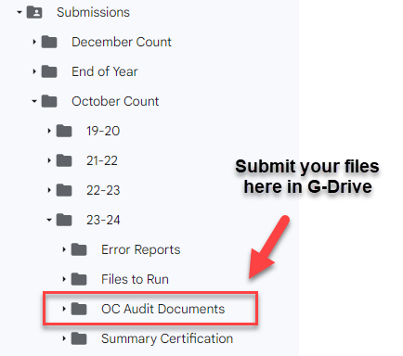
When your school is finished checking items in this document and uploading documents to G-Drive, you will need to sign, date, and upload this entire checklist form to G-Drive. The signature page is the last page of this document. The deadline date to upload this entire signed checklist is November 6, 2023.

The CDE Audit Resource Guide lists more specific rules and requirements on each of the student types/scenarios in the checklist below. CSI schools are welcome to look at that resource if more information is needed (see links above). However, please direct any questions to our CSI office rather than to CDE. This is simply because CDE asks that questions come from the district office rather than from the school level. CSI can typically answer questions for you without the need to contact CDE.

Section I
All Schools Need to Provide Some Items in This Section
Instructions on pulling attendance, enrollment, and scheduling reports for both Infinite Campus and PowerSchool is an additional resource found in Appendix II of this Audit Handbook.
By default, both Infinite Campus and PowerSchool identify students as eligible for full-time funding. It is the responsibility of each school to adjust the funding codes. If you claim funding on students who are not eligible, it is almost guaranteed that CDE will catch it in the State audit and your school will need to return that funding.
Attendance
☐ Daily attendance summary for a minimum of the 11-day count period (see the October Count Date and Count Window table near the beginning of this document for the count window dates or use your school’s approved alternate count window) This is required for all schools from your SIS and is due 10/16/2023 (don’t submit until the 11-day count period is complete)
☐ For students absent on the pupil enrollment count date), detailed daily attendance showing that student was present prior to the pupil enrollment count date and resumed attendance within 30 calendar days after the pupil enrollment count date Required for all schools with students as described. Due 11/6/2023.
Enrollment
☐ Enrollment history showing entry and withdrawal dates for students entering either as a new student OR current students who withdrew during the school’s 11-day count window (use the official count window dates or your school’s approved alternative count window dates) Due 10/16/2023.
☐ IEP (only a portion that includes the student’s name and service delivery dates is needed) for students aged 21 years claimed for funding who are receiving special education services (service delivery dates must encompass the pupil enrollment count date). This is not required for students under age 21 unless noted in one of the other items below. Due 11/6/2023
IEPs must be current (i.e., not more than 365 days old) and include services that encompass the pupil enrollment count date.
Scheduled Hours
☐ Individual student schedules (from your SIS) for all secondary students (usually grades 6-12 unless grades below 9th follow an elementary type of schedule where they do not change classrooms/instructors and have passing periods) effective as of the pupil enrollment count date and including classes scheduled equal to one half of the school year. (Due on Count Day 10/2/2023! —pull at end of count day and upload to G-Drive; schools with an approved alternate count date upload at the end of that approved date)
- Homeschool students are included in this rule. If you do not keep schedules in your SIS for these students, then you will need to provide something from an alternative source like Excel where you should be documenting courses taken on which days/times of the week.
- Postsecondary option courses such as ASCENT, concurrent enrollment, and early college courses must be included in the student schedules.
- Supplemental and blended learning courses will need to provide additional aspects for student schedules (see Section II)
- Student schedules must clearly crosswalk to the main school bell schedules. Provide additional documentation if this is not the case.
- If your school uses semesters, then provide the first semester schedule.
- If your school uses trimesters, then provide the first and second trimester schedules.
- If your school uses quarters, then provide the first and second quarter schedules.
- If your school uses hexters, then provide the first, second, and third hexter schedules.
- If your school uses mini sessions, then provide half of the mini session schedules.
☐ Online schools and programs (those with official state approval) should review the schedule documentation requirements under Section II in this checklist.
☐ IEP (only a portion that includes the student’s name and service delivery dates is needed) for students whose SPED services are not already reflected on the SIS student schedule
IEPs must be current (i.e., not more than 365 days old) and include services that encompass the pupil enrollment count date.
Section II
Some Schools Will Need to Provide Items in This Section (listed alphabetically)
ASCENT Students
Due 11/6/2023; let CSI know if you will not have the documents by this date
ASCENT is a program which allows students to participate in concurrent enrollment the year after 12th grade only (which has been defined as the fifth year of high school, as determined by a student’s AYG).
☐ Current ASCENT cooperative agreement (MOU) between the CSI school and the IHE
☐ Fall semester documentation showing that the school paid its nonrefundable obligation of the student’s share of tuition directly to the IHE on the student’s behalf. This documentation must list each student by name plus the number of credits for which the district/charter school paid for each student to verify the student’s funding level eligibility
- Tuition payment verification/invoice (between the school and the IHE)
- College credit hour verification (from the IHE)
☐ Documentation demonstrating the student has completed the minimum college coursework prior to their ASCENT year (for example, a college transcript)
►Fall semester courses offered through an IHE which are not “in session” on count date (i.e., those that begin and end prior to the count date, or those that begin after the count date and end prior to the end of the fall semester) may be included for funding.
- For courses beginning after the count date and finishing prior to the end of the fall semester, the student must be enrolled and scheduled for the course as of the count date.
- Only postsecondary courses starting and ending during the semester of the pupil enrollment count date can be included for funding.
►Only those courses for which the school directly paid all tuition costs to the IHE will be considered in the determination of funding level.
Blended Learning Courses
Due 10/16/2023
“Blended learning courses” refer to courses taken by students enrolled in traditional, brick-and-mortar schools (i.e., those with funding codes 80, 82, 85, or 86) in which some of the instruction is regularly received in person on-site and some of the instruction is received regularly off-site, digitally (with some element of student control over the time, place, path, and/or pace of participation).
These courses are meant to supplement a student’s brick-and-mortar schedule; a student enrolled in a brick and-mortar school should never be primarily scheduled into blended learning and/or supplemental online courses.
In order to include the digitally delivered off-site portion of the blended learning course in the determination for funding, the following documentation must be provided at the time of audit:
☐ Check this box if your school will be claiming funding for students in these types of courses. Due to the complexity of documentation required, schools will need to consult the CDE October Count Audit Resource Guide under the Blended Learning Courses section and are responsible for submitting every type of required supporting document listed there.
Concurrent Enrollment Students
Due 11/4/2022; let CSI know if you will not have the documents by this date.
For all concurrently enrolled students (regardless of year in school or location of course)
Schools should take the time to review the Concurrent Enrollment Students section of the CDE October Count Audit Resource Guide to ensure they are interpreting concurrent enrollment courses correctly, reporting students correctly in the October Count collection, and submitting correct supporting documentation.
Early Colleges with students enrolled in postsecondary course options should refer to the Early College Students section further below.
☐ Check this box if your school will be claiming funding for students in these types of courses. Due to the complexity of documentation required, schools will need to consult the CDE October Count Audit Resource Guide under the Concurrent Enrollment Students section and are responsible for submitting every type of required supporting document listed there.
New for 23-24, schools must also provide school graduation requirements plus high school transcripts. Postsecondary courses offered ONLINE that do not meet concurrent enrollment requirements will be evaluated as Contractual Courses.
Contractual Education Students
Due 10/16/2023
Contractual education students are those students for whom a school is paying tuition to another district or third-party entity to educate one of its students. Tuition is defined as money paid to cover basic education costs.
Schools should consult with contract providers to determine how services fit into the school defined remote learning policies for educational process and plans. Schools should ensure that the contracted services align with the school’s adopted policies.
Only those courses for which a school incurred the cost of a student’s tuition may be considered as instructional time for funding purposes.
Only the actual time in which a student is scheduled to receive services will be used in the evaluation of the student’s schedule for funding purposes.
☐ Program/school calendar and program/school bell schedule (from educational provider)
☐ 11-day count period attendance (at a minimum) (from educational provider)
☐ Individual Student Schedule (from educational provider). The determination of funding level will be based only on the actual time in which the student is scheduled to receive services.
☐ IEP service delivery page if the student is receiving SPED services from the educational provider
IEPs must be current (i.e., not more than 365 days old) and include services that encompass the pupil enrollment count date.
☐ Purchase agreement or contract for educational services between school and educational provider. Alternatively, evidence of tuition paid by the school to the educational provider.
☐ Additional documentation, as described in the CDE October Count Audit Resource Guide, for all applicable unique student, course, school, and program types (one example is supplemental learning courses0.
Detention Center Students
Due 10/16/2023
Documents required from the last known school of attendance (this would be your school if the student transferred from your school to the detention center without attending another school in between).
☐ Completed detention center notification (AUD-101) indicating that the student is eligible to be submitted for funding by the last known school along with confirmation that funding was returned to the district/school providing the educational services at the Youth Services Center (YSC)
☐ Documentation supporting membership (enrollment history and detailed period attendance for the current school year prior to the pupil enrollment count date) (covered in Section I)
☐ Documentation supporting scheduled hours as of the pupil enrollment count date (covered in Section I)
Dropout Recovery Students
Due 11/6/2023; let CSI know if you will not have the documents by this date
Dropout recovery students are those students who are attending a dropout recovery program offered and ran by a community college in which all courses are being taken at the institution of higher education (IHE).
Because all courses are being taken at the IHE, funding eligibility is determined by the number of credit hours for which the school is paying tuition.
For funding purposes, dropout recovery students do not refer to those who are enrolled in a program operated by the local education provider (e.g., district/school). An example of a program that is not considered dropout recovery for this purpose is a “credit recover” program offered by the district/school.
☐ List of students participating in this type of program.

☐ Cooperative agreement (MOU) between the Local Education Provider (LEP) and community college – Community College must meet the definition as outlined in Section 23-60-201, C.R.S. or a Junior College as defined in Section 23-71-102, C.R.S.
☐ College Credit Hour Verification (from the IHE)
☐ Tuition Payment Verification (from the district/school to the IHE), including payment for classes not credited on the community college’s transcript
☐ Evidence of enrollment at the IHE
☐ High school transcript generated prior to, or during, the semester of the pupil enrollment count date showing high school credits
Early College Students
Due 11/6/2023; let CSI know if you will not have the documents by this date
An “Early College” is a secondary school that provides only a curriculum that is designed in a manner that ensures that a student who successfully completes the curriculum will have completed either an associate degree or sixty credit hours toward the completion of a postsecondary credential.
Do not flag students in your SIS as “concurrently enrolled” simply because they are attending an Early College—the students must be concurrently enrolled and taking postsecondary courses to qualify as such.
In the event an early college student is concurrently enrolled in postsecondary courses, then provide the following:
☐ Current concurrent enrollment cooperative agreement (MOU) between the CSI school and the IHE
☐ Documentation showing that the school paid its nonrefundable obligation of the student’s share of tuition directly to the IHE on the student’s behalf. This documentation must include the name of each student plus the number of credits for each student for which the district/charter school paid in order to verify the student’s funding level eligibility
- Tuition payment verification/invoice (between the school and the IHE)
- College credit hour verification (from the IHE)

►Fall semester courses offered through an IHE which are not “in session” on count date (i.e., those that begin and end prior to the count date, or those that begin after the count date and end prior to the end of the fall semester) may be included for funding.
- For courses beginning after the count date and finishing prior to the end of the fall semester, the student must be enrolled and scheduled for the course as of the count date.
- Although attendance is no longer required for Concurrent Enrollment courses, students taking high school courses must still meet the attendance requirement, even if they are also taking Concurrent Enrollment courses.
Expelled Students
Due 10/16/2023
Expelled students may be eligible for funding if the district/school is providing educational services to the student as of the pupil enrollment count date. Expelled students include the following:
- Prior to the pupil enrollment count date
  - Prior school year
  - Current school year
- After the pupil enrollment count date
  - Example: Students who established attendance prior to the pupil enrollment count date, were suspended as of the pupil enrollment count date, and who then began receiving expelled services within 30 days following the pupil enrollment count date
☐ Attendance: Regardless of the circumstances, all expelled students must meet the same attendance criteria as all other students (as covered in Section I). As such, the school should be prepared to provide appropriate attendance documentation from the applicable school(s) and/or program(s), (and for any given student type/scenario through which the educational services might be provided) showing that the requirements have been met. For example, if the student was receiving expelled services through an online program or home-bound tutoring scenario, the school would need to provide the appropriate online or home-bound attendance documentation
☐ Student schedule: Individual student schedules (as covered in Section I). Include a description and frequency of expelled educational services being delivered to the student
Facility Students
Due 10/16/2023
Funding rules for students placed in facility schools are very complicated. If you believe that a student at your school has been placed in a facility school during the October count window, then please check the box below and notify CSI that you have a facility student to report this year in the October Count collection.
☐ Check this box if you have a facility student to report in the October Count collection.
First Grade Students (Under Age 6)
Beginning with the 2020-2021 school year, first grade students no longer need to be at least 6 years old as of October 1 in order to be eligible for full-time funding. Instead, all students in grades K-12 must be at least 5 years old as of October 1 in order to be eligible for funding.
Foreign Exchange Students
Due 10/16/2023
Foreign exchange students with a J-1 visa (where a school is not receiving any tuition for the educations services provided to the student) enrolled through a sponsor organization, as designated by the U.S. Department of State, are eligible for funding.
☐ Documentation showing that the school did not receive tuition to educate the foreign exchange student. Examples of acceptable documentation include evidence of a J-1 student visa or documentation from the sponsor organization as designated by the US Department of State. Passport copies are only acceptable if they clearly list the specific visa type
Home-Bound Students
Due 10/16/2023
A home-bound student is a student receiving his/her educational services at a location other than the school building (e.g. student’s home or hospital) because the student is not able to physically attend school.
The student schedule used to determine funding level eligibility for Home-Bound students will be dependent on when the student goes Home-Bound and whether the student established attendance in a program other than the Home-Bound program.
- Home-Bound students with established attendance in a Home-Bound program or through Home-Bound services only
  - Funding level is determined based on the scheduled teacher-pupil instruction and contact time provided for in the Home-Bound program or through the Home-Bound services in the current school year
- Home-Bound with established attendance, prior to the pupil enrollment count date, in a program other than the Home-Bound program or through Home-Bound services (e.g., in a traditional classroom setting)
  - Funding level is determined based upon the scheduled teacher-pupil instruction and contact time as evidenced by the student’s schedule at the time of Home-Bound
☐ Evidence of enrollment and 11-day count window attendance (as covered in Section I)
In some cases, the school may need to provide multiple types of attendance to show the student met the requirements (i.e., SIS attendance report prior to going home-bound, and tutor logs after designated as home-bound)
☐ Individual student schedule (as covered in Section I)
In some cases, the student’s schedule may include a description and frequency of home-bound educational services being delivered to the student (i.e., days/times for scheduled tutoring sessions, etc.)
For example, if a home-bound student is scheduled to receive in-home tutoring 2 hours every Monday, Wednesday, and Friday for a total of 6 hours per week, this would be the student’s schedule
☐ If the student was receiving home-bound services through an online program or home-bound tutoring scenario, the school would need to provide the appropriate online or home-bound attendance documentation, such as logins and/or tutor logs
Home-School Students (Home-Based)
Due 10/16/2023
A home-school (or home-based) student is a pupil receiving education under a non-public, home-based educational program where the parent or guardian (not the school) has taken on the primary responsibility for providing the student’s education in a home setting.
Students enrolled in a private school will be evaluated similarly to home-school students (and as such are eligible for a maximum of part-time funding).
Only teacher-led instruction may be considered as instructional time for funding purposes; instruction being provided by parents (including that which is delivered “under the supervision of” teachers) may not be included in the calculation of instructional time.
☐ Evidence of enrollment and 11-day count window attendance (as covered in Section I)
- For students participating in a school/district operated home-school options program or school, attendance beyond the 11-day count period may be necessary depending on the frequency in which the students attend these programs or schools. For example, if a program meets once during the 11-day count period and not on the count date, additional documentation is required to prove the attendance requirement is met
- Only days of actual student-teacher contact may be used as attendance days for the purposes of showing that the attendance requirements have been met
- For elementary home-school students receiving educational services at a district school, if the student attends after attendance has been taken for the day, the district/school may need to collect additional attendance documentation for the student (e.g., the student comes in for afternoon “specials” and attendance is only taken in the morning)
☐ Individual student schedule (as covered in Section I)
- For all home-school students, including elementary home-school students receiving educational services at a district school, a student schedule or other documentation will be necessary at the time of audit evidencing the days/times the student is/was expected to attend as this may not be captured in the school’s student information system.
High School Equivalency Diploma Students (Previously GED)
Due 10/16/2023
High School Equivalency Diploma Students are eligible for funding if they:
- Are actively enrolled and participating in an HSED program, OR
- Have received an HSED certificate and have returned to earn their high school diploma
☐ Students who are actively enrolled and participating in a HSED program:
Schools can only report HSED students for funding if the school is incurring the cost to educate the student. This is true whether the student is attending a district program or if the school is contracting with another entity to provide the educational services for the HSED student
If the school is paying tuition to another entity or district to provide the HSED program services, the school will need to be prepared to provide:
- HSED program calendar and bell/class schedule
- HSED program student attendance for the 11-day count period
- HSED program student schedule as of the pupil enrollment count date
- Contract or agreement between the district and the entity or district providing the educational services for the HSED student
- Tuition payment verification by school to the entity or district
☐ Students who have received an HSED certificate and have returned to earn their high school diploma:
Schools can only submit these students for funding if the students are under the age of 21 as of the pupil enrollment count date, and have not met the district’s minimum graduation requirements as of the pupil enrollment count date
- An exception is a student receiving services as outlined in an IEP that turns 21 in the semester of the pupil enrollment count date
IEPs must be current (i.e., not more than 365 days old) and include services that encompass the pupil enrollment count date.
- Provide evidence of enrollment, attendance, and individual student schedule (as covered in Section I)
☐ Students pursuing an HSED certificate:
Are eligible to participate in Concurrent Enrollment courses; however, during the 5th year of high school and beyond, HSED students (like other students) are limited in the number of credit hours they are eligible to take.
- Refer to the Concurrent Enrollment Student section of the CDE October Count Audit Resource Guide to confirm eligibility.
Independent Study Courses (Offsite)
Due 10/16/2023
Independent study courses refer to those courses in which some or all of the course is being completed off-site, independently by the student. Typically, the portion of the course completed off-site does not include instruction—either synchronous or asynchronous. As such, only the time of actual teacher-pupil instruction and contact can be included when determining funding eligibility.
☐ Documentation supporting the amount of actual teacher-pupil instruction and contact time per day or week
In the absence of regularly scheduled teacher-pupil instruction and contact time, these courses cannot be used in the determination of funding.
☐ Description of the independent study course, including student expectations regarding days and times of meetings
☐ Evidence of enrollment, attendance, and individual student schedule (as covered in Section I)
Innovative Learning Opportunities Program
Due 10/16/2023
Students participating in the ILOP program are exempt from meeting the minimum scheduled hours threshold that is otherwise required for full-time funding. However, to be eligible for funding, districts must still provide documentation which demonstrates that these students have met the enrollment and attendance requirements. Additionally, based on the nature of the specific innovative learning opportunity in which a student is participating, further documentation may be necessary to demonstrate the student’s participation in the program.
Only courses for which the school incurred the entire cost of the student’s tuition may be considered in the determination of funding level.
☐ Individual student schedule must include at least one ILOP course as part of the ILOP Course Assurances
☐ Copy of the ILOP Course Assurances for the current ILOP program year
- For work-based innovative learning opportunities (including apprenticeships, internships, residencies, etc.):
☐ Employer contract dated on or before the count date that includes the following information:
Student name, term (example “Fall 2023”), employer name, description of work, and approximate expected amount of work time per week
☐ If a student has no courses on-site at the high school, verification of attendance from the employer
- For innovative learning opportunities in which another entity is contracted to educate or support the student:
☐ Purchase agreement or contract for educational services between the school and the educational provider. Alternatively, evidence of tuition paid by the school to the educational provider
☐ If a student has no courses on-site at the high school, verification of attendance from the employer/educational provider
Kindergarten Special Circumstances
Due 10/16/2023
Retained Kindergarten students enrolled in a half day program
☐ Retained Kindergarten students enrolled in a half day program for an SRD
- If a student is retained for a second year of kindergarten due to a significant reading deficiency (SRD) identified by the school in the prior year READ collection, the student is eligible for full-time funding (even if enrolled in a half-day Kindergarten program) as long as the student is scheduled for a minimum of 90 semester hours of teacher-pupil instruction and contact time in the semester of the pupil enrollment count date.
- Must be reported with grade code 006.
Kindergarten Students (Under the Age of 5 as of October 1)
Kindergarten students who are at least five years old on or before October 1 (not related to the count date; stays the same each year) of the current school year are eligible for a maximum of full-time funding assuming they are enrolled in a full-day kindergarten program that provides for at least 360 hours of teacher pupil instruction and contact time in the semester of the pupil enrollment count date.
Kindergarten students under the age of five as of October 1 are not eligible for any funding unless they meet one of the exceptions outlined below.
☐ Highly Advanced Gifted/Early Access Students: An Advanced Learning Plan (ALP) dated on or before Sept. 30 indicating the district/school identified the student for early access or grade acceleration
☐ Active Military: Enrollment documentation from the prior school for the current school year, AND
- Copy of active military orders effective as of the count date, OR
- Copy of medical discharge, retirement papers, or death certificate evidencing cause of death that resulted from being on active duty or from injuries sustained while on active duty dated within one year
Online Schools and Programs
This section refers only to those online schools and programs that have applied, undergone the review process, and received a notification of approval (for multi-district online schools) and recognition (for single-district schools and programs) from the Office of Blended and Online Learning.
Schools are encouraged to review the full Online Schools and Programs section of the CDE Audit Resource Guide for full details on audit expectations due to the complexity of this type of student scenario and funding requirements.
This checklist has separate sections for supplemental online and blended learning courses not offered through a formally approved online school or program.
☐ Documentation evidencing enrollment eligibility Due 10/16/2023
  - Proof of Colorado residency (POR) that is dated within 365 days preceding or on the pupil enrollment count date (schools should collect this upon initial enrollment and annually thereafter).
    - See the full Online Schools and Programs section of the CDE Audit Resource Guide for acceptable forms of POR.
    - Proof of residency is not required for students who are required to be on-site regularly for any portion of the instructional day if appropriate evidence of on-site attendance is provided. Otherwise, proof of Colorado residency is required.
☐ Documentation evidencing attendance Due 10/16/2023
- The definition of attendance or evidence of participation will be on file with CDE as part of the school’s Authorizer Assurances.
- Documentation must show proof of attendance on the count day. In the event the student did not attend or participate on the count date, documentation evidencing attendance or participation during the current school year prior to the pupil enrollment count date and within 30 calendar days following the count date is acceptable.
☐ Individual student schedules Due on Count Day!
- Student schedules must clearly state all courses into which the student is scheduled during the entire semester of the count date (first semester).
  - For elementary and grades 6-8 where students follow the exact same schedule, then a master/bell schedule will suffice.
  - For Elementary and grades 6-8 where students do not follow the exact same schedule must have individual schedules submitted for audit.
  - Students in grades 9-12 are supposed to have individualized schedules that must be submitted for audit.
☐ Course Documentation (typically a course catalog that contains all the following) Due on Count Day!
- For each course code and name that appears on student schedules (and which is used in the determination of funding), provide documentation including:
  - Assigned semester credit hours (for students in grades 9-12)
  - Equivalent teacher-pupil instruction and contact time (i.e., an equivalency statement as to instructional hours per semester)
  - Description of the course content so that a reasonable person with enough understanding of the material would understand the overall breadth of the course.
  - If a course is to be used in the determination of funding, an entry is required even if no credits are awarded (e.g., zero-credit courses, pass/fail courses, etc.)
  - If a singular document (such as a course catalog, vendor course guidebook, student handbook, etc.) does not contain all the required course information, supplemental documents which contain the missing information may be provided.
Preschool Students
Beginning with the 2023-2024 school year, data reported in the Student October Count data collection will no longer be used to determine funding amounts for districts providing educational services for preschool students, including funding historically associated with Colorado Preschool Program (CPP), Early Childhood At-Risk Enhancement (ECARE), or preschool students with an Individualized Education Program (IEP) receiving integrated preschool. Instead, funding associated with Universal Preschool (UPK) will be distributed directly to eligible providers by the Colorado Department of Early Childhood (CDEC) which oversees the implementation of UPK.
Supplemental Online Students
Due 10/16/2023
“Supplemental online courses” refer to courses taken by students enrolled in traditional, brick-and-mortar schools (i.e., those with funding codes 80, 82, 85, or 86) in which all of the instruction is received off-site, digitally (with some element of student control over the time, place, path, and/or pace of participation).
☐ Check this box if your school will be claiming funding for students in these types of courses. Due to the complexity of documentation required, schools will need to consult the CDE October Count Audit Resource Guide under the Supplemental Online Courses section and are responsible for submitting every type of required supporting document listed there.
Transfer Students
Due 10/16/2023
It’s always to the benefit of schools to get documentation on where students are coming from and where they are going to any time in the school year!
Within-District Transfers
☐ Enrollment history that includes enrollment and withdrawal dates for the current school year
☐ Student schedules that were in place prior to and after the pupil enrollment count date (the schedule that was in place prior to the pupil enrollment count date should be used to determine funding eligibility)
☐ Attendance documentation showing the student established attendance during the current school year prior to the pupil enrollment count date and resumed attendance within 30 days following the pupil enrollment count date. Attendance documentation is likely to be needed from both schools
Within-State Transfers
☐ Attendance documentation from the prior Colorado public school district showing that the student established attendance during the current school year prior to transferring
Out-of-State Transfers
☐ Documentation to support that the student transferred from another state or country
- The student’s last school or educational setting was not in Colorado.
- From the start of school through the last day of the 11-day count window in the current school year.
- Schools should have in place a process for documenting when the student arrived in Colorado.
Transition Students
Due 10/16/2023
As with all students, schools must be able to clearly document that both the membership and scheduled hours’ requirement have been met by all 18-21 age students receiving transition services. To do so, schools should know, for each student receiving said services, the types and method of delivery for those services.
Only the actual time in which a student is scheduled to receive services will be used in the evaluation of the student’s schedule for funding purposes.
Regardless of the setting in which services are being delivered, the following documentation must be provided:
☐ Transition program calendar and bell schedule
☐ Student Attendance
In some cases, attendance may not be adequately tracked in the school’s information system due to the nature and variation of individual transition student schedules. In these cases, the school should be prepared to provide appropriate evidence of attendance
☐ Individual Education Program (IEP)
All 18–21-year-old students receiving transition services must have an IEP that shows services being delivered as of the pupil enrollment count date. Further, the IEP should clearly state the types of services being delivered, and the approximate number of hours per week in which the student is scheduled to receive those services
In some cases, and individual student schedule may be necessary to supplement the IEP if the IEP does not list out all services being provided (including general education courses). Student schedules and IEPs should be consistent with one another
IEPs must be current (i.e., not more than 365 days old) and include services that encompass the pupil enrollment count date.
TREP Students
Due 10/16/2023
The Teacher Recruitment Education and Preparation (TREP) program was added to the Concurrent Enrollment Programs Act (CEPA) by SB 21-185. The TREP program creates the opportunity for qualified students in a teaching career pathway to concurrently enroll in postsecondary courses for the two years following the 12th grade year (defined as the 5th and 6th years of high school, as determined by the student’s AYG).
The documentation requirements and determination of funding eligibility for students participating in TREP vary from traditional students. Schools must ensure that students have met the programmatic requirements as described here: https://www.cde.state.co.us/postsecondary/trep
☐ Current TREP cooperative agreement (MOU) between the CSI school and the IHE
☐ Documentation showing that the school paid its nonrefundable obligation of the student’s share of tuition directly to the IHE on the student’s behalf. This documentation must include the name of each student plus the number of credits for each student for which the district/charter school paid to verify the student’s funding level eligibility
- Tuition payment verification/invoice (between the school and the IHE)
- College credit hour verification (from the IHE)
☐ High school transcripts
Truant Students
Due 10/16/2023
A habitually truant student may be included in a school’s funded count if the student has a schedule that supports funding as of the pupil enrollment count date AND if one of the following sets of attendance criteria have been met:
- Student attended all, or a portion of, the pupil enrollment count date OR
- Established attendance prior to the pupil enrollment count date in the current school year AND resumed attendance within 30 days following the pupil enrollment count date, OR
- Established attendance prior to the pupil enrollment count date in the current school year AND the school filed legal action to compel attendance during the current school year, but no later than 10 school days following the pupil enrollment count date
- If attendance requirements are met, then no other documentation is needed.
☐ Attendance documentation from the current school year evidencing that the student established attendance prior to the pupil enrollment count date
☐ Truancy documentation evidencing legal action has been filed within 10 school days following the pupil enrollment count date
Examples of legal action include, but are not limited to:
  - A diversion agreement between the court and the student
  - Filing a Petition to Compel Attendance with the court and served with a summons to the student and parent or legal guardian
  - Proof of Service showing that the parent or legal guardian has received the petition and summons
  - Proof of an ongoing court case with a showing that the student is not complying with the order to compel attendance and notice to the court was provided no later than 10 school days following the pupil enrollment count date
A letter of intent to file truancy addressed to the parents/legal guardians is not adequate documentation
Work-Based Learning Students
Due 10/16/2023
☐ Evidence of enrollment, attendance, and individual student schedule (as covered in Section I)
If the student is only enrolled in a work-based learning experience course, then you must provide attendance verification from the employer
☐ Scheduled hours documentation, such as a “work-based learning experience contract,” evidencing:
- Student Name and Term (ex. “Fall 2023”)
- Total number of scheduled hours to be worked by the student during the semester of the pupil enrollment count date
  - Actual hours worked during the semester may be substituted if documentation is inadequate to show number of scheduled hours to be worked
- Statement or cross-walk that indicates the number of hours to be worked (for each work-based learning experience, if applicable) in order to earn the equivalent credit hours
- Statement indicating equivalent teacher-pupil instruction and contact time similar to a “traditional” brick and mortar course resulting in the same credit hours (towards meeting district/school graduation requirements)
☐ In the absence of scheduled hours documentation, the school may provide a high school transcript showing the number of credit hours earned in the semester of the pupil enrollment count date for this course type

Signature Form Follows on Next Page

When your school is finished check marking items and uploading documents, you will need to sign, date, and upload this entire checklist to G-Drive under Submissions/October Count/23-24/OC Audit Documents.
You may use electronic signatures below.
Do not upload just the signature page since CSI needs to see each of the items that you should have checked for every scenario that you are reporting funded students for.
The deadline date to upload this signed document is November 6, 2023.
School Certification Statement for the
2023-24 October Count Audit—Supporting Documentation

I hereby certify that I have submitted all required supporting documentation and certify that the information provided is accurate, verifiable, and complete to the best of my knowledge.

____________________________________________________ ______________________
Signature, Head of School Date
____________________________________________________ ______________________
Signature, Data Submissions Contact Date

II: SIS Attendance, Enrollment, and Schedule Report

Infinite Campus Report Extracts
The following instructions illustrate how to extract Attendance, Enrollment, and Student Schedule reports from Infinite Campus.
Even though some screenshots may not illustrate the current school year, they should still be applicable in a general sense and won’t be updated until they change significantly with the vendor. However, be sure to use the dates described in the steps rather than those in the screenshot if it is from a different year.
Report 1: Attendance
- Click on Attendance
- Click on Reports
- Click on Register
- For What report type would you like? Select Student Daily Attendance
- For the date range, select the 11-day window of 09/25/2023 – 10/9/2023 (as displayed in the screenshot below))
- If your school is approved for alternative count window dates, then use those dates
- For schools with students absent on Count Day (10/2/2023 or your approved alternative count day), use 7/1/2023-11/2/2023
- Click Generate Report
- Please review the resulting report to ensure accuracy and save it as a PDF using the following naming convention: “SchoolCode_School_AttendanceOctCt_CurrentDate”.
Example: 1633_CECA_AttendanceOctCt_10162023

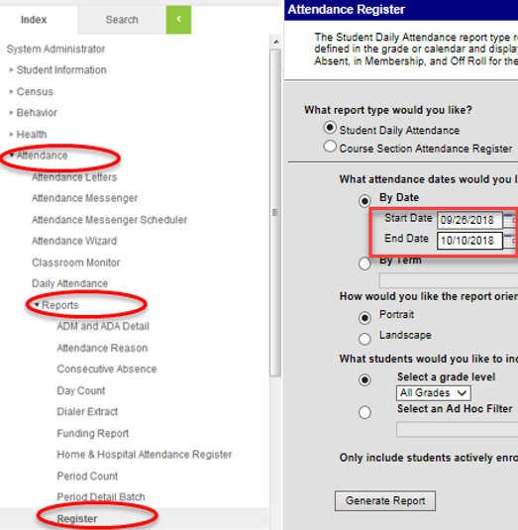

Report 2: Enrollment Entry/Exit
- Click Student Information
- Click Reports
- Click Enrollment Status
- Choose All Students for grades to include in the report
- Choose Active Year for the calendar
- For Enrollment Add Date, include July 1st through the Count Day (ex: 7/1/2023-10/2/2023)
- If your school is approved for an alternative count day, then use that date
- For Enrollment Drop Date, include July 1 through the end of the 11-day window (ex: 7/1/2023-10/9/2023)
- If your school is approved for an alternative count window, then use those dates
- For Display Options, make sure both Start Date and End Date are checked
- Choose whatever sorting method you prefer
- Click Generate ReportPlease review the entry report and exit report to ensure accuracy and save them as PDFs using the following naming convention: “SchoolCode_School_EnrollmentOctCt_CurrentDate”
Example: 1633_CECA_EnrollmentOctCt_10162023
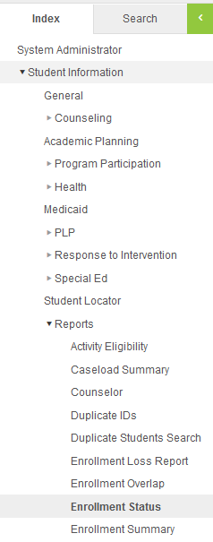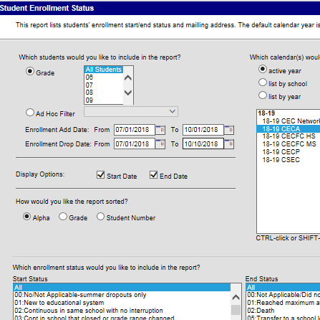

Report 3: Student Schedules (Typically, grades 6-12 where students move between classes and have passing periods)
**This report needs to be run on Count Day and submitted to G-Drive by the end of the day**

- Click Scheduling
- Click Reports
- Click Schedule Batch
- For Report Options, you can use the default format or choose from the display options
- For Grade, choose All Students
- Click Generate Report
- Please review the student schedules export to ensure accuracy and save it using the following naming convention:
“SchoolCode_School_StudentSchedulesOctCt_CurrentDate”
Example: 1633_CECA_StudentSchedulesOctCt_10022023
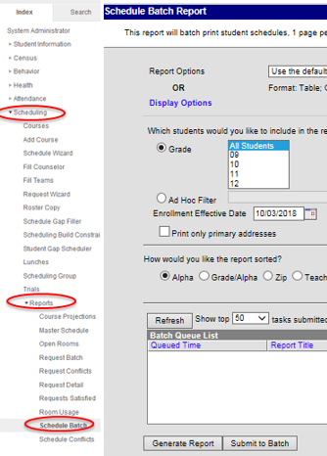

PowerSchool Report Extracts
The following instructions illustrate how to extract Attendance, Enrollment, and Student Schedule reports from PowerSchool.
Even though some screenshots may not illustrate the current school year, they should still be applicable in a general sense and won’t be updated until they change significantly with the vendor. However, be sure to use the dates described in the steps rather than those in the screenshot if it is from a different year.
Before Extracting any Reports First Create a Reporting Segment
In order to create a report based on the 11-day window (5 days prior, Count Day, and 5 days after), you’ll need to first create a Reporting Segment.
- In the left hand menu, click on School
- Click on Reporting Segments
- Click New
- For Segment Name, include a name like “October Count [YEAR]”
- For Start Date, choose the start date of the 11-day window
- For End Date, choose the end date of the 11-day window
- For 23-24, use the count window of 09/25/2023 – 10/9/2023 (if approved for alternative count window dates, then use those dates)
- For schools with students absent on Count Day (10/2/2023 or your approved alternative count day), use 7/1/2023-11/2/2023
- Click Submit
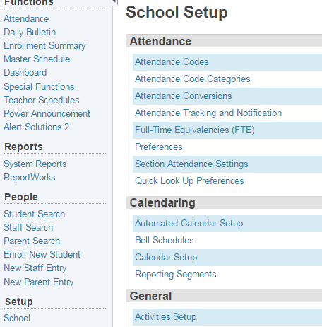
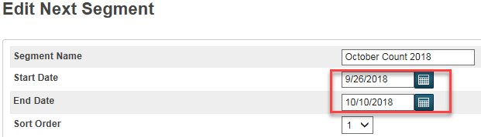
Report 1: Attendance
Before running this report, you’ll want to follow these steps to refresh your attendance.
- From the Start Page, click Special Functions. The Special Functions page appears.
- Click Attendance Functions. The Attendance Functions page appears.
- Click Refresh Premier Attendance Views Data. The Refresh Attendance Views Data Report page appears.
- Specify the students to be included in the refresh process.
- Specify the date range for which you wish to refresh the attendance views.
- Click Submit. The report will begin to process in the report queue.
- When the report is complete, click the View link to review the status of the refresh process.
After you have refreshed your attendance, follow these steps to generate the attendance report.
- Click on System Report
- Click on Monthly Student Attendance Report
- Select appropriate Attendance Mode and Conversion (typically, “Meeting” and “Period to Day”).
- For Students to Include, select “All Students”.
- For Reporting Segment, select the date range you created at the beginning of these instructions (ex: 09/25/2023 – 10/9/2023 in the image).
- For The report will break to a new page for each: choose “Month”.
- Click Submit.
- Please review this report to ensure accuracy and save it as a PDF using the following naming convention: “SchoolCode_School_AttendanceOctCt_CurrentDate”
Example: 0075_AHS_AttendanceOctCt_10162023
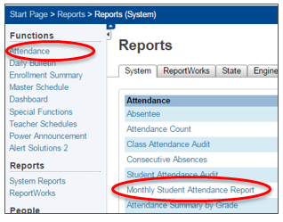
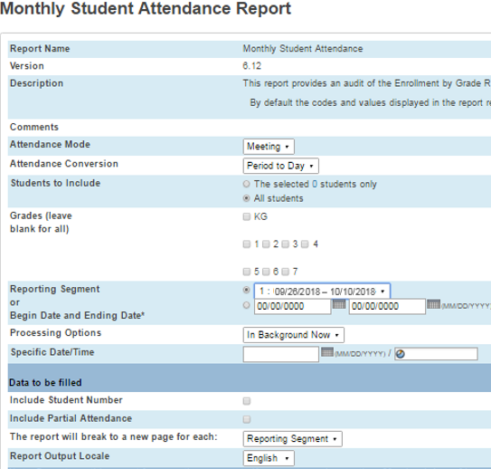
Reports 2: Enrollment Entry / Exit
- On the Start Page of PowerSchool, add the following into the Search bar:

/EntryDate>=7/1/2023;EntryDate<=10/9/2023

With the last entry date being the last day of your school’s 11-day window.
- Click the search (magnifying glass icon)
- Click on the down arrow next to the Select Function button (bottom right of the window)
- Click on List Students from the Select Function window
- Type the following in the List Students screen
*count
LastFirst
State_StudentNumber
grade_level
EntryCode
EntryDate
ExitCode
ExitDate
Enroll_status
- For Other Options, check the Export box
- Click Submit.
- A file will download. Please review the entry report and exit report to ensure accuracy.
Notes on Enroll Status Codes:
0 is active
-1 is PRE REGISTERED
2 is transferred out
- Save this file using the following naming convention: “SchoolCode_School_EnrollmentOctCt_CurrentDate”
Example: 0075_AHS_EnrollmentOctCt_10162023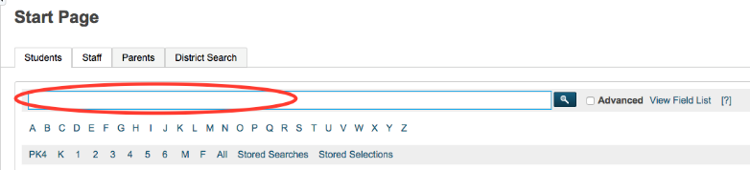
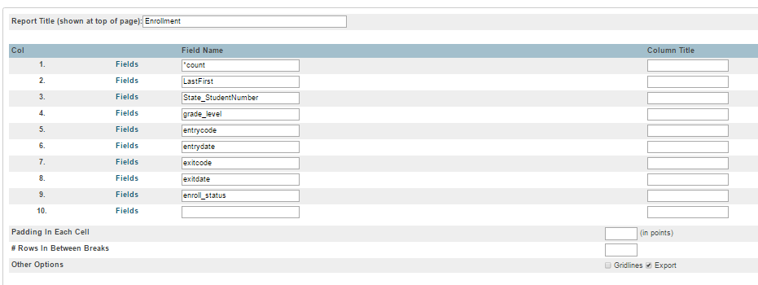
Report 3: Student Schedules (Typically, grades 6-12, where students move between classes and have passing periods)
**This report needs to be run on Count Day and submitted to G-Drive by the end of the day**

- To get a list of active students on Count Day, type the following in the search box:
*As_of=MM/DD/YYYY
with MM/DD/YYYY being the date of Count Day
- Click on the down arrow and choose Export Using Template
- For Type of Export, choose “Student Schedules”
- For Export Template?, choose “October Count” **
- For Which Records?, choose “Only schedules of…”
- Click Submit
- You will get an Excel file listing students by name and period. You will want to sort by name so each student’s classes are grouped together.
- Please review the student schedules export to ensure accuracy, then save it using the following naming convention: “SchoolCode_School_StudentSchedulesOctCt_CurrentDate”
Example: 0075_AHS_StudentSchedulesOctCt_10022023
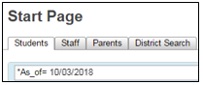

III: Crosschecking Funding Eligibility with Student Schedules
Once schools have performed a calendar calculation and have determined the number of minutes required to be eligible for full- or part-time funding, a bell schedule calculation should be performed for each secondary school in order to determine how many classes a student will need in order to meet those full- or part-time minute requirements. This enables the school to then evaluate each secondary student’s schedule to ensure that each student is submitted for the appropriate amount of funding.
By default, both PowerSchool and Infinite Campus have students identified as eligible for full-time funding. It is the school’s responsibility to adjust the funding code for each student based on eligibility criteria (enrollment, attendance, scheduled hours, etc.). The following instructions provide one way to use your SIS to find students who meet (or do not meet) schedule hour criteria to be eligible for part- or full-time funding.
The school is responsible for reviewing the students who don’t have the necessary number of courses to qualify for full time funding and either:
- update the schedule so that on/before Count Day, the student has the required number of courses
or
- adjust the student’s funding status so that on/before Count Day, the funding status is accurate.

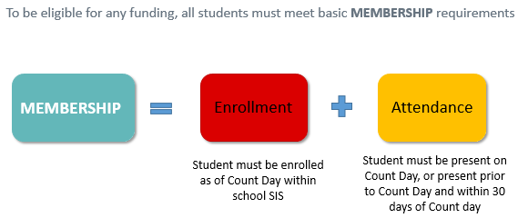
See the CSI webpage on School Calendar and Instructional Hours for resources on instructional hours and scheduling requirements. The CDE Calendar and Instructional Hours Guidance​ document is particularly important.

PowerSchool Instructions
In the Search bar, type in *number_of_classes<# with # being the number of classes needed to qualify for full time funding. Then press ‘Enter” or click the magnifying glass icon to search.
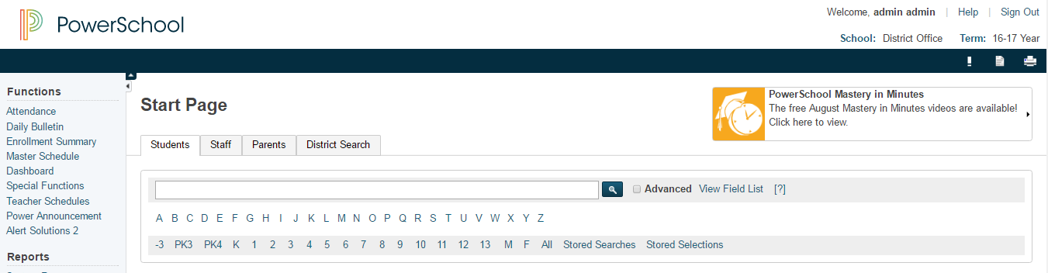
This search will result in a listing of any students with fewer than the number of classes necessary to qualify for full-time funding based on scheduled hours alone.

Infinite Campus Instructions

Student Gap Scheduler
The Student Gap Scheduler tool is used to find students with holes in their schedule. This tool may be used to generate a report to show students with a hole in their schedule for staff to identify students who may not qualify for full time funding based on scheduled hours alone.
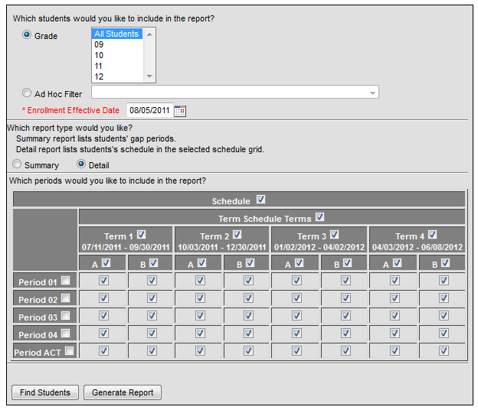
- Go to: Scheduling > Student Gap Scheduler
- Select the students whose schedules you wish to analyze (by grade or Ad Hoc filter)
- Select the enrollment effective date.
Be sure the Enrollment Effective Date is a date within the calendar selected; otherwise no results will be returned. (Note: Schools should run this report BEFORE Count Day to ensure students have accurate schedules. It should also be run ON Count Day to ensure that students have the appropriate funding status selected based on the Count Day schedule.)
- If running the report, select the type of report. The summary mode will list the empty periods each student has. The detail mode will print a mini schedule for the student, with an “X” indicating a scheduled course and gray shading indicating an empty period. (Note: Detail report tends to be easier to skim to identify students with significant schedule gaps.)
- Select the terms/periods for analysis using the checkbox grid at the bottom.
  - Selecting the Schedule checkbox at the top of the grid will automatically check all term/period boxes.
  - Selecting (or deselecting) a term will check all boxes in that term.
  - Selecting (or deselecting) a period will check all boxes for that period.
  - Note: Schools should select as many terms as needed in order to have half of the school year’s school days included. Ex: In a school with a semester schedule, checking first semester should suffice. In a school with a trimester schedule, check both first and second semester should suffice.
- Selecting Find Students will run a search and show students with a hole in their schedule in the search results. Generate report will create a PDF report that may be printed or saved as needed.
- Note: Schools can use the Generate Report option to print the mini schedules for students. Schools should then go through the report, identify any students with significant gaps (grey blocks) in the schedule.
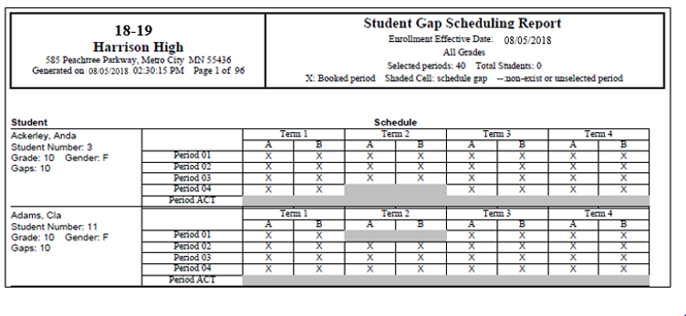

IV: Free and Reduced Lunch Eligibility Checklist

Current year resources for determining FRL eligibility status as well as guidance on how to enter data into PowerSchool and Infinite Campus are available on the CSI Free and Reduced Lunch Eligibility webpage.
All schools are required to have documentation that supports the free and reduced lunch eligibility for every student. Schools are responsible for updating their student information system (SIS) to include free and reduced lunch eligibility regularly throughout the year, and particularly before required state reporting deadlines (most importantly for October Count).
Please know that it is the “eligibility” that must be recorded. It is not whether the student is actually receiving free or reduced lunches.
If FRL eligibility status is not being maintained in the SIS, schools or the SFA should communicate with CSI about providing the updated FRL status before required state reporting deadlines, particularly the October Count data collection.
Once the October Count data is finalized, it cannot be changed, so it is critical that your data is reported correctly. FRL status is used in accountability reports and also in determining At-Risk funding. It is the responsibility of each school to ensure that the data is correct in your October Count file submissions so that you don’t experience negative performance report outcomes, cuts to At-Risk funding from underreporting your FRL data, or audit exceptions during At-Risk state audits for students inaccurately reported as free or reduced lunch eligible.
Determining FRL eligibility:
- For schools not participating with an SFA, you will need to have families fill out the state FEDS form to determine FRL eligibility status for each of your students for the current school year. Current year forms, instructions to provide to families, and the eligibility guidance have all been posted to the CSI Free and Reduced Lunch Eligibility webpage.
- For schools using an SFA this year, please be sure to have families complete the federal meal plan application (online is the preferred method) and work with your SFA on data matches and updating your SIS with the eligibility status for all students. This includes schools using the CSI SFA.
All schools are strongly encouraged to complete the following FRL checklist as part of the October Count collection and internal audit. Check off the following items as you complete them. A signature form is not included with this FRL checklist for the current year.
School is participating with an SFA:
New in 23-24, the Healthy Meals for All program allows public School Food Authorities (SFAs) participating in the National School Lunch and Breakfast programs to provide free meals to all students. For accountability purposes plus At-Risk and Title I funding, CSI schools still need to ensure they are collecting FRL eligibilities and storing that data in their SIS in order to extract the data for state collections during the year.

☐ Completed the current year CSI Organizational Submissions, FRL Participation Survey by the August deadline (lets CSI know whether your school is participating with an SFA or not for the current year).
☐ Current year federal meal benefit application and instructions have been provided to all families.
- Very Important- these should not be completed and signed prior to July 1 or they are invalid!
- For the October Count collection, the forms must be signed between July 1 and count day (October 2nd for 23-24).
- Continue to provide forms to all new students as they transfer in. Work with your SFA on the exact process because this may be automated.
☐ Consider scheduling opportunities for families to complete federal meal benefit application or at the school (back to school event, before/after school, orientation event, zoom meeting, conference call, etc.).
☐ Consider sending direct communications to families encouraging them to complete the federal meal benefit application form. CSI has posted an F&R Information Letter to Households Template on the Free and Reduced Lunch Eligibility that schools are welcome to edit and provide to families.
☐ An MOU, privacy statements, and all processing steps for file exchanges have been finalized with the SFA that your school is contracting with (your school is ready to begin exchanging data with the SFA).
☐ All completed federal meal benefit application forms have been provided to the SFA (if on paper) Consider having a tracking sheet to ensure that all families have completed a form. Double check that the forms are complete, accurate, and signed & dated before submitting to your SFA.
☐ In the absence of current year FRL eligibility documentation (typically only for last minute enrollees before count date), you may utilize carryover documentation evidencing free lunch eligibility if the October Count date falls within the first 30 school days of the current school year.
- You may use the carryover only if you do not have anything new for the current year eligibility status. In other words, you cannot use a free or reduced lunch status from the carryover just because there is a new status for the current year and the student is now not eligible.
- In cases where students transfer between districts on or before the count date, the USDA does allow for the transfer of lunch eligibility status from one district to another. In such cases, if the receiving school is able to include the student in the October Count the school can report the student’s lunch eligibly status from the prior district if it has documentation as to the student’s eligibility from the prior district. In the absence of such documentation, the receiving school must obtain new or updated documentation evidencing the student’s lunch eligibility.
- In the event a school is unable to use prior year carryover documentation to evidence free lunch eligibility because the count date does not fall within the first 30 days of school, the school may use the carryover as long as a variance waiver has been approved by CDE to extend the 30 school day requirement (as it relates to the at-risk count only). CSI will submit a request for all schools to use the variance waiver and notify schools when approval is received.
☐ All student records have an updated FRL eligibility status as of the October Count date in the school SIS
New in 23-24, an additional FRL field named “FRL Eligibility Identification” was added to the Student Demographic file layout. This field is required for all students and must be populated in the school SIS with the applicable type of documentation the school used to identify the student as free lunch eligible.
☐ Student records have been updated to free lunch eligible where a CSI signed McKinney-Vento form has been returned to the school (student is considered homeless). MKV form must have been signed by CSI by count day to report the student as homeless and free lunch eligible in the October Count collection.
☐ Student records have been updated to free lunch eligible where a student shows up on the CDE migrant list. Schools should receive an error message in the October Count file submission if migrant students are not coded as free lunch eligible.
☐ Student records have been updated to free lunch eligible where CSI has notified our school on a foster student. Schools should receive an error message in the October Count file submission if foster students are not coded as free lunch eligible.
☐ Student records have been updated to free lunch eligible where extended eligibility to other students residing in the same household is allowable by direct certifications (SNAP/TANF). This is not allowable in the case of migrant or foster scenarios.
Schools should create a document noting the name of the school staff member who flagged the student, the date it was done, and retain that document in case the student is part of an At-Risk audit sample.
☐ The SD file extract from your SIS has been reviewed to ensure that FRL statuses appear correct for all students prior to submission to CSI.
☐ The FRL Counts within the October Count summary report (includes trend data) have been thoroughly reviewed prior to the certification deadline (please do this as soon as you receive the summary report to allow plenty of time to correct data if needed).

School is not participating with an SFA:
Schools using an electronic version of the FEDS forms must follow requirements found within the CDE Online Signature Guidance.
☐ Completed the current year CSI Organizational Submissions, FRL Participation Survey by the deadline (lets CSI know whether your school is participating with an SFA or not for the current year).
☐ Current year state FEDS forms and instructions have been provided to all families
- Very Important- these should not be completed and signed prior to July 1 or they are invalid!
- For the October Count collection, the forms must be signed between July 1 and count day (October 2nd for 23-24).
- Continue to provide forms to all new students as they transfer in. Work with your SFA on the exact process because this may be automated.
☐ Consider scheduling opportunities for families to complete the state FEDS form at the school (back to school event, before/after school, orientation event, Zoom meeting, conference call, etc.).
☐ Consider sending direct communications to families encouraging them to complete the state FEDS form. CSI has posted an F&R Information Letter to Households Template on the CSI Free and Reduced Lunch Eligibility webpage that schools are welcome to edit and provide to families.
☐ All state FEDS forms have been collected from families and processed to determine the FRL eligibility status for each student. Consider a tracking system to ensure all forms have been returned. Double check that the forms are complete, accurate, and signed & dated.
☐ In the absence of current year FRL eligibility documentation (typically only for last minute enrollees before count date), you may utilize carryover documentation evidencing free lunch eligibility if the October Count date falls within the first 30 school days of the current school year.
- You may use the carryover only if you do not have anything new for the current year eligibility status. You cannot use a free or reduced lunch status from the carryover just because there is a new status for the current year and the student is now not eligible.
- In cases where students transfer between districts on or before the count date, the USDA does allow for the transfer of lunch eligibility status from one district to another. In such cases, if the receiving school is able to include the student in the October Count the school can report the student’s lunch eligibly status from the prior district if it has documentation as to the student’s eligibility from the prior district. In the absence of such documentation, the receiving school must obtain new or updated documentation evidencing the student’s lunch eligibility.
- In the event a school is unable to use prior year carryover documentation to evidence free lunch eligibility because the count date does not fall within the first 30 days of school, the school may use the carryover as long as a variance waiver has been approved by CDE to extend the 30 school day requirement (as it relates to the at-risk count only). CSI will submit a request for all schools to use the variance waiver and notify schools when approval is received.
☐ All student records have an updated FRL eligibility status as of the October Count date in the school SIS.
New in 23-24, an additional FRL field named “FRL Eligibility Identification” was added to the Student Demographic file layout. This field is required for all students and must be populated in the school SIS with the applicable type of documentation the school used to identify the student as free lunch eligible.
☐ Student records have been updated to free lunch eligible where a CSI signed McKinney-Vento form has been returned to the school.
☐ Student records have been updated to free lunch eligible where a student shows up on the CDE migrant list. Schools should receive an error message in the October Count file submission if migrant students are not coded as free lunch eligible.
☐ Student records have been updated to free lunch eligible where CSI has notified our school on a foster student. Schools should receive an error message in the October Count file submission if foster students are not coded as free lunch eligible.
☐ Student records have been updated to free lunch eligible where extended eligibility to other students residing in the same household is allowable by direct certifications (SNAP/TANF). This is not allowable in the case of migrant or foster scenarios.
Schools should create a document noting the name of the school staff member who flagged the student, the date it was done, and retain that document in case the student is part of an At-Risk audit sample.
☐ The SD file extract from your SIS has been reviewed to ensure that FRL statuses appear correct for all students prior to submission to CSI.
☐ The FRL Counts within the October Count summary report (includes trend data) have been thoroughly reviewed prior to the certification deadline (please do this as soon as you receive the report to allow plenty of time to correct data if needed).

