File Naming and FileZilla Quiz

- Which naming structure should be used when submitting a Student Demographic (SD) file to CSI?

A. 2019 06 17 NLCS_6266_SD_EOY.xlsx | B. 6914_Pinnacle_SD_05232019.csv
C. 7278.RFMA.SD. csv | D. SMCS_SD_05172019.csv

- Select the best location to place your SDA files for the recently completed school year?

A. /Submissions/SDA/SY 18-19/Error Reports | B. /Submissions/SDA/SY 17-18/Files to Run
C. /Submissions/SDA/SY 18-19/Files to Run | D./Submissions/EOY/SY 18-19/Files to Run
- Which of the following may result in significantly more errors in your error report when we process your file?

A. Placing file in the wrong folder | C. Opening the error report, making changes, and resaving
B. Opening the csv file, making changes, and resaving | D. Submitting new files without making any changes in your SIS

- What is the best naming structure if your school submits multiple files in one day?

A. 2035_CPA_SP_12122019 | C.1795_CSEC_SA_12142019v2
B.2837_ECA_Staff_AssignmentPM | D. All of the above

- CSI has provided you a listing of issues to review and resolve based on your recent file submittal. Which area in FileZilla would you access the file?

A. 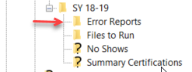 | C. 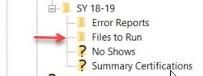
B. 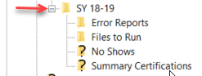 | D. 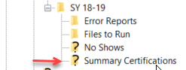

- What are the steps that should be taken to ensure CSI processes your new files in a timely manner?

A. Utilize the proper naming structure of extracted files with no spaces, school name/code, and date. | C. Notify the submissions inbox that new files are available to run and include path
B. Place files in the correct Files to Run folder for the current school year | D. All of the above*

